AP Physics – Thermo Lab

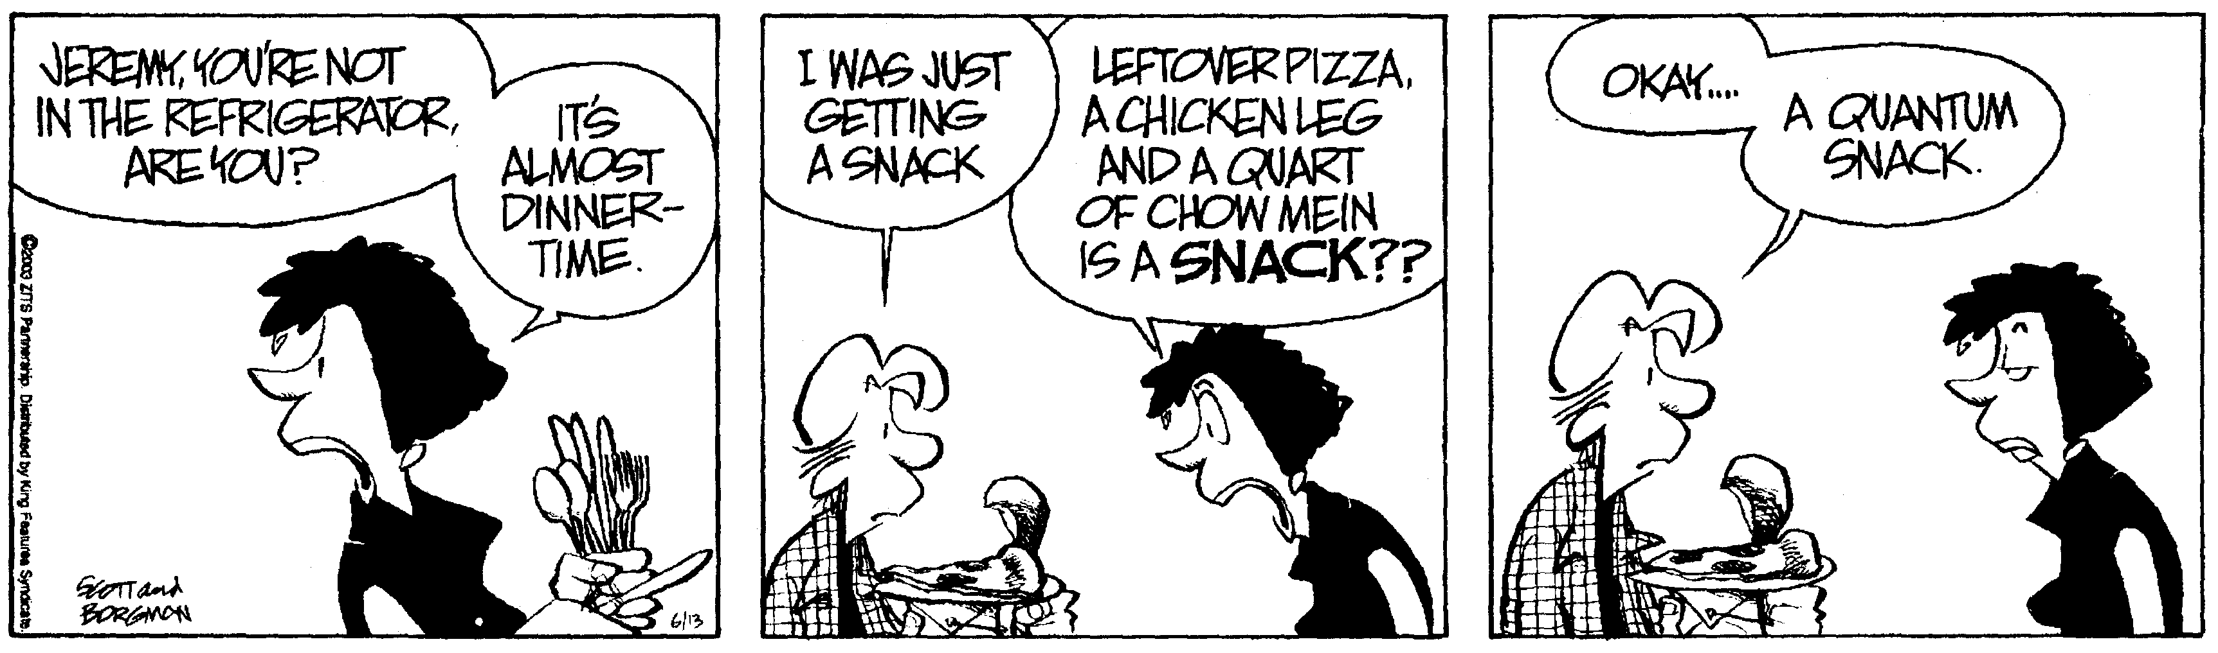
True wisdom is less presuming than folly. The wise man doubteth often, and changeth his mind; the fool is obstinate, and doubteth not; he knoweth all things but his own ignorance. – Akhenaton

In this lab you will make ice cream

The purpose of the lab is to use cold temperature mixture of salt and ice to make ice cream.

Then you eat the ice cream.

Here is the recipe that the Physics Kahuna (actually it was the memshahib) used.

Ice Cream in a Baggie.

½ cup milk
½ teaspoon vanilla
1 tablespoon sugar

Mix milk, vanilla, and sugar.

Anyway. Pour a half cup of ice cream goop into a baggie. Seal it.

Put the baggie into a coffee can. Fill the can with ice and throw in a couple of handfuls of salt.

Put the lid on the can and roll it around and shake it (make sure the lid stays on). Check out the ice cream mixture every few minutes to see if it’s frozen yet. You can stop when it is frozen and then slurp up the ice cream. Then eat the stuff.

How about this for a deal. No lab report..

