Notes: The Electromagnetic Spectrum
BIG IDEAS | DETAILS
The Electromagnetic Spectrum | The electromagnetic spectrum is the ______________ of all wavelengths of radiation  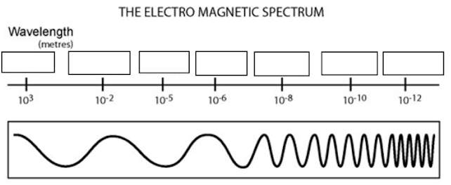  EM waves are different from ocean and other waves, because they can travel in a ___________________. All waves on the EM spectrum travel at a ____________ speed.
Speed of light | Light is the fastest thing in the universe - moving at a speed of ________________ m/s. Since they move at the same speed, all EM waves cover the same distance in one year. A light year is a measure of _____________________________, defined as how _______ light travels in _______________________.
How waves work | The parts of a wave:  - Crest: ___________________________________________________  - Trough: _________________________________________________  - Wavelength: _____________________________________________  Frequency is how many _____________________ pass by in a minute. The greater the frequency, the _____________ the energy of the wave.  Since all waves on the EM spectrum travel at the speed of light, a short wavelength means a _________ frequency. On the EM spectrum, ___________________ have the highest frequency.
Visible Light & Color | We can only see a small portion of the EM spectrum - ______________ light, which has wavelengths from ________ to _________ nm. When these waves strike objects, some wavelengths are reflected while others are absorbed. The color we see is the wavelengths that were _________________.

