1. Which of the following contain measured quantities and which contain exact quantities?
a) There are 60 seconds in a minute.
b) There are 1000 meters in a kilometer.
c) A certain brand of butter is composed of 81.23% fat.
d) There are 0.621371 miles in a kilometer.
e) A person is 172.345176 cm tall.
f) There are 365 days in a year.
g) The mass of a 100.0 gram calibration weight.
h) A wallet contains $58.66.
i) There are 21 eggs in a refrigerator.
j) The length of a television show is sixty minutes.
k) There are 454 grams in a pound.
l) A car’s gas tank holds 58.7 liters.
m) There are 1000 liters in a cubic meter.
n) Usain Bolt can run 27.31 mph

2. Determine the number of significant digits in the following measured values:
13,200,000 9200.0300
801,200 5.1105 x 10⁻⁴
0.0003651000 6.308000 x 10³

3. Round off the following numbers to 3 significant digits:
0.002866 608,712,000
77,459 7.50498 x 10⁻⁵
31249.99 3.096349 x 10³

4. Perform the indicated operations: (Use the proper number of significant figures)
0.0082 + 28.2 + 6057.36 + 883.2
790 x 52.8795
5300.35 – 5297.3
8487.89
5.3300

5. An empty beaker has a mass of 109.3 grams. After a solution has been added, the mass is 132.143 grams. How much of the solution was added? (Use the proper number of significant figures)

6. What is the volume measurement for this graduate?

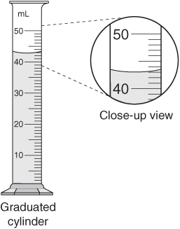

7. What is the length measurement shown below in centimeters?
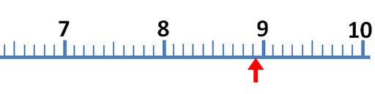
8. What is the volume measurement from this pipet in mL?
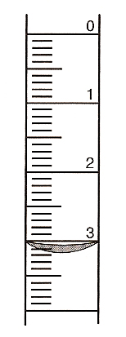

9. Carry out the following conversions-you must show work! (Use the proper number of significant figures)
7.21 inches to meters
4.25823 gallons to milliliters
6.1 x 10⁻² square inches to square centimeters
3.2734 x 10⁻³ liters to cubic inches
3.4111 x 10⁴ grams to pounds

Refer to this Fig Newton label for questions 10-13:

Nutrition Facts
Serving Size | 2 cookies (31 g)
Servings per Container | 15
Amount per Serving
Calories | 110
Calories from Fat | 20
Total Fat | 2.5 g
Sodium | 115 mg
Total Carbohydrate | 22 g
Dietary Fiber | 1 g
Sugars | 14 g
Protein | 1 g

10. What is the mass percentage of fat in Fig Newtons?

11. How many grams of sugar are in one package of Fig Newtons?

12. If someone ate 8 Fig Newtons, how many pounds of protein would they ingest?

13. The recommended daily intake of sodium is 2.4 grams. What percent of the recommended daily intake of sodium would be obtained by eating 1 package of Fig Newton cookies?

14. When you are riding in a car going sixty miles per hour, how many significant figures does the speedometer on the car give?

15. The volume of blood flowing through an adult liver is 25 mL per second. How many gallons per hour is this? (Use the proper number of significant figures)

16. An average bee carries 0.0018 oz of nectar per trip to the hive. How many trips does it take to transport 2.50 kg of nectar? (Use the proper number of significant figures)

17. An engine has a displacement of 440 cubic inches. Convert this into liters.

18. If a newborn baby weighs eight pounds, three ounces, what is the baby's mass in kg?

19. If natural gas costs $9.90 per thousand cubic feet, and it takes 0.304 ft³ of gas to boil 1.0 liters of water, how much would it cost to boil a 2.5 liter pot of water?

20. What is your height in centimeters and your mass in kilograms? (you can lie a little)

21. You read online that the model of car that you drive gets 29.5 miles per gallon. The car’s manual says your gas tank holds 13.9 gallons. Predict how many miles you could go on a full tank of gas. Should you give three digits in your answer? Explain why or why not.

22. Household bleach can be used to disinfect water for drinking. It is recommended that 3 drops of bleach be added to each liter of water. How much water would a 4.0 liter jug of bleach be able to treat if 20 drops equal one milliliter?

23. Normal body temperature is given as 37°C. What is this temperature in °F? (Use the correct number of significant figures).

Challenge Problem
24. Play the computer game “Fling the Teacher” on significant figures.

https://sites.google.com/a/revisemaths.org.uk/revise/home/number/rounding-to-significant-figures/fling

Click on view bigger version to play. Print the screen at the end when you win and attach to this homework to earn your two points.

