1. Indicate the physical state (gas, liquid, solid) of the following metals placed in ice water and boiling water:

boiling water ice water
tin

gallium

bromine

mercury

2. A container of phosphorous originally at 0°C is placed in an oven at 200°C. Draw a graph of the container’s temperature vs. time.

3. A container of bromine and iodine originally at 0°C is placed in an oven at 200°C. Draw a graph of the container’s temperature vs. time. Assume there is no chemical reaction.

4. A container of an unknown substance is removed from the refrigerator and placed in an oven at 250°C. After 15 minutes, the temperature inside the container is still only 15°C. Give two possible reasons why.

5. The human body contains approximately 5.7 liters of blood. Assuming that the density of blood is 1.06 g/mL and that the specific heats of blood and water are the same, how many calories are required to raise the temperature of the blood by 1.4°C?

6. What is the specific heat of a substance if 569 calories raises the temperature of 72.2 grams of the substance from 13°C to 89°C?

7. How much energy would be required to raise the temperature of a 58.4 kg block of aluminum from 25°C to 275°C?

8. Calculate the amount of heat released when 72.2 grams of steam at 100°C condenses to liquid at 100°C.

9. Calculate the amount of heat required to convert 31.8 grams of ice at 0°C to water at 0°C.

10. Calculate the amount of heat required to convert 82.9 grams of liquid mercury at 630 K to mercury gas at 630 K.

11. Calculate the amount of heat required to change 8.22 kg of ice at 0°C to water at 65°C.

12. Calculate the amount of heat released when 69.0 g of steam at 175°C is converted to ice at -25°C.

13. Calculate the amount of energy needed to heat 821 g of zirconium from 25°C to 255°C.

14. Calculate the amount of heat energy needed to melt 42.3 kg of tin originally at 25°C.

15. Calculate the amount of energy released when 71.5 g of molten nickel at its melting temperature is cooled to 0°C.

16. If 99.7 kJ of energy was supplied to 71.2 kg of xenon at a temperature of 25°C, what would be the final temperature?

17. If 68.3 kJ raised the temperature of a block of lead by 36.2°C, what was the mass of the block of lead?

18. Why is the heat of vaporization always higher than the heat of fusion?

19. On a previous homework, the operation of a refrigerator was discussed. Instead of just compressing and expanding a gas, getting the refrigerant to turn into a liquid when it is compressed, greatly improves the efficiency of the refrigerator. Explain why.

20. You have a picnic cooler with 4 liters of lemonade at room temperature (25°C). How much ice you would need to get the lemonade down to a temperature of 0°C?

21. Explain how opening the refrigerator affects the temperature of your house.

22. What is wrong with the caption on the attached picture?

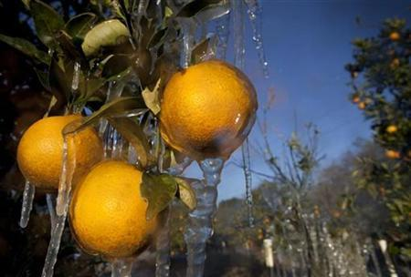
A protective layer of ice form on oranges in a grove near Dover, Florida December 14, 2010.
Credit: Reuters/Scott Audette

23. Visit the Cool Vest website: (http://www.coolvest.com/default.aspx?AspxAutoDetectCookieSupport=1 ).

Explain how a Cool Vest works.

24. (Challenge Problem) Assume an average sized house (volume = 350,000 liters) is filled with air at a temperature of 35°C and a relative humidity of 80%. You want to run an air conditioner to drop the temperature down to 25°C and a relative humidity of 45%. Calculate how much energy needs to be removed from the house to lower the temperature. Calculate how much energy needs to be removed from the house to lower the humidity.

