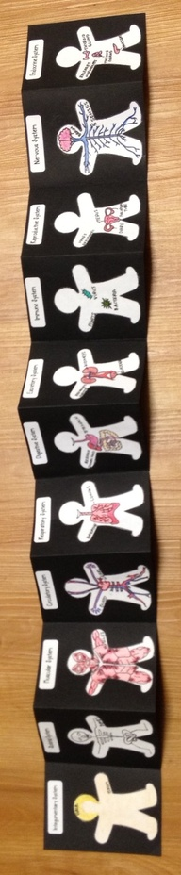
The Human Body
11 Organ Systems Foldable
1. Each student received both printouts below and were asked to color and cut them out.
2. Then we created the background. Each student got to choose a 12 x 18 piece of construction paper and we folded it once hot dog style, then folded it hamburger style, then hamburger style into thirds, creating 12 total squares.
3. Cut along the hot dog style fold, and glue one end piece from one strip to the beginning piece of the other strip (creating 11 total squares in a long strip)
4. I wrote all the names of the organ systems in order (from the book) on the board.
5. Then using their notes and book they had to match the picture to the title, write the title on that square and glue it down.

11 Systems: 1. Integumentary System (Hair & Skin) 2. Skeletal System 3. Muscular System
4. Circulatory System 5. Respiratory System
6. Digestive System 7. Excretory System
8. Immune System 9. Reproductive System
10. Nervous System 11. Endocrine System

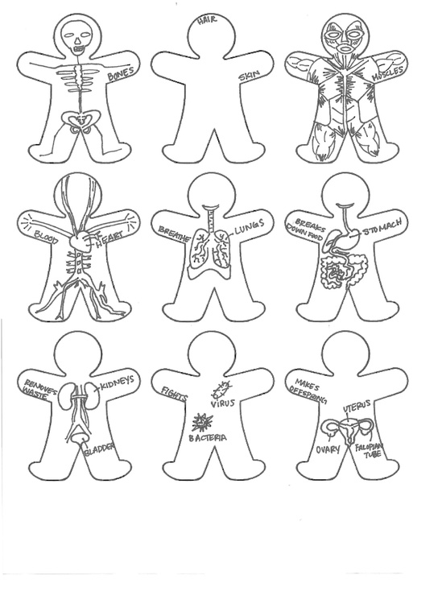
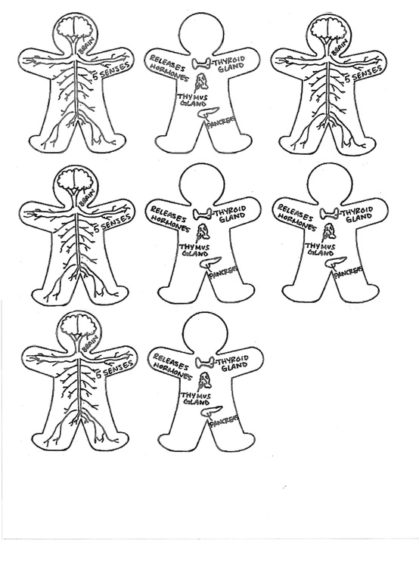
Skeletal System
Integumentary System
Muscular System
Circulatory System
Respiratory System
Digestive System
Excretory System
Immune System
Reproductive System
Nervous System
Endocrine System

