Newton’s Hovercraft
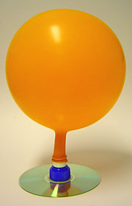
Objectives:
- to create a balloon powered hovercraft for maximum speed and distance
- to learn how to use the formula Speed= Distance / Time
- to understand Newton’s 3rd Law: Every action has an equal and opposite reaction

Materials
- Old CD
- Soda Lid
- Hot Glue
- 1 Large Balloon and several small, long balloons
- Tape
- Straws

What to do
- Glue the base so the lid covers the hole in the center of the CD.
- Blow up a balloon and pinch the neck so that no air can escape.
- Stretch the neck of the balloon over the lid.
- Release the air from the balloon.
- Shove the hovercraft as far as possible without lifting.

Conclusion:
- Who had the best hovercraft that went the furthest? Why do you think theirs was the best?

- Who had the slowest hovercraft? Why do you think it was the slowest?

- If you could begin this project again, what would you do different?

- How does the movement of the car show Newton’s 1st Law? Explain thoroughly.

- How does the movement of the car show Newton’s 2rd Law? Explain thoroughly.

- How does the movement of the car show Newton’s 3rd Law? Explain thoroughly.

