ULTRA-SIMPLE HOVERCRAFT
can lift several adults!
1997 William J. Beaty
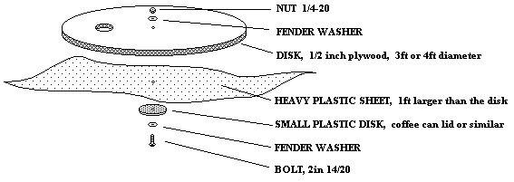
NEEDED:
- PLYWOOD, 3ft or 4ft square, 3/8in or 1/2in thick
(or buy a 48in precut round tabletop).
- PLASTIC SHEET, 1ft larger than the above wood
(Avoid using 1mil thickness garbage bags, instead use a heavy 4mil or 6mil plastic dropcloth from a paint store, or 'Visqueen' sheet, or an old plastic shower curtain)
- LEAF BLOWER (battery powered, or gasoline), or use the type of old-style 'ShopVac' cannister vacuum cleaner which has a blower outlet.
- SMALL PLASTIC DISK, coffee can lid, or 6" disk 1/8in thick plastic or thin wood.
- BOLT, 2in, 1/4-20
- NUT, 1/4-20
- FENDER WASHERS (TWO)
- SMOOTH FLOOR (linoleum, ball court, or smooth concrete)
- electric saber saw, drill, razor knife, staplegun, duct tape
- Optional: lawn chair and clamps/screws to hold it down.
- Optional: some sort of rubber bumper for the edge. Nail on some old bike tires? Just cover it with duct tape?

INSTRUCTIONS:
MAKE THE WOOD DISK
Cut out your plywood disk. You can leave it square, or experiment with other shapes instead of round, but the sharp corners can hurt people. Round is best for safety.
Drill a 5/16in hole in the exact center, and make sure that the 2in bolt easily passes through it.
NOTE: people tell me that you can avoid using a big bolt. Instead, fasten down the small plastic disk with several short wood screws. This is a big improvement! Kids sitting on the hovercraft won't get poked in the butt anymore by that big bolt sticking up.
Make a hole in the plywood which exactly fits the end of your leaf blower or shopvac hose. This hole must be placed half way between the center of the disk and the edge, as shown below. It's a good idea to trace the hole in pencil on the wood (place the mouth of the leaf blower on the wood and trace around it.) It DOES NOT have to fit perfectly. Later you can seal any leaks with duct tape. Or just let it leak. The hose should be flush with the bottom surface (don't let it stick out or the floor will block the air flow.)
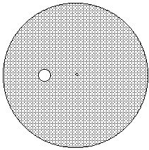
MAKE THE PLASTIC SHEET
Next, lay your plywood disk on the center of your large plastic sheet. Fold the edges of the sheet up over the plywood, then use the staplegun to staple it to the top of the plywood disk. Put a staple about every 4 inches. The plastic should be tight against the wood, but don't pull it TOO tight or the plastic will tear loose when inflated. When finished, you can cut off the excess plastic. If you wish, used duct tape to tape the edge of the plastic down to make it look nice. From above, it should look like this:
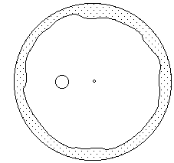

ADD THE "SKIRT LIFTER"
Poke a hole in the center of the coffee can lid. Attach it to the bottom of the hovercraft as shown below. It goes over the plastic sheet. It pins the plastic sheet firmly against the plywood. (The coffee can lid forms the "donut hole" when the leaf blower slightly inflates the plastic into a "donut" shape.)
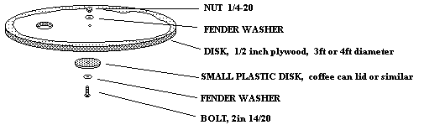
CUT THE CENTER HOLES
Use your razor knife to cut six vent holes in the plastic as shown below. They should be about 2in diameter. They must be placed within a few inches of the coffee can lid. Space them out so that there is plenty of plastic between each of them. But if they are too far away from the center, they will become plugged when the plastic sheet lays flat against the floor. If the plastic between the holes is too narrow, it will tear. If you wish, reinforce the thin necks of plastic between the holes using a couple of layers of duct tape.
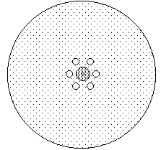
DONE!
Flip your hovercraft over so the plastic sheet is on the bottom. Place it on a smooth floor. Stick the leaf blower into the hole and turn it on. The plastic on the bottom should inflate. If it does not, lift the plywood up a bit to let the air get in and inflate the "skirt." The hovercraft will lift up slightly and start gliding around.

DEBUGGING
If it doesn't work, first read the above article again to see if you missed anything.
Always make sure to lift the wood disk up a few inches while the blower is running. If the disk stays flat against the floor, then the air can't get out of the blower, and the plastic sheet will never inflate.
When you turn it on for the very first time, run it on a smooth shiney floor such as linoleum or a wooden Gym floor. Try other kinds of rough floors and rugs later, after you know it works. Smooth dirt works OK, but it makes a big cloud of dust. I've never tried it on water.
If too much air is leaking from the around the leaf blower, add some temporary duct tape at the point where the nozzle goes into the hole in the wood.
Still no luck? Maybe your plastic sheet is too loose. Turn the hovercraft up on edge and turn on the blower. The plastic sheet should inflate, and it should lift up from the wood by only three or four inches. If the sheet is too tight then it will tear loose from the staples. But if it's too loose it will form a floppy bag and won't glide around.
DON'T use a hair blow-dryer, it won't work. You need either a "Shopvac"-style vacuum cleaner, or a lawn leaf blower. If you use a Shopvac, remove the dust bag and use the Shopvac's blower outlet (the hovercraft needs pressure, not suction!)

HOW IT WORKS
The air inflates the plastic which pushes upon the floor and provides a ground-hugging "skirt." This lifts the entire hovercraft. The coffee-can lid provides "strain relief" for the plastic sheet, so that the inflated plastic doesn't tear loose from the center. The coffee can lid also lifts up the plastic so air can escape through the vent holes and pressurize the center donut-hole. The air then leaks along the floor and out from the edges of the hovercraft. This creates an "Air Film Bearing" which has very low friction. The plastic isn't touching the floor. Instead it is riding on a thin layer or "film" which is made out of air. Climb aboard!
This hovercraft can support many hundreds of pounds. It works best on very smooth surfaces (linoleum, or school gym floor.)

