AP Physics - Hooke’s Law Lab

Human beings, who are almost unique in having the ability to learn from the experience of others,
are also remarkable for their apparent disinclination to do so. -- Douglas Adams

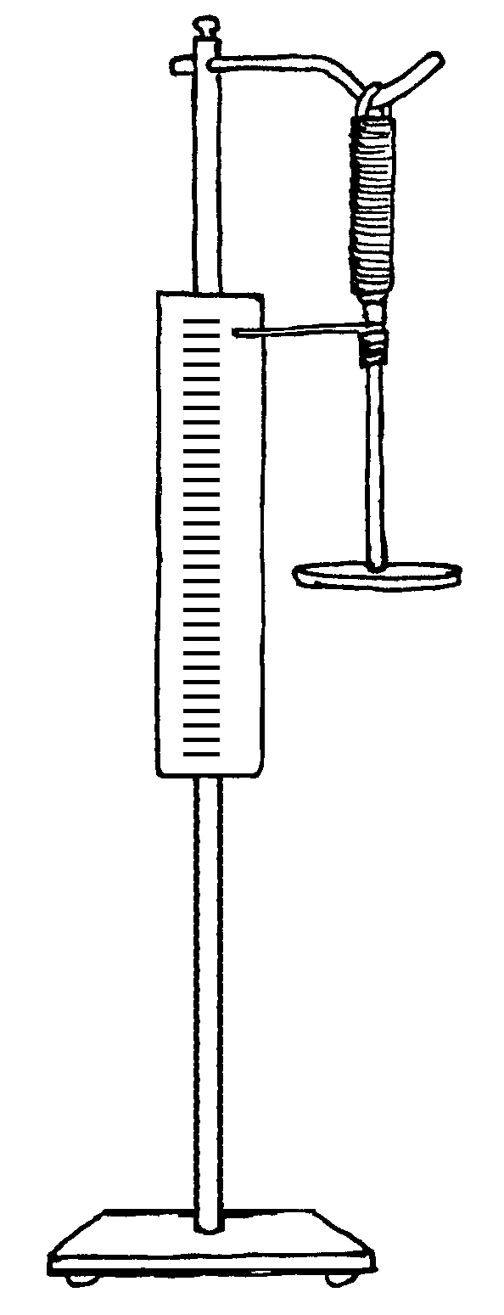
In this enchanting lab you will explore the wonders of the spring constant. Using the device pictured and some slot masses, determine the spring constant for the spring on the device.

