AP Physics – Work/Energy - 2

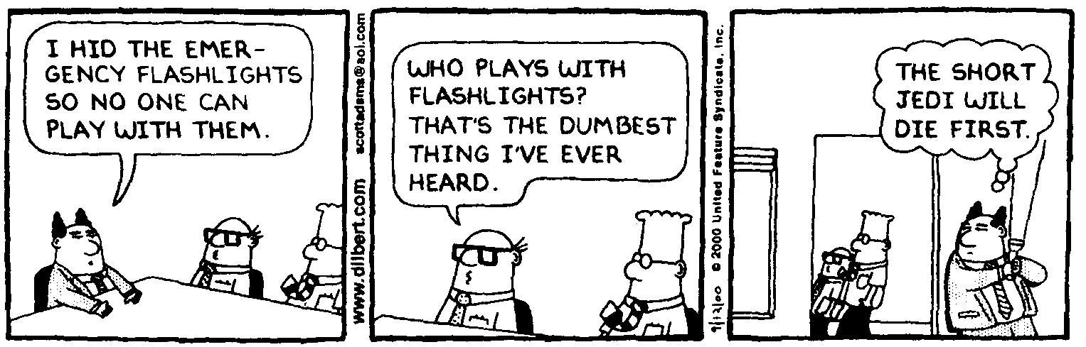
You, Identify, Now!__________________________________________________________Per __
He that would make his own liberty secure must guard even his enemy from oppression; for if he violates this duty he establishes a precedent that will reach to himself. --Thomas Paine
- A 2.45 kg rock is dropped from the top of a 15.5 m vertical cliff. (a) What is the potential energy of the rock relative to the base of the cliff before it is dropped? (b) What is the kinetic energy of the rock just before it hits the ground below? (c) What is the velocity of the rock at a point 5.00 m above the base of the cliff? (d) How much total energy does the rock have half way down?

- A roller coaster is at the top of a 75.0 m hill. It rolls down the hill on very low friction wheels and climbs up to the top of a 45.0 m hill. Find (a) the speed of the thing at the bottom of the first hill and (b) its speed at the top of the second hill.

- You push a 45.0 kg wooden crate up a ramp that makes an angle of 22.0° to the horizontal at a constant speed. The coefficient of kinetic friction for the crate and ramp is 0.385 (a) How much work have you done if you push it a distance of 10.5 m up the ramp? (b) What is the change in potential energy for the crate relative to the base of the ramp?

- A 2.5 kg ball hangs from the overhead by a string that is 75 cm long. The height of the room is 3.0 m. What is the potential energy of the ball (a) relative to the deck? (b) Relative to the top of an 88 cm tall tabletop? (c) Relative to the overhead?

- A block A of mass m₁ rests on a very smooth table and is attached to block B of mass m₂ that hangs over the table as shown. Block A is distance 3 d from the end of the table. Block B is distance 2d from the deck and distance d from the tabletop. (a) What is the potential energy of block B relative to the deck? (b) What is the acceleration of the system when block A is released? (c) What is the kinetic energy of block B just before it hits the deck? (d) What is the kinetic energy of block A at the moment it reaches the edge of the table (e) What is the potential energy of block A at the same point? (d) What is the kinetic energy of block A just before it hits the deck?

