AP Physics – Vectors be Everwhere – 2

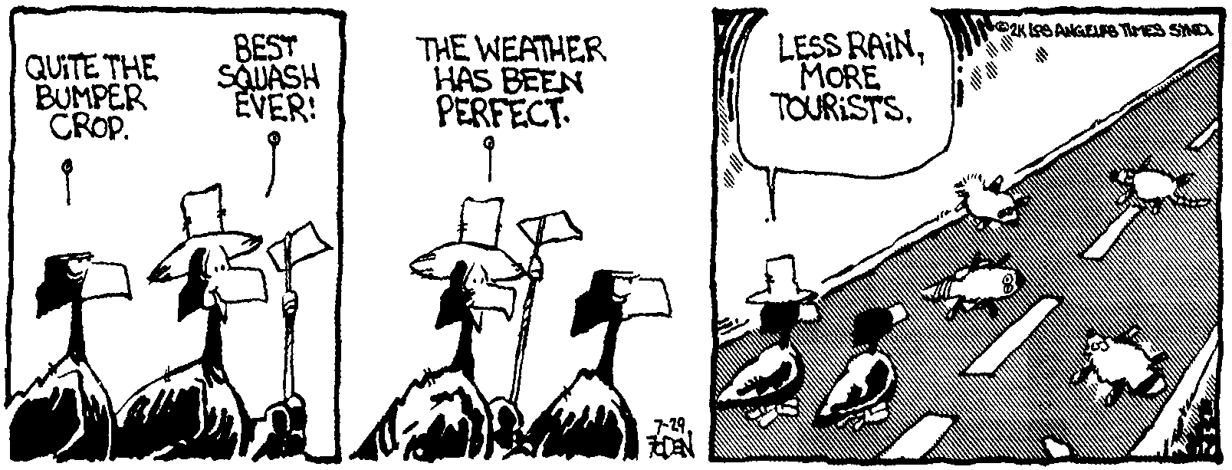
Blame _____________________________________________________________________Per___
I don't want to get to the end of my life and find that I lived just the length of it. I want to have
lived the width of it as well. -- Diane Ackerman
- A ball is thrown with an angle of 12.0 ° to the horizon with a speed of 15.0 m/s. What are its horizontal and vertical components?

- A frog falls from its rainforrest tree. If we ignore wind resistance, (a) how much time does it take the frog to fall a distance of 12.0 m? (b) how fast is the frog falling at this point?

- A cannon shoots a large cannonball. The cannonball has a speed of 125 m/s when it leaves the barrel. If the elevation angle was 32.0°, what is the horizontal distance that the cannonball travels?

- A ball is thrown at some angle. The ball is in the air for 4.50 seconds before it hits. If it travels 45.0 meters before it hits the ground, what was the initial velocity of the ball (magnitude and direction please)?

- A crow flies aloft carrying a shiny rock in its beak. The crow reaches an altitude of 65.0 m and is flying at 34.5 km/h. It releases the rock. Find: (a) the time it will take the rock to hit the ground below, (b) the horizontal distance the rock will travel before it hits, and (c) the speed of the rock when it hits the ground.

- A ball rolls across a table at constant velocity. The ball is traveling at speed v. The table is a distance h above the deck below. How far from the edge of the table does the ball travel before it hits the deck?

