AP Physics – Torque – 1

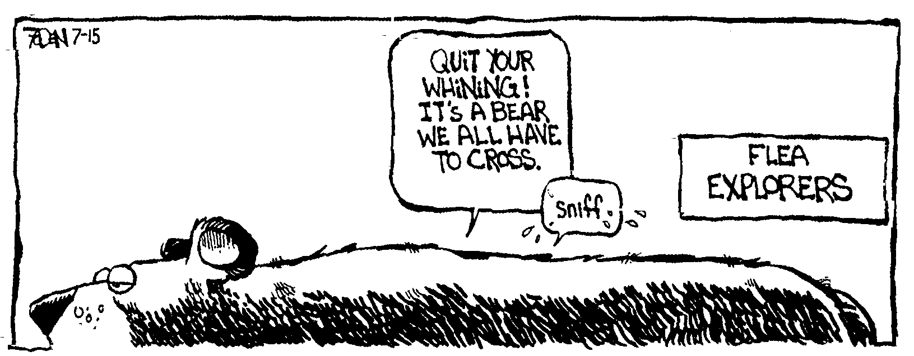
Name ___________________________________________________________________Per___
When it comes time to die, be not like those whose hearts are filled with the fear of death, so when their time comes they weep and pray for a little more time to live their lives over again in a different way. Sing your death song, and die like a hero going home. -- Chief Aupumut, Mohican leader
- A 3.45 kg ball moving to the right at 2.50 m/s smacks head on into a 4.00 kg ball that is at rest. If the first ball ends up moving with a speed of 1.20 m/s to the left. What is the velocity of the 4.00 kg ball after the collision?

- Pluto (the planet, not the Disney cartoon character – who the Physics Kahuna never thought was funny) has a mass of 1.20 x 10²² kg. The mean distance between it and the sun is 5.90 x 10¹². The mass of the sun, Sol, is like 1.99 x 10³⁰ kg. How long in Earth years is a Pluto year?

- A force of 235 N applied to a lid on a jar generates a torque of 155 Nm, what is the lever arm (i.e., the radius of the lid)?

- A 1200 kg car is moving on a flat circular track that has a radius of 0.50 km. The car is traveling at 88 km/h. (a) What is the centripetal force? (b) What is the coefficient of kinetic friction for the tires and the road surface?

- A uniform beam of weight 254 N sticks out from a vertical wall. A lightweight cable connects the end of the beam to the wall, making an angle of 65.0° between the beam and the cable. (a) What is the tension in the cable? (b) What is the force exerted on the beam by the wall?

- A pair of adult nitwits sit balanced on a teeter totter type device. One of them, who’s mass is 45.2 kg, is 1.30 m from the point of balance. The other chowder-head is 2.15 m from the point of balance. What is the mass of the second person?

- A uniform 225 N ladder leans against a smooth vertical wall. The ladder is 9.00 m in length. It makes an angle of 78.0° with the deck. A 65.0 kg Bengal tiger rests on one of the rungs 3.00 m from the top end of the ladder. (a) Find the force of friction exerted by the deck on the bottom of the ladder. (b) What is the upward force exerted by the ladder?

- A bird flying over your head drops a walnut that it was carrying in its beak. If the bird is flying horizontally at an altitude of 23.5 m, and the walnut travels a horizontal distance of 12.5 m, how fast was the bird flying?

- One end of a spring is attached to a solid wall while the other end just reaches to the edge of a horizontal, frictionless tabletop, which is 88.5 cm above the deck. A 2.00 kg block is placed against the end of the spring and pushed toward the wall until the spring has been compressed a distance of 15.0 cm. The block is released, slides across the table, and strikes the floor a horizontal distance of 1.20 m from the edge of the table. Air resistance is negligible. Find (a) the time elapsed from the instant the block leaves the table to the instant it strikes the floor, (b) The horizontal component of the velocity of the block just before it hits the floor, (c) The work done on the block by the spring, and (d) The spring constant.

