AP Physics – Newton’s Laws – 1

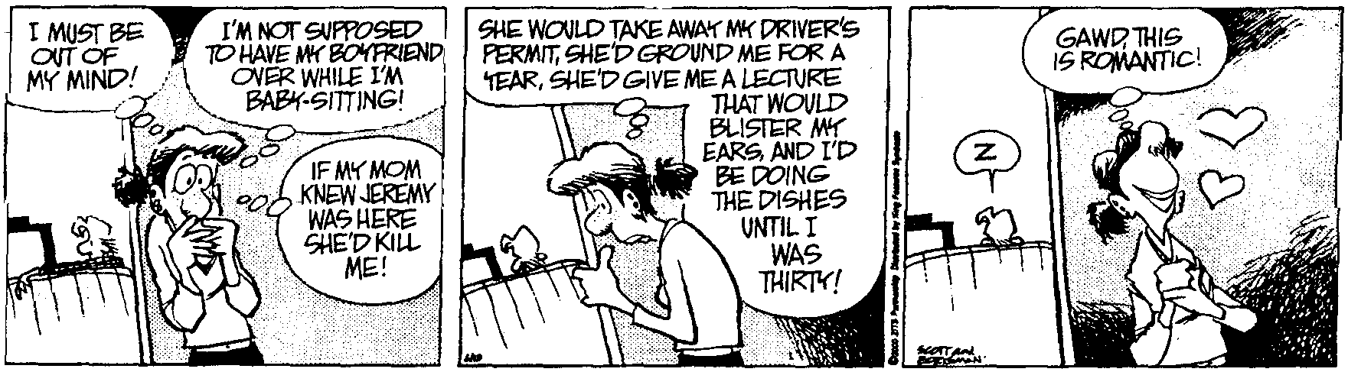
Nmea _____________________________________________________________________Per ___
The society which scorns excellence in plumbing because plumbing is a humble activity, and tolerates shoddiness in philosophy because it is an exalted activity, will have neither good plumbing nor
good philosophy. Neither its pipes nor its theories will hold water. -- John W. Gardner
- A rock is thrown at an angle of 35.0° to the horizontal with a speed of 11.5 m/s. How far does it travel?

- A 450 kg mass is accelerated at 2.5 m/s². (a) What is the force causing this acceleration? (b) If the mass of the car is doubled, what happens to the acceleration?

- How much does a 34.5 kg gymnast weigh?

- A 2500 kg car experiences a net 250 N force, (a) what is the acceleration acting on the car? (b) What is the car’s speed at the end of 35 seconds?

- An artillery shell has a mass of 75 kg. The projectile is fired from the weapon and has a velocity of 670 m/s when it leaves the barrel. The gun barrel is 2.7 m long. (a) Assuming the force and therefore the acceleration is constant while the projectile is in the barrel, what is the force that acted on the projectile? (b) If the elevation angle is 52°, what is the horizontal range of the projectile?

- A ball is attached to a string and hangs from the ceiling. Draw a FBD of the system. Label the vectors.

- The space shuttle has a mass of 2.0 x 10⁶ kg. At lift off the engines generate an upward thrust of 1.3 x 10⁸ N. (a) Draw a FBD of the space shuttle system.

- What is the weight of the space shuttle?

- What is the acceleration of the shuttle when it is launched?

- The average acceleration of the shuttle during its 7.5 minute run is 18 m/s². What velocity does it theoretically achieve at the end of that time?

- A 3.45 g hockey puck rests on a flat, smooth table. A horizontal net force of 85.0 N acts on it for 1.10 seconds. The puck slides across the table at the end of that time and then falls off the table. The table’s top surface is 85.0 cm above the deck. Find (a) the acceleration of the puck, (b) the speed of the puck after the 1.10 s, (c) the horizontal distance from the table edge to where the puck impacts the deck.

