AP Physics – Momentum – 1

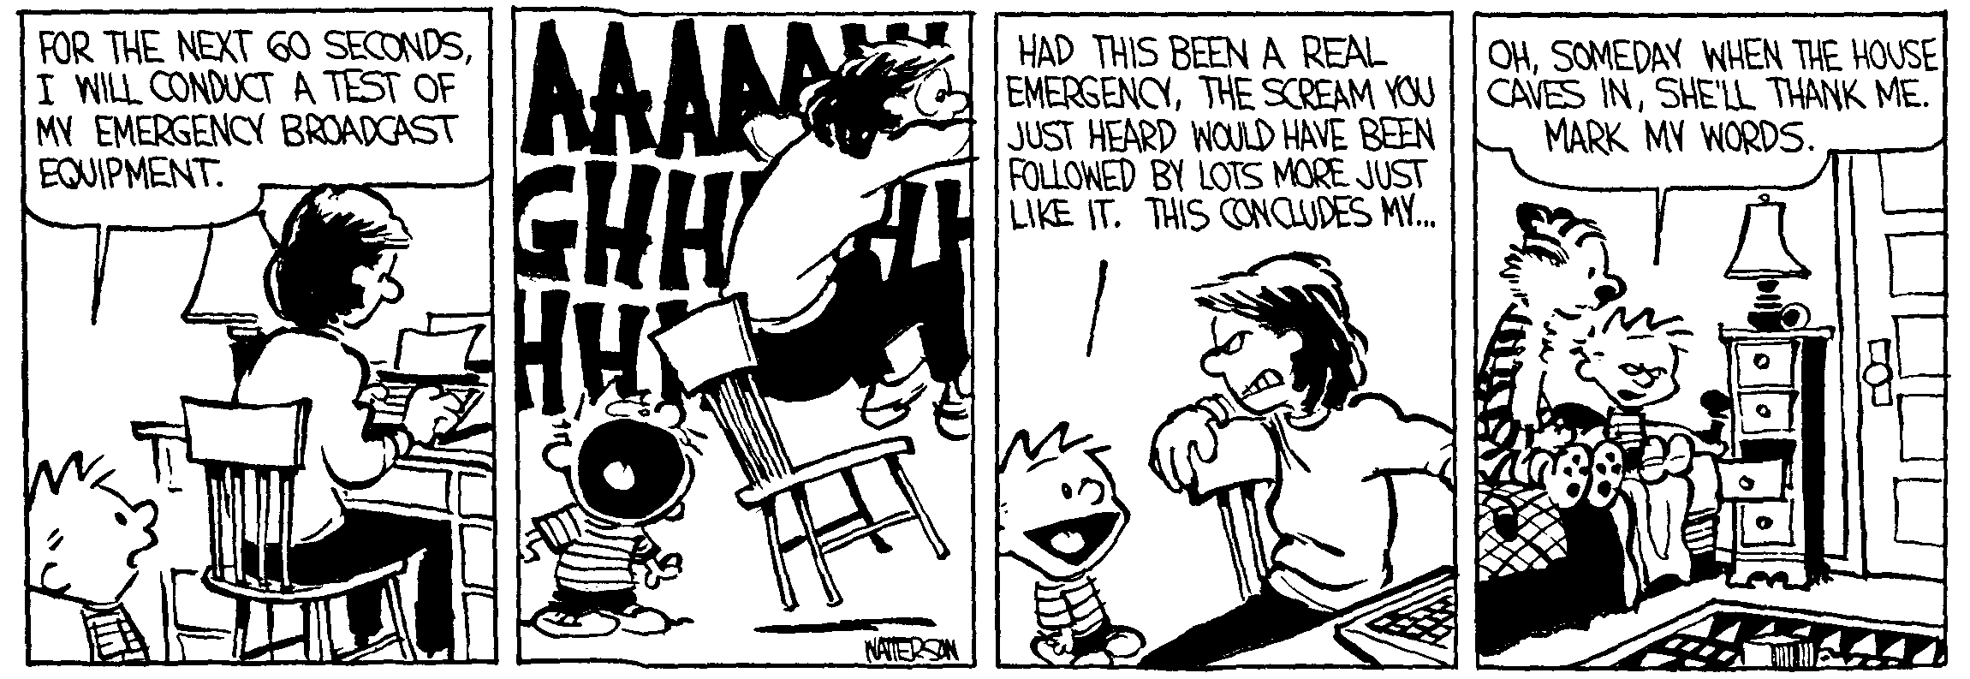
Dozer _________________________________________________________________Per___
Outside of a dog, a book is man's best friend. Inside of a dog it is too dark to read. -- Groucho
- When you catch a baseball, it can hurt. It hurts less if one ‘goes with the ball’. This is because:
- This makes the KE less
- This makes the momentum change less
- This makes the time interval for stopping greater
- This makes the impulse less

- If two objects have an inelastic collision and one is initially at rest, is it possible for both of them to be at rest after the smash up? Is it possible for only one of them to be at rest? How come?

- In a bizarre carnival activity you are required to catch a tennis ball. This you easily do. Next, a solid metal (iron) ball of the same diameter is to be thrown to you. You are given the following choices: same kinetic energy, same velocity, or same momentum. Which of them would be the best choice to give you the easiest catch? How come?

- Okay, what is the magnitude of the momentum of a proton that is traveling at 2.35 x 10⁵ m/s?

- It takes you all of 0.018 s to initially touch and then catch a 0.600 kg football travelling at 16.0 m/s. (a) What is the change in momentum for the football? (b) What is the impulse? (c) What is the force that must be exerted to stop the ball?

- You throw a 0.345 kg ball straight up with an initial velocity of 13.5 m/s. (a) What is the momentum of the ball at the highest point of its path? (b) What is its momentum halfway up? (c) What is its kinetic energy halfway up?

- A 6.50 kg block slides down a ramp that is elevated at 42.0° a distance of 1.50 m. The coefficient of kinetic friction is 0.235. (a) What is the potential energy of the block before it begins to slide? (b) What is the work done by friction as the block slides down the ramp (said energy being converted into heat)? (c) What is the speed of the block when it reaches the bottom? (d) What is the average acceleration of the block down the ramp? (e) What is the momentum of the block at the bottom of the ramp?

- A 750.0 g ball is thrown. It travels a distance of 58.0 m and is in the air for a total time of 1.65 s. Ignoring wind resistance and assuming that it is caught at the same height it was thrown from, find: (a) the horizontal velocity of the ball, (b) the initial vertical velocity of the ball, (c) the maximum height the ball reaches, (d) the launch angle of the ball, and (e) the kinetic energy of the ball when it is first thrown.

- A low friction pulley, light string deal with two masses is set up as shown. If the acceleration of the system is 0.225 m/s², what is the mass of the other weight?

- A heavy crate rests on the deck. The coefficient of kinetic friction is 0.225. A rigid rod is attached to the crate and is used to push it. If a force of 235 N is applied to the rod, what is the acceleration of the box?

