AP Physics – Gravity – 1

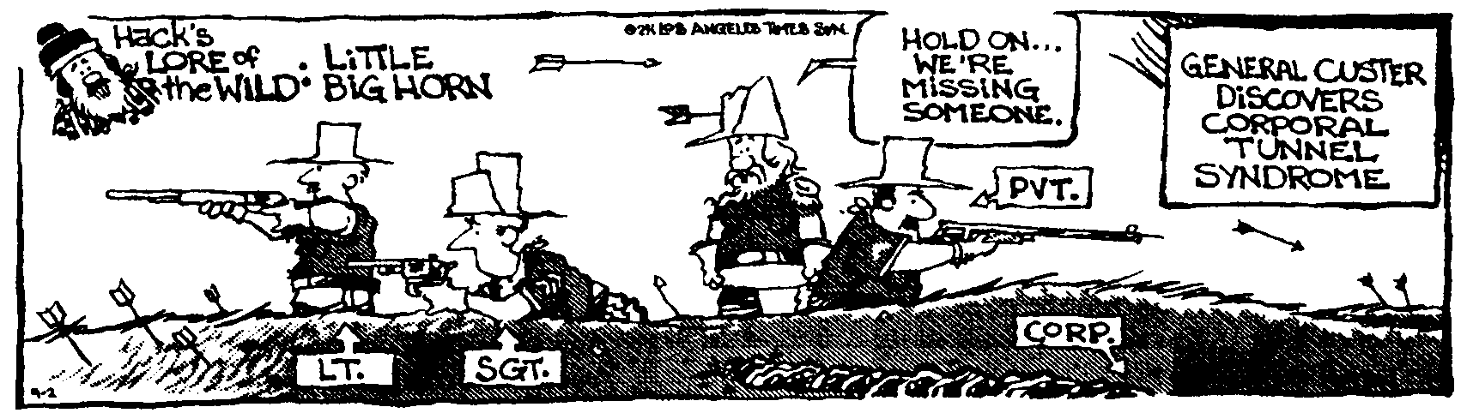
ID Please _________________________________________________________________Per___
People like you and I, though mortal of course like everyone else, do not grow old no matter how long we live...[We] never cease to stand like curious children before the great Mystery into which we were born. -- Albert Einstein
- A space rock has a mass of 2.50 kg. It is 1 250 m from an asteroid. If the force of gravity is 0.225 N between them, what is the mass of the asteroid?

- You weigh 458 N on earth, but you are on Mars. Here’s some data on Mars: radius = 3.38 x 10⁶ m mass = 6.42 x 10²³ kg. (a) How much do you weigh on Mars? (b) What is the acceleration of gravity on Mars? (c) If you drop a 3.50 kg rock from the surface of Mars and it falls a distance of 1.20 m, how fast will it be going just before it hits the surface? (d) What is its potential energy before you release it?

- A 48.0 kg projectile is fired by the USS Herpes at an angle of 46.0° with a speed of 345 m/s. (a) What is the range of the projectile (ignoring wind resistance)? (b) What is the kinetic energy and potential energy when the projectile is at the highest point of its path? (c) What is the kinetic energy and potential energy just before it splashes?

- A 65 700 kg celestial body experiences a 0.115 N force of attraction between it and a 75 500 kg space rock. How far apart are they?

- A 4.50 kg ball traveling east at 10.5 m/s smacks into a 3.45 kg ball. The first ball ends up going north at a speed of 3.50 m/s. For the second ball, what is the (a) horizontal velocity, (b) vertical velocity, and (c) kinetic energy after the collision?

- What is the force of gravity between earth and the moon? The earth’s mass is 5.98 x 10²⁴ kg, the distance from the earth to the moon is 3.90 x 108 m. The mass of the moon is 7.30 x 1022 kg.

