AP Physics – Work and Energy – 1
- How much work is done on a 55 N package you carry horizontally for a distance of 12 m? None
- How much work is done on a 625 N rock that you lift 0.85 m?
- You apply a 225 N force to a heavy crate with a rope that makes a 27.0° angle with the horizontal, if you pull the crate a distance of 3.50 m, how much work was done?
- You pull a 55.5 kg wooden box with a rope that makes a 28.0° angle with the horizontal at a constant speed. The coefficient of kinetic friction between the box and the deck is 0.330. You pull the crate a distance of 2.25 m. How much work was done?

Constant speed: f = Fcos θ
- A bear with a mass of 218 kg runs up a hill. At the top of the hill, she has gained 23.5 kJ of potential energy. How high was the hill?
- A 1.25 kg rock is thrown with a velocity of 12.5 m/s at an angle of 43.0° to the horizontal. (a) How much kinetic energy does it have when it is initially released? (b) What is its kinetic energy at the highest point in its trajectory?
- A 2.00 kg bullet leaves the barrel of a gun at a speed of 40.0 m/s. (a) Find its kinetic energy, (b) Find the average force exerted on the bullet by the expanding gases as the bullet moves through the length of the 50.0 cm barrel.

- Three blocks of masses 1.0, 2.0, and 4.0 kilograms are connected by massless strings, one of which passes over a frictionless pulley of negligible mass, as shown below. Calculate each of the following.
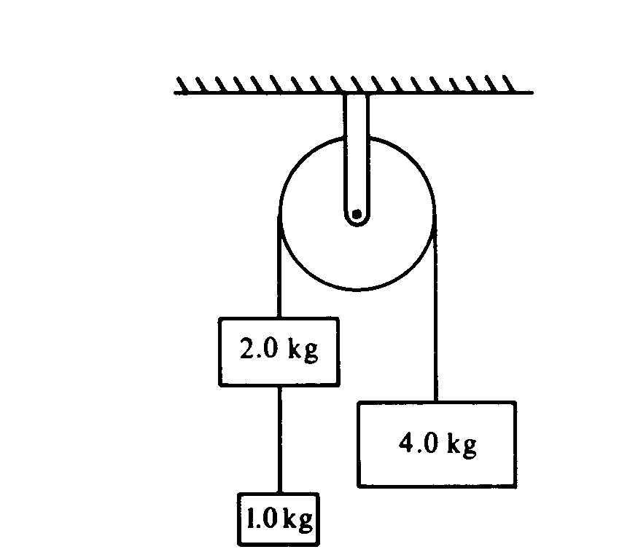
  - The acceleration of the 4.0 kilogram block.
  - The tension in the string supporting the 4.0 kilogram block.
  - The tension in the string connected to the 1.0 kilogram block.
(a)
(b)
(c)

