AP Physics – Nuclear Stuff – 2 ans
- What is the energy of a quantum of 475 nm light?
- Electrons are ejected from a metal surface with speeds ranging up to 4.60 x 10⁵ m/s when light with a wavelength of 625 nm is incident on it. (a) What is the work function? (b) What is the cutoff frequency for this surface?
(b)
- Find the minimum film thickness for destructive interference in reflected light for a thin film. Figure on a first minima deal. The film’s index of refraction is 1.45. It is illuminated by light that has wavelength of 525 nm.
- A series of measurements were taken of the maximum kinetic energy of photoelectrons emitted from a metallic surface when light of various frequencies is incident on the surface.
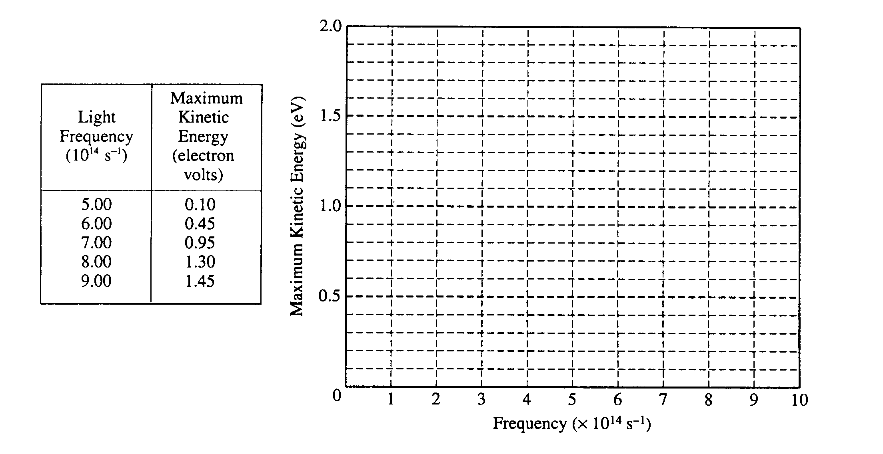
  - The table below lists the measurements that were taken. On the axes below, plot the kinetic energy versus light frequency for the five data points given. Draw on the graph the line that is your estimate of the best straight-line fit to the data points.
  - From this experiment, determine a value of Planck's constant h in units of electron volt-seconds. Briefly explain how you did this.
Equation for a line. h is the slope of the line
- Light of wavelength 350.0 nm in incident on a potassium surface. Electrons are emitted that have a maximum kinetic energy of 1.31 eV. Find (a) the work function of potassium, (b) the cutoff wavelength, (c) the cutoff frequency.
(a)
(b)
(c)

- You have three metals – lithium, aluminum, and mercury. Their work functions are: 2.30 eV, 4.10 eV, and 4.5 eV respectively. Light with a frequency of 1.0 x 10¹⁵ Hz is incident on all three metals. Determine (a) which metals will emit electrons and (b) the maximum kinetic energy for those that exhibit the effect.
(a) E of photon
E of photon must be greater than work function for emission to take place. Emission is possible for lithium and aluminum

(b) Lithium:
Aluminum:

- Radon – 222 is formed by the alpha decay of radium. Write out the equation for this decay.
- A beam of light reflects off of a fish that is under the surface of a lake. The ray is refracted at the surface and is seen by a person in a boat. The angle of refraction is 43.0°. Find: (a) The angle of incidence made by the ray, (b) the fish is 2.20 m below the surface, if the fish rises straight up, at what depth will it no longer be visible to the person in the boat?
(a)
(b)

- A diffraction grating has exactly 5 000 lines per centimeter. Helium laser light of wavelength 633 nm is incident on the grating. (a) What is the angle for the first order maxima? (b) If the grating is 1.25 m from a screen, what is the distance from central maxima to the first order maxima?
Slit separation = inverse of slit density

- What is the fundamental frequency and wavelength that resonates in a tube that is closed at one end which has a length of 2.35 m?

