AP Physics – Vectors be Everwhere – 2

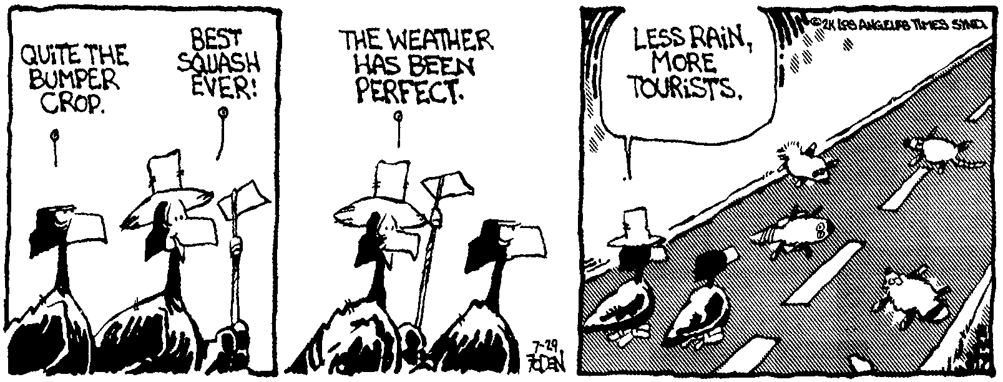
Blame _____________________________________________________________________Per___
I don't want to get to the end of my life and find that I lived just the length of it. I want to have
lived the width of it as well. -- Diane Ackerman
- A ball is thrown with an angle of 12.0 ° to the horizon with a speed of 15.0 m/s. What are its horizontal and vertical components?

- A frog falls from its rainforest tree. If we ignore wind resistance, (a) how much time does it take the frog to fall a distance of 12.0 m? (b) How fast is the frog falling at this point?

- A plane has an airspeed of 235 km/h. It takes off and wants to fly to a city that is directly north of it at a distance of 455 km. The wind is blowing to the east (from the west) at 42 km/h. Find (a) the course that the pilot must steer in order to fly directly north to the city and (b) the time it will take to arrive at the city.

- A crow flies aloft carrying a shiny rock in its beak. The crow reaches an altitude of 65.0 m and is flying at 34.5 km/h. It releases the rock. Find: (a) the time it will take the rock to hit the ground below, (b) the horizontal distance the rock will travel before it hits, and (c) the speed of the rock when it hits the ground.

- A ball rolls across a table at constant velocity. The ball is traveling at speed v. The table is a distance h above the deck below. How far from the edge of the table does the ball travel before it hits the deck?

- A ball rolls down a ramp, starting from rest. The ball experiences an acceleration of 0.035 m/s². The ramp is 2.0 m long. When it reaches the bottom of the ramp it rolls across a table top at a constant speed for a distance of 0.650 m. It then reaches the edge of the table and falls to the deck below. Make a velocity vs time graph of the ball’s motion on the grid below.

- A ball is thrown at an angle of 25.0° to the horizon. The ball has a horizontal velocity component of 12.5 m/s. Find (a) the vertical velocity component of the ball. (b) the magnitude of the actual velocity. (c) How high would the ball travel before it begins to come down again?

