AP Physics – Home Circuit Activity

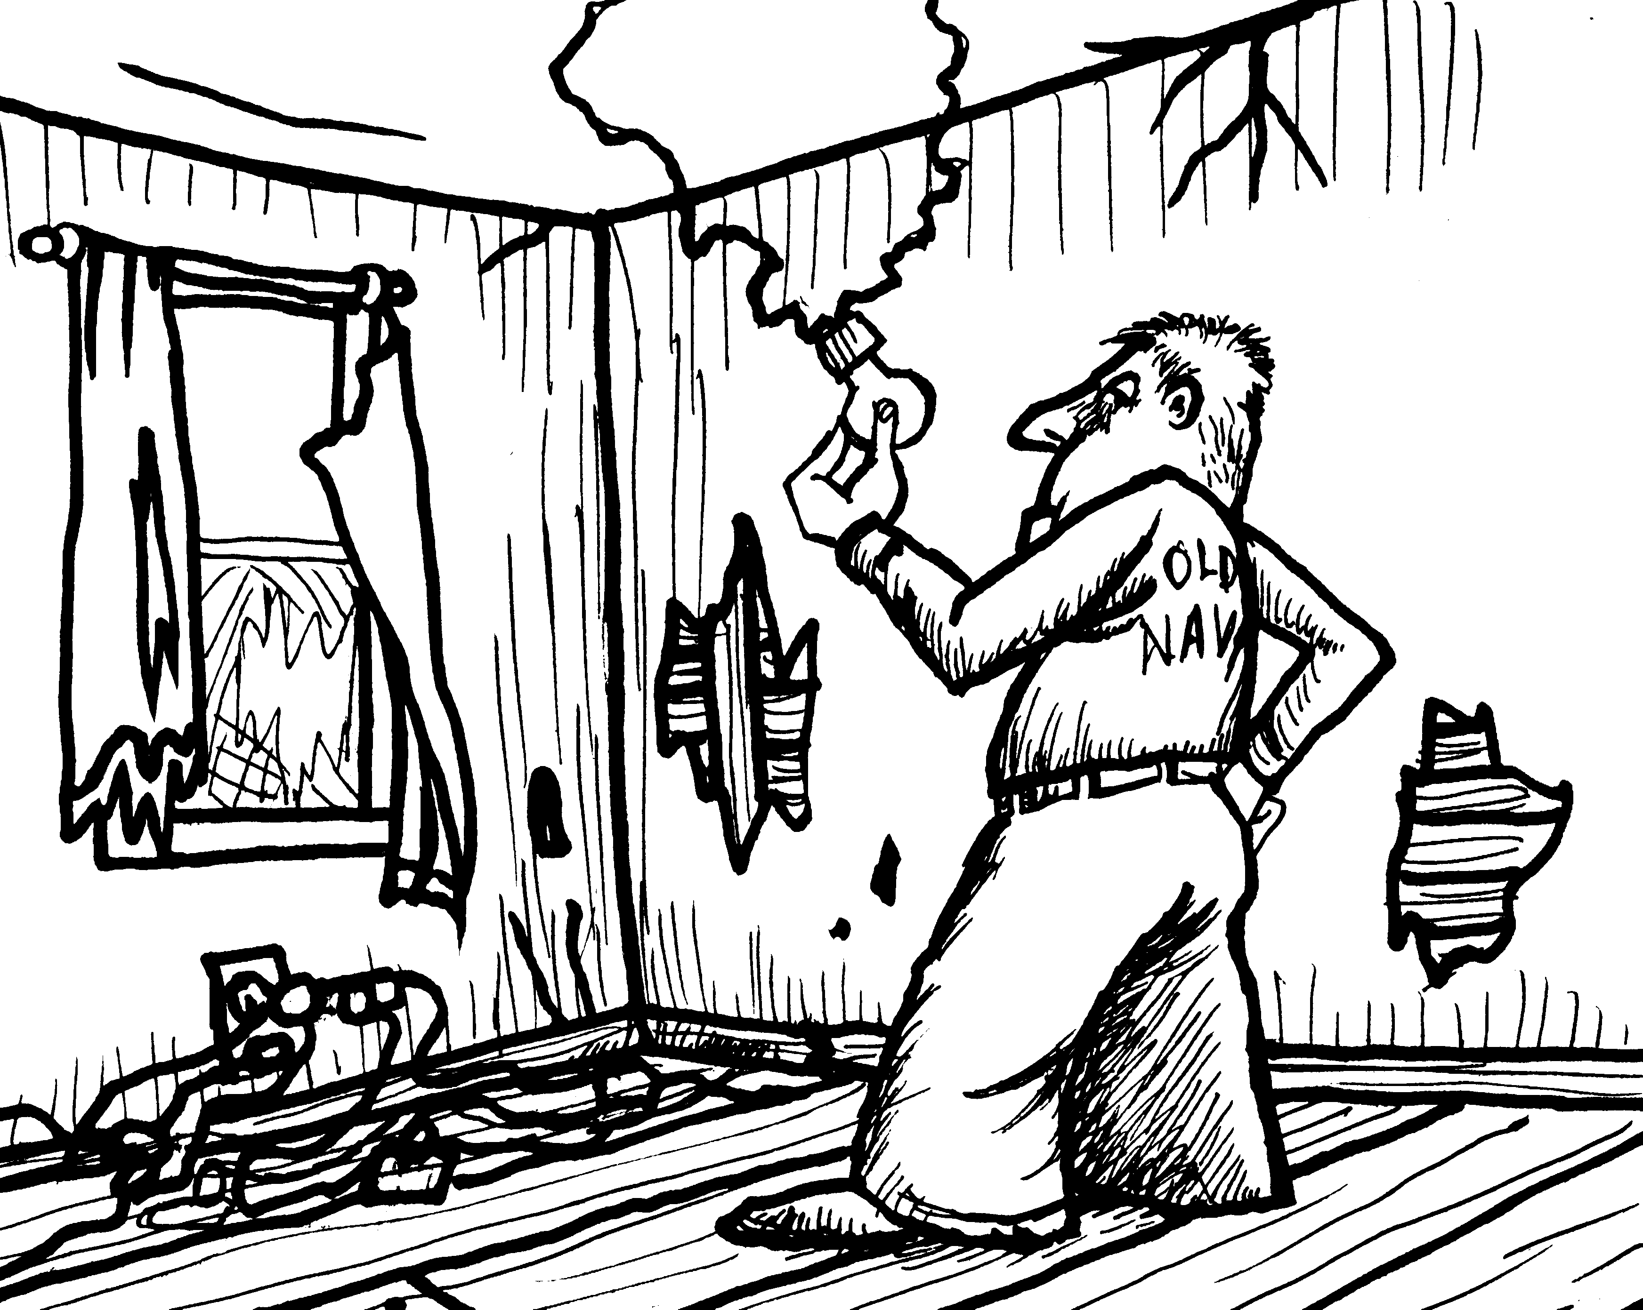
In this activity you will examine your home’s electrical system and discover how it has been laid out. This will actually be a very practical activity as it is very useful to be familiar with the power distribution of your domicile. The Physics Kahuna would like to see you do this with your parents and siblings. It will give you an understanding of how the household circuits are protected and what needs to be done to restore overloaded circuits to operating status.

Procedure: Use the following list as a guide to the things you will find out and do. Do not feel limited to just these actions – anything else you can think of to do, please do. Just be safe. Don’t actually do anything to the circuits, just find out about them. Once you have found out all the required information you will type up paper that reports your findings. The map and circuit diagram should be included as an attachment. If you were unable to discover any of the required items, discuss the problems that you encountered and your miserable excuse for failing to carry out your mission.

- How does power enter your domicile?
- Locate your household circuit board panel.
- Determine what type of circuit protection is employed – fuses, circuit breakers?
- Find the number of circuits that your home has.
- Determine the current rating for these circuits.
- If a circuit has an overload what action must be taken to restore current to the circuit?
- Identify the rooms that are associated with each circuit.
- Determine the number and location of the outlets and fixed electrical connections (this would mainly be lights).
- Identify circuits (if any) that are dedicated to only one device. This might be something like a stove, furnace, air conditioner, refrigerator, &tc.
- Make a carefully crafted map showing the location of the electric control panel, electric outlets, and fixed electrical connections for the dump you live in.
- Make an accurate circuit diagram showing all the circuits in the home.
- Identify the device that is the one single greatest consumer of electricity in your house.

