AP Physics – Gravity

Sir Isaac Newton is credited with the discovery of gravity. Now, of course we know that he didn’t really discover the thing – let’s face it, people knew about gravity for as long as there have been people. Gravity didn’t have to be discovered for crying out loud! Your basic tiny little toddler figures it out in the first few months of life. So what is the big deal with Newton and gravity? Well, what Newton did was to describe gravity, extend its effects from the surface of the earth (which everyone understood) out into space to explain the behavior of the planets (which nobody suspected), and to formulate a mathematical law that accurately described the force of gravity between objects with mass.

Perhaps the greatest success of his theory of gravity was to successfully explain the motion of the heavens – planets, moons, &tc.

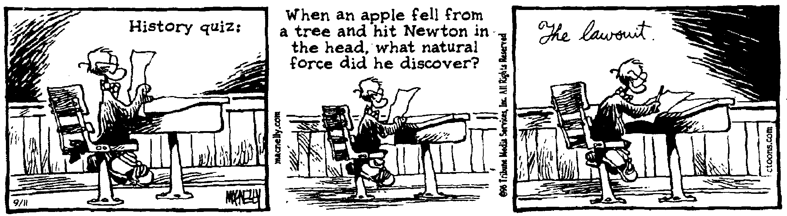
Newton’s theory is very simple. Gravity is a force of attraction between any two objects that have mass. Two objects sitting on a desktop attract each other with a force that we call gravity. They don’t go flying together because gravity is a very weak force and is only significant when one or the other of the masses is enormous – planet size. This is why we aren’t attracted to objects that we pass on our daily wanderings.

The size of the force of gravity is given by this equation:

Newton’s law of gravity
G is the universal gravitational constant.
m₁ is the mass of one of the bodies and m₂ is the mass of the other body.

r is the distance between the two bodies.

The value of G is the same everywhere throughout the universe.

On the old AP Physics Test the equation is written as:

Newton’s law of gravity is an inverse-square Law. This means that the force of gravity gets smaller or larger by the square of the distance. The force is directly proportional to the masses, so if the mass of one of the objects doubles, the force of gravity would double. But if the distance doubled, the force of gravity would decrease by a factor of four. That’s because it decreases by the square of the distance. Inverse-square laws are very common in physics. We’ll see more of them in our explorations.

To give the particulars of the theory:

Universal Law of Gravitation

- Gravitational force is a field force between two particles -- in all mediums.
- Force varies as the inverse square of the distance
- Force is proportional to mass of objects.
- The gravity force acts from the center of the two objects.
- The gravitational force is always attractive.
- The gravitational force cannot be shielded or canceled.

Solving gravity problems is quite simple. Let’s do one.

- A girl, Brandy (42.5 kg), sits 1.50 m from a boy (63.0 kg), George. What is the force of gravity between them? (This will tell us how attracted they are to each other.)

You can see that this is a tiny force, one so small that Brandy will never, the Physics Kahuna is sure, notice its presence. George must generate some other attractive force if there is to be a relationship between the two of them.

One useful application of Newton’s law of gravity was to weigh Earth – this allowed physicists to make an accurate determination of the earth’s mass. Let’s do that.

- Find the mass of the earth. r_{e} = 6.38 x 10⁶ m. We will use a 10.0 kg mass in our solution (not that it matters), the other mass will be that of the earth.

This is the force of gravity using Newton’s law. But we know that the force of gravity must also equal F = mg, so we set them equal to one another:

The mass of the object cancels out:
Solve for the mass of the earth

Center of Gravity: A stone resting on the ground is acted upon by gravity. In fact, every atom within the rock is attracted to the earth. The sum of all these forces is the thing that we call weight. Wouldn’t it be a real pain to have to add up every single vector for every single atom in an object in order to find out what it weighed? Well fortunately, we don’t have to do that. Nature sort of does it for us. Basically the vectors all add together to give us one big vector, the weight vector, which is directed down and which acts at a point where all the weight appears to be concentrated. This point is called the center of gravity.

For an object like a uniform sphere, the center of gravity, or CG, is located at its geometric center. Irregular objects, like, say, your average baseball bat would have their CG located closer to the fat end of the bat rather than the center.

The dot represents the CG of the objects in the drawings below:
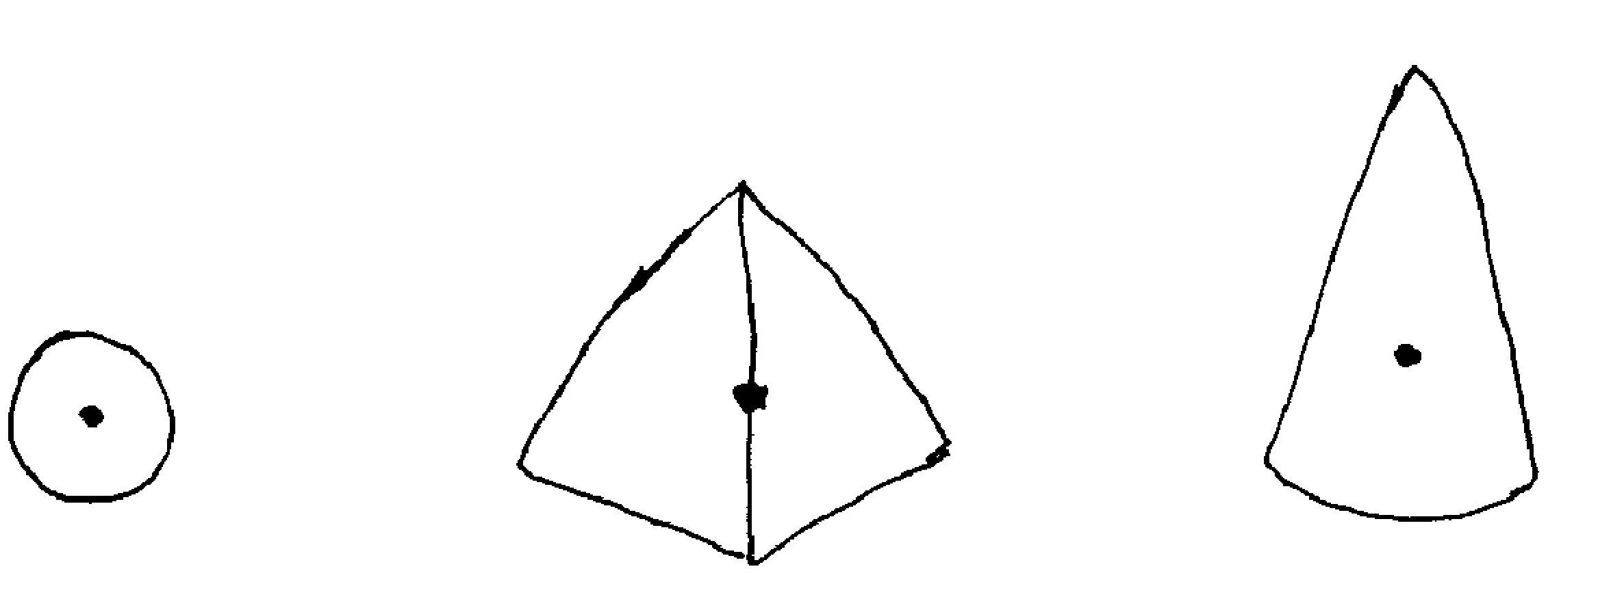

The weight of these objects, e.g., the vector we call weight, is applied at the CG.

When a ball is thrown in the air, it follows a parabolic path. Actually, what follows this parabolic path is the CG of the ball.

This is also true for irregular objects that are thrown. If you throw a crescent wrench so that it spins when you release it, it seems to follow a very erratic path. Its CG, however, traces out a nice smooth parabola.
All irregular objects rotate about their CG when thrown.

Let’s do some more gravity problems.

- You weigh 567 N on earth. How much would you weigh on Mars?

First we must calculate the mass by using the weight on earth:

Now we need only find the force of gravity between our person and Mars. For the distance we use the radius of Mars, since the person is on the surface of Mars and the force of gravity acts at the center of the planet.

- What is the acceleration of gravity on Venus?

We know: and

The acceleration on Venus would be slightly smaller than the acceleration on earth.
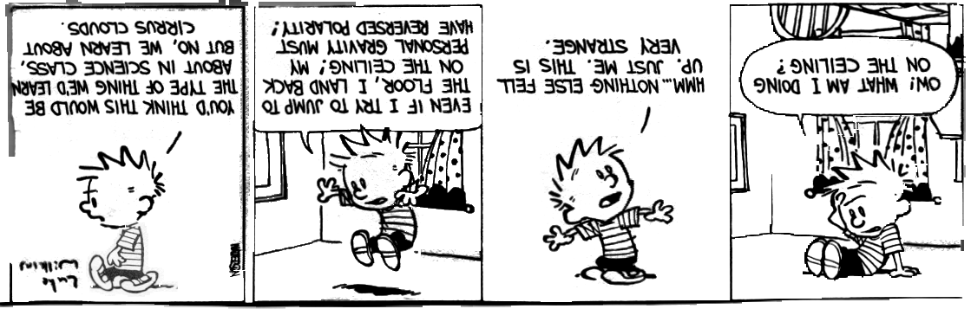
AP Question: We’re revisiting one we already looked over, but this time we can analyze it on Mars.

- 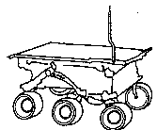The Sojourner rover vehicle was used to explore the surface of Mars as part of the Pathfinder mission in 1997. Use the data in the tables below to answer the questions that follow.

Sojourner Data
Mass of Sojourner vehicle: 11.5kg
Wheel diameter: 0.13 m
Stored energy available: 5.4 x l0⁵ J
Power required for driving under average conditions: 10 W
Land speed: 6.7 x 10⁻³ m/s

Mars Data

Radius: 0.53 x Earth's radius
Mass: 0.11 x Earth's mass

- Determine the acceleration due to gravity at the surface of Mars in terms of g, the acceleration due to gravity at the surface of Earth.

Force and mass are directly proportional to each other. Force is inversely proportional to the radius squared.

We set up the proportions for g, the acceleration of gravity on earth.

- Calculate Sojourner's weight on the surface of Mars.

(c) Assume that when leaving the Pathfinder spacecraft Sojourner rolls down a ramp inclined at 20° to the horizontal. The ramp must be lightweight but strong enough to support Sojourner. Calculate the minimum normal force that must be supplied by the ramp.

1. Draw a FBD:

(d) What is the net force on Sojourner as it travels across the Martian surface at constant velocity? Justify your answer.

Zero. If it is traveling at constant velocity in the x direction then there is no acceleration and no net force. . The force of gravity is cancelled by the normal force resulting in no motion in the y direction.

(e) Determine the maximum distance that Sojourner can travel on a horizontal Martian surface using its stored energy.

(f). Suppose that 0.010% of the power for driving is expended against atmospheric drag as Sojourner travels on the Martian surface. Calculate the magnitude of the drag force.

Dear Doctor Science,
If, theoretically, you were at the exact center of the earth and you dropped a ball, what would it do?
-- Rick McGuire from Birmingham, MI

Dr. Science responds:
It would fly into your face at great velocity. Most probably, it would damage one eye and, if your reflexes were slow enough, could permanently blind you. That's why I can't urge you strongly enough to leave experiments like this to trained scientists! We've been there before. We know what to expect in situations like this. I wouldn't think of going to the center of the earth without protective eyewear, nor would I tamper with terrestrial forces without first having done my homework! The Center of the Earth, man! Didn't you see the movie starring James Mason and Pat Boone? Sure, it had a happy ending -- all movies did back then. But the reality of Pat Boone taking a shower surrounded by glowing Technicolor rocks...the mind can only stand so much.
Dear Cecil:
Why are there high tides twice a day when the earth rotates beneath the moon only once a day? In diagrams it appears the moon's gravity causes the earth's oceans to bulge (creating a high tide) not only on the side toward the moon, but also on the side away from the moon. I've heard some unconvincing explanations for this, including: "the water on the far side is flung away from the earth" (why?); "the moon attracts the earth, and the water on the far side is left behind" (why isn't the water on the far side attracted too?); and "the earth and the moon both revolve around a common point" (I know that, but what does that have to do with the question?). Please help.
--Kathleen Hunt, Brookline, Massachusetts

Cecil replies:
Not to discourage you, Kathleen, but this makes 22 questions from you in three months. Think quality, not quantity. This isn't a scrap drive.
The following homely metaphor is sometimes used to explain why there are two tides: the earth and moon, which are really dual planets, are like two figure skaters spinning around one another while holding hands. Centrifugal force naturally tends to pull them apart, but their clasped hands (i.e., their mutual gravitational attraction) keep them together. Similarly, centrifugal force tends to fling the ocean outward on the side of the earth away from the moon. On the near side, the water is tugged moonward by lunar gravity.

There's just one problem with this explanation. It's wrong. Cecil has consulted with the physics division of the Straight Dope Science Advisory Board and is satisfied that centrifugal force (OK, inertia, if you want to get technical) has nothing to do with why there are two tides.
The real reason is this. The pull of gravity drops off rapidly with distance. Lunar gravity tugs on the side of the earth facing it a lot, on the earth itself a medium amount, and on the opposite side of the earth relatively little. In short, the far-side tide is a result of the moon attracting the earth, leaving the ocean behind. Which, looking back at your letter, I guess you already knew and didn't find convincing. If so, Kathleen, come on. Would I lie to you?

--CECIL ADAMS

The Ballad of Blasphemous Bill

I took a contract to bury the body of blasphemous Bill MacKie,
Whenever, wherever or whatsoever the manner of death he die --
Whether he die in the light o' day or under the peak-faced moon;
In cabin or dance-hall, camp or dive, mucklucks or patent shoon;

On velvet tundra or virgin peak, by glacier, drift or draw;
In muskeg hollow or canyon gloom, by avalanche, fang or claw;
By battle, murder or sudden wealth, by pestilence, hooch or lead --
I swore on the Book I would follow and look till I found my tombless dead.

For Bill was a dainty kind of cuss, and his mind was mighty sot
On a dinky patch with flowers and grass in a civilized bone-yard lot.
And where he died or how he died, it didn't matter a damn
So long as he had a grave with frills and a tombstone "epigram".

So I promised him, and he paid the price in good cheechako coin
(Which the same I blowed in that very night down in the Tenderloin).
Then I painted a three-foot slab of pine: "Here lies poor Bill MacKie",
And I hung it up on my cabin wall and I waited for Bill to die.

Years passed away, and at last one day came a squaw with a story strange,
Of a long-deserted line of traps 'way back of the Bighorn range;
Of a little hut by the great divide, and a white man stiff and still,
Lying there by his lonesome self, and I figured it must be Bill.

So I thought of the contract I'd made with him, and I took down from the shelf
The swell black box with the silver plate he'd picked out for hisself;
And I packed it full of grub and "hooch", and I slung it on the sleigh;
Then I harnessed up my team of dogs and was off at dawn of day.

You know what it's like in the Yukon wild when it's sixty-nine below;
When the ice-worms wriggle their purple heads through the crust of the pale blue snow;
When the pine-trees crack like little guns in the silence of the wood,
And the icicles hang down like tusks under the parka hood;

When the stove-pipe smoke breaks sudden off, and the sky is weirdly lit,
And the careless feel of a bit of steel burns like a red-hot spit;
When the mercury is a frozen ball, and the frost-fiend stalks to kill --
Well, it was just like that that day when I set out to look for Bill.

Oh, the awful hush that seemed to crush me down on every hand,
As I blundered blind with a trail to find through that blank and bitter land;
Half dazed, half crazed in the winter wild, with its grim heart-breaking woes,
And the ruthless strife for a grip on life that only the sourdough knows!

North by the compass, North I pressed; river and peak and plain
Passed like a dream I slept to lose and I waked to dream again.
River and plain and mighty peak -- and who could stand unawed?
As their summits blazed, he could stand undazed at the foot of the throne of God.

North, aye, North, through a land accurst, shunned by the scouring brutes,
And all I heard was my own harsh word and the whine of the malamutes,
Till at last I came to a cabin squat, built in the side of a hill,
And I burst in the door, and there on the floor, frozen to death, lay Bill.

Ice, white ice, like a winding-sheet, sheathing each smoke-grimed wall;
Ice on the stove-pipe, ice on the bed, ice gleaming over all;
Sparkling ice on the dead man's chest, glittering ice in his hair,
Ice on his fingers, ice in his heart, ice in his glassy stare;

Hard as a log and trussed like a frog, with his arms and legs outspread.
I gazed at the coffin I'd brought for him, and I gazed at the gruesome dead,
And at last I spoke: "Bill liked his joke; but still, goldarn his eyes,
A man had ought to consider his mates in the way he goes and dies."

Have you ever stood in an Arctic hut in the shadow of the Pole,
With a little coffin six by three and a grief you can't control?
Have you ever sat by a frozen corpse that looks at you with a grin,
And that seems to say: "You may try all day, but you'll never jam me in"?

I'm not a man of the quitting kind, but I never felt so blue
As I sat there gazing at that stiff and studying what I'd do.
Then I rose and I kicked off the husky dogs that were nosing round about,
And I lit a roaring fire in the stove, and I started to thaw Bill out.

Well, I thawed and thawed for thirteen days, but it didn't seem no good;
His arms and legs stuck out like pegs, as if they was made of wood.
Till at last I said: "It ain't no use -- he's froze too hard to thaw;
He's obstinate, and he won't lie straight, so I guess I got to -- saw."

So I sawed off poor Bill's arms and legs, and I laid him snug and straight
In the little coffin he picked hisself, with the dinky silver plate;
And I came nigh near to shedding a tear as I nailed him safely down;
Then I stowed him away in my Yukon sleigh, and I started back to town.

So I buried him as the contract was in a narrow grave and deep,
And there he's waiting the Great Clean-up, when the Judgment sluice-heads sweep;
And I smoke my pipe and I meditate in the light of the Midnight Sun,
And sometimes I wonder if they was, the awful things I done.

And as I sit and the parson talks, expounding of the Law,
I often think of poor old Bill -- and how hard he was to saw.

----------------Robert Service

