Grade 2 Composing and Decomposing Numbers
Composing and Decomposing Numbers Using Standard and Expanded Form
Learning Objectives - Students will:
Students learn to compose and decompose numbers into the thousands place as they move from standard form to expanded form and back again. Students explore composing and decomposing numbers using base ten blocks and place value cards.
•Build numbers up to the thousands place with base ten blocks.
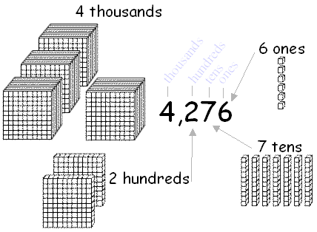
•Determine the value of each digit in the number.
4,276 = four thousands + two hundreds + seven tens + six ones
•Compose and decompose numbers using standard and expanded form.
4,276 = 4000 + 200 + 70 + 6
•Use place value cards to compare the values of each digit in the numbers.
4000
Thousands
Hundreds
Tens
Ones
200

4  70 | 2 | 7 | 6
6

NCTM Standards and Expectations
•Develop a sense of whole numbers and represent and use them in flexible ways, including relating, composing, and decomposing numbers.
•Use multiple models to develop initial understandings of place value and the base-ten number system
•Understand the place-value structure of the base-ten number system and be able to represent and compare whole numbers and decimals.
•Recognize equivalent representations for the same number and generate them by decomposing and composing numbers.

Common Core State Standards – Mathematics (before grade 2, grade 2 and after grade 2)
Kindergarten, Counting & Cardinality K.CC.C.7
Compare two numbers between 1 and 10 presented as written numerals.

Grade 1, Number & Operations 1.NBT.3
Compare two two-digit numbers based on meanings of the tens and ones digits, recording the results of comparisons with the symbols >, =, and <.

Grade 2, Number & Operations 2.NBT.3
Read and write numbers to 1000 using base-ten numerals, number names, and expanded form.

Grade 2, Number & Operations 2.NBT.4
Compare two three-digit numbers based on meanings of the hundreds, tens, and ones digits, using >, =, and < symbols to record the results of comparisons.

Grade 4, Number & Operations Base Ten 4.NBT.1
Recognize that in a multi-digit whole number, a digit in one place represents ten times what it represents in the place to its right. For example, recognize that 700 ÷ 70 = 10 by applying concepts of place value and division.

Grade 4, Number & Operations Base Ten 4.NBT.2
Read and write multi-digit whole numbers using base-ten numerals, number names, and expanded form. Compare two multi-digit numbers based on meanings of the digits in each place, using >, =, and <. symbols to record the results of comparisons.

Grade 5, Number & Operation Base Ten 5.NBT.1
Recognize that in a multi-digit number, a digit in one place represents 10 times as much as it represents in the place to its right and 1/10 of what it represents in the place to its left.

Questions for Second Grade Students
1. What is the difference between standard form and expanded form?
[The standard form of a number is the number written using digits. The expanded form of a number displays the value of each digit and represents the number as the sum of the parts. For example, 345 can be written as 300 + 40 + 5. Both forms are correct; they are just different ways to represent a number.]
2. If you had the numbers 856 and 578, to which place would you look to find the greater number?
[You need to look at the hundreds place. Eight hundred (or 8) is greater than 500 (or 5), so you know that 856 is the greater number, regardless of the digits in the tens and ones place.]
3. In the numbers 435 and 487, both numbers have a four in the hundreds place. How would you figure out which one is the greater number?
[Since both numbers have the same digit in the hundreds place, you need to look to the next place over. In this case, you look at the tens. There are 3 tens, which gives you a value of 30, and 8 tens have a value of 80. Since 80 is greater than 30, 487 is the greater number.]
4. Which number is greater, 235 or 84?
[The number 235 has a 2 in the hundreds place. Although the number 84 has a first digit of 8, it occurs in the tens place; therefore, the value of the digit in the hundreds place is 0. Since 2 is greater than 0, then 235 is greater than 84.]

