Vectors
Aaargh! Where’s my Treasure?
Materials:
Pencil or Pen
Graph Paper
GPS

GPS Procedure:
- Listen and follow my instructions on how to use the GPS unit.
- Enter in the first set of coordinated given to you by the teacher in the GPS by selecting “Mark” and using the joystick to go down to the coordinates listed. Note the Mark number at the top of the screen.
- After the coordinates are entered, go to “Find” on the main menu.
- Choose “Waypoint” and select the Mark that you created earlier.
- Now we will go outside and allow the GPS unit to find the satellites it needs to direct us to our location.
- After finding my location, you will go to 5 different locations and place a card with your team name on it in a selected marker color. Do not hide the card but instead make it visible so that it can be found! Also, make sure it won’t blow away or be removed. You won’t be finding the cards until the next day.
- Write down the coordinates where you have placed your cards on a separate sheet of paper.

Graphing your Vectors
- Get a piece of graph paper from the back of the classroom.
- On the paper, you will sketch the areas where you hid your cards. You will draw arrows from the classroom to the first point, then another arrow to the second point and so on. These arrows represent vectors.
- Each student (not each team) will draw a very precise treasure map using vectors on graph paper.
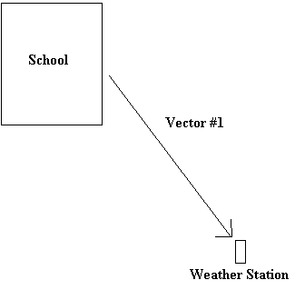

Conclusion:
- What is a vector? How do we show vectors? What 2 things must you know to have a vector?

- What is the difference between a vector and scalar?

