Pathologies of the Skeletal System:

Joints –

- Ankylosis - loss or absence of mobility due to disease, injury or surgical procedure

- Arthralgia - joint pain

- Arthrosclerosis - stiffness of the joints

- ____________ - inflammation of a bursa (repetitive stress)

- Chondroma - slow growing benign tumor derived from cartilage cells

- Chondromalacia - abnormal softening of cartilage

- Hallux Valgus - (bunion) abnormal enlargement of the at the base of the great toe
- Luxation - (_________________) dislocation or displacement of a bone from its joint.

  - Subluxation –

- Synovitis - inflammation of the synovial membrane

Arthritis –

- inflammatory condition of one or more joints

- ___________________- (wear and tear arthritis) - Degenerative Joint Disease (DJD)

- Gouty arthritis - (gout) type of arthritis associated with the formation of uric acid crystals in the joint as the results of hyperuricemia

- _________________________________ - (RA) autoimmune disorder; symptoms are generalized and usually more severe; synovial membranes are thickened; other tissues are also attacked causing the joints to become swollen, painful and immobile

- Ankylosing spondylitis - rheumatoid arthritis characterized by progressive stiffening of the spine caused by fusion of the vertebral bodies

- Juvenile rheumatoid arthritis - affects _______________

Spinal Column –

- __________________________________ - (ruptured disk) a rupture to the intervertebral disk that results in pressure on the spinal nerve roots

- Lumbago - (low back pain)

- Spondylitis - inflammation of the vertebrae

- Spondylolisthesis - forward movement of the body of one of the lower lumbar vertebra on the vertebra below it or on the sacrum

- Spondylosis - degenerative condition of the vertebrae

- Spina bifida - congenital defect; where the spinal canal fails to close around the spinal cord

Curvatures of the Spine –

  - Kyphosis - ___________________________________________________ (humpback/dowager’s hump)
  - Lordosis - _______________________________________________________ (swayback)
  - Scoliosis - ______________________________________________________
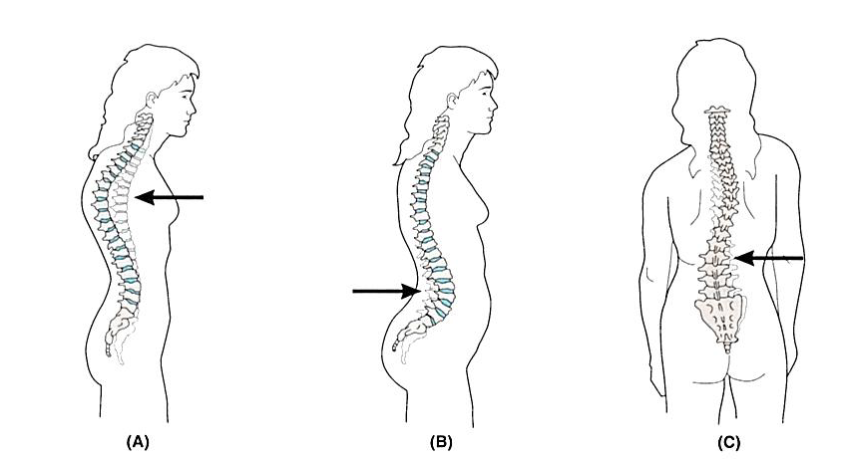

Bones -
- Exostosis - benign growth on the surface of a bone

- Ostealgia - any pain linked to an abnormal condition within a bone

- Osteitis - inflammation of a bone

- ___________________ - abnormal softening of a bone due to disease

- Osteomyelitis - inflammation of the bone and bone marrow

- Osteonecrosis - destruction and death of bone tissue caused by an insufficient blood supply, infection, malignancy, or trauma

- Paget’s disease - (osteitis deformans) disease of unknown cause that is characterized by extensive bone destruction followed by abnormal bone repair

- Periostitis - inflammation of the periosteum

- Rickets - caused by calcium D deficiency in early childhood results in demineralized bones and related deformities

- Talipes - (club foot) congenital deformity in which the foot may be turned outward or inward

- Tumors of Bones
  - Ewing’s sarcoma - group of cancers that most frequently affects children or adolescents; usually occur in the diaphysis of the long bone

  - Myeloma - malignant tumor composed of cells derived from blood-forming tissue of the bone marrow

  - Osteochondroma - most common benign tumor

Osteoporosis –

- Marked by loss of bone density and an increase in bone porosity

  - Vertebral crush fractures - (compression fractures) occur when one or more of the vertebrae become so weak that they collapse spontaneously or under minimum all stress

  - Colles’ fracture - fracture of the lower end of the radius

  - Osteoporotic hip fracture - can occur spontaneously or as a result of a fall

Fractures –

- (Fx) broken bone
  - Greenstick - (incomplete fracture)

  - Closed fracture - (simple/closed)

  - Open fracture - (compound)

  - Comminuted –

  - Compression –

  - Spiral –

  - Stress –
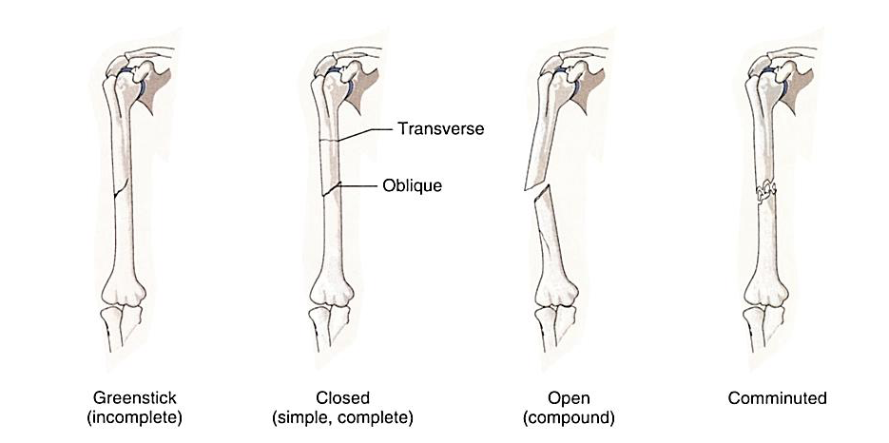

- Fat embolus - form when a long bone is fractured and fat cells from the yellow bone marrow are released into the blood

- Crepitation (crepitus) -

- ___________ - formed as a bone heals; bulging deposit around the area of the break

Diagnostic Procedures of the Skeletal System:

- ___________________________ - surgical puncture of the joint space to remove synovial fluid

- Arthroscopy - visual examination of the internal structure of a joint

- Bone Density Testing (BDT) - (bone mass measurement/densitometry) use of several types of radiation tests to determine bone density

- Bone Marrow Biopsy (BMB) - performed by inserting a sharp needle into the hipbone or sternum and removing bone marrow cells.

- Bone Scan - use of nuclear medicine to detect bone cancer and osteomyelitis

- Dual X-Ray Absorptiometry (DXA) - a low-exposure radiographic measurement that is most often used to detect early signs osteoporosis

- Ultrasonic bone density testing (bone sonometer) uses sound waves to take measurements of the heel bone

- _______________________________________________ (MRI) - used to image soft tissue structures

- Radiographs (X-Rays) - used to visualize fractured bones

Treatment Procedures of the Skeletal System:

Medications –

- ____________________________________________________ (NSAIDs) - used to control pain and inflammation

- Acetaminophen - controls pain

- Antipyretics - Fever reducers

- COX-2 inhibitors - control pain and inflammation of osteoarthritis and RA

Bone Marrow Transplant (BMT) - (stem cell transplant) used to treat certain types of cancers

- Autologous Transplant - using some of the patient’s own bone marrow that was harvested before treatment began

- Allogenic Transplants - using bone marrow from a donor

- Cord Blood - collected from the umbilical cord immediately after birth

Joints –

- Arthroscopic surgery - treatment of the interior of a joint

- Bursectomy - surgical removal of a bursa

- ___________________ - surgical repair of cartilage

- Synovectomy - surgical removal of the synovial membrane of a joint

- Arthrodesis - (fusion/surgical ankylosis) surgical process to stiffen a joint

- Arthrolysis - surgical loosening of an ankylosed joint

- Periosteotomy - an incision through the periosteum

Joint Replacement –

- ___________________ - any surgical repair of a damaged joint

- Prosthesis/implant - a substitute for a diseased or missing part of the body

- Total Knee Replacement (TKR) - all parts of the knee are replaced

- Partial Knee Replacement (PKR) - only part of the knee was replaced

- Total Hip Replacement (THR) - consists of two components; thigh and socket

- Revision surgery - replacement of a worn or failed implant

Spinal Column –

- Diskectomy - surgical removal of an intervertebral disk

- Percutaneous diskectomy - a thin tube is inserted through the skin of the back to suction out the ruptured disk or to vaporize it with a laser

- ________________________ - surgical removal of a lamina from a vertebra

- Spinal Fusion - technique to immobilize part of the spine by joining together two or more vertebra

Bones –

- Craniectomy - surgical removal of a portion of the skull

- Craniotomy - (bone flap) surgical incision or opening into the skull that is performed to gain access to part of the brain.

- Cranioplasty - surgical repair of the skull

- Osteoclasis - surgical fracture of a bone to correct a deformity

- Ostectomy - surgical removal of bone

- Osteoplasty - surgical repair of bones

- _________________ - suturing or wiring together of bones

- Osteotomy - surgical incision of sectioning of bone; used to realign a joint damaged by arthritis

Treatment of Fractures -
- __________________________ (closed reduction) - attempt to realign the bone involved or joint dislocation

- Traction - pulling force exerted on a limb in a distal direction in an effort to return the bone or joint to normal alignment

- Immobilization (stabilization) - act of holding, suturing, or fastening the bone in a fixed position with strapping or cast

- External Fixation - fracture treatment procedure in which pins are placed through the soft tissue and bone so that an external appliance can be used to hold the pieces of bone firmly in place while healing

- Internal Fixation (open reduction internal fixation (ORIF)) - fracture treatment procedure in which pins or a plate are placed directly into the bone to hole the broken pieces in place.

Medical Specialties Related to the Skeletal System:

- Chiropractor
- Orthopedic Surgeon
- Orthotics
- Osteopathic Physician
- Podiatrist
- Rheumatologist

- Rheumatism
- Emergency Medical Technician (EMT)
- Paramedic (EMT-P)
- Prosthetist
- Pedorthist
- Podiatric Medical Assistant
- Orthopedic Assistant

