Position Match with the GLX
Purpose:
In this experiment, students use the GLX to achieve an understanding of graphs.

Equipment:
GLX (PS-2002)
Motion Sensor (PS-2103)

Data Collection Procedure:
- Press the Home  button to get to the Home screen.
- Use the arrow and check buttons to navigate to the Data Files Button .

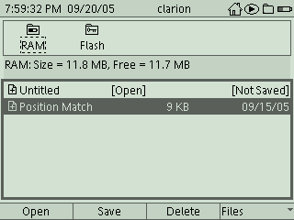

- Select the Position Match file. Press  to open the file as in the picture above.
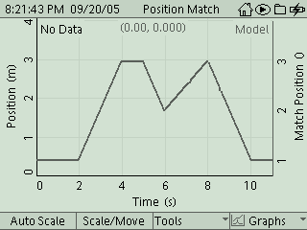

- Press the Home Button then to observe the graph above.
- One lab partner will stand in front of the motion detector. A second lab partner will hold the GLX up so that the partner in front of the motion detector can see the graph on the screen.
- Press the Start  Button on the GLX.
- Try to match the position-time graph.
- After 11 seconds, press the Stop Button.
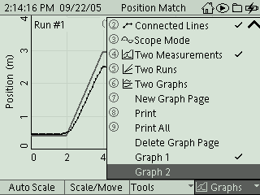
- Press the button and select “Graph 2” as in the picture above.
- The “error” graph will give a score in units of “m*s.” The lower the score, the better.
- Press the button and select “Graph 1” to return to the original graph.

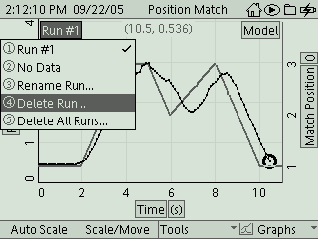
- Press the Check Button and then press the arrow buttons to navigate to and select the Run number as in the picture above. Delete the data run.
- Repeat the previous steps 3 times and record your data for yourself in the data table. Have each partner repeat this and record their own data on their lab sheet.

Data Table

Trial One Trial Two Trial Three
Error ________________ __________________ _________________

Experiment 2:

1. Press the Home button to return to the main screen. Select Data Files. Select Files in the lower, right hand side of the screen. Choose New File. Press the Home button again to return to the main screen.

2. Press F1 to get to the graph page.

3. Study each graph below and then attempt to create each graph through your movement. Once you have created the graphs, describe the movement required beside each graph. Include if you moved forwards or backwards and if you were walking fast or slow.

____________________________________

____________________________________

____________________________________

____________________________________

____________________________________

____________________________________

____________________________________

____________________________________

____________________________________

____________________________________

____________________________________

____________________________________

____________________________________

____________________________________

____________________________________

Conclusion:

1. What does the slope of these graphs represent? How do you know this?

2. How would the shape of the graph change if you started at the same position and walked in the same direction, but did not walk at a constant speed?

3. Vocabulary: Use your textbook to define each of the following:

a. Distance:

b. Displacement:

c. Velocity:

d. Speed:

