One-Pager Midterm Exam
The pages MUST be finished by the end of class on the date of our exam. You will be given class time to work on this, but may need to work outside of class to complete the project.

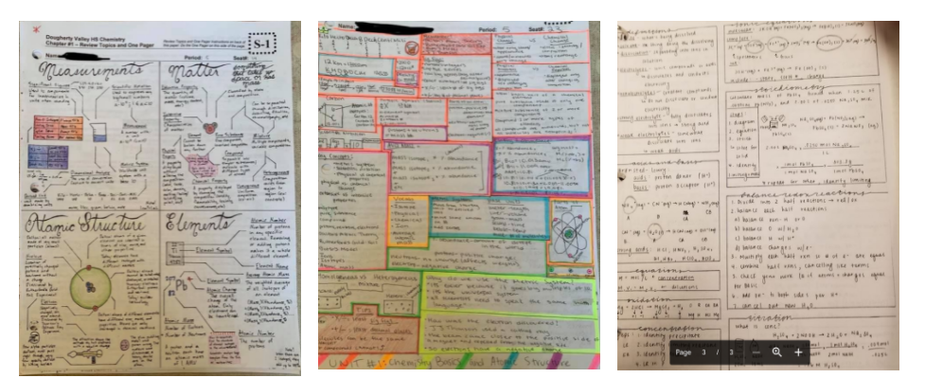

What: You will be making a one page summary ( “One Pager” ) for each Chapter we have covered (Chapters 1-4).

How: Create a one page summary showing your understanding of the concepts. You will need to do it by hand on a piece of 8.5 x 11 inch standard printer paper.

Materials Needed:
- Variety of pens, markers, colored pencils, crayons, ruler, pencil
- If you do not have access to these materials, please tell me and I will get you what you need.
- Several pieces of paper (for brainstorming) to the final version
- You will have access to anything from your notes to your computer to do this one pager.

The vocabulary and topics that need to be covered are below and are organized by chapter for your convenience.

Follow this format for your One-Pager For EACH Chapter. Check off steps as you go.

- Include any 5 key vocabulary words and their definitions
- Use 4+ colors. PENS, PENCIL COLORS, MARKERS, COLORED PICTURES WORK GREAT!
- Fill up the entire piece of paper. (One side of one page per chapter so you will have 4 single sided sheets)
- Topics are labeled and the concepts are well organized under topic in an easily comprehensible manner.
- Information within the topics has a logical flow and provides evidence of organized thinking.
- Creativity is evident in the one pager via use of jokes, humor, mnemonic devices, creative analogies, use of color, use of ruler and other such things.

General Chemistry Midterm Topics

Chapter 1
Vocabulary to Know
Include any 5 in your chapter “one pager”
- atom  - nucleus  - atomic number  - atomic mass  - metal  - nonmetal  - metalloid | - mass/atomic number  - periodic table  - alkali metal  - alkaline earth metal  - halogens  - noble gases | - electron  - neutron  - isotope  - period  - transition metals  - atomic radius | - proton  - group  - ion  - cation  - anion  - significant figures

1.Classification of matter
a. States of matter, pure substances, elements, compounds, mixtures (wks)

2. Properties of matter (you have a practice wks you can do in your binders)
a. Chemical /physical change
b. Extensive vs. intensive properties
c. Separation o mixtures

3. Units of Measure
a. SI units
b. Dimensional analysis (note questions that gave you a hard time!!!)
c. Qualitative vs. quantitative
d. Volume, density, temperature ( K →°C)
e. Conversion factors
f. Dimensional analysis squared, cubed and dual unit conversations

4. Uncertainty in Measurement
a. Precision vs. accuracy
b. Significant figures (add/subtract divide/multiply)

Chapter 2
Vocabulary to Know
Include any 5 in your chapter “one pager”
- average atomic mass  - complete chemical symbol  - octet rule | - ionic compounds  - covalent compounds  - structural formula | - monatomic ion  - polyatomic ion  - cation  - anion  - chemical formula

1.Atomic Theory of Matter
a. Law of conservation of mass
- Law of definite proportions
- Law of multiple proportions
- Dalton’s Atomic Theory

2. Atomic Structure
a. Protons, neutrons, electrons
b. Millikan, Rutherford and their experiments
c. Radiation
d. isotopes, atomic mass, atomic number, complete chemical symbol

3. Periodic table
a. Organization (groups periods)
b. Names of groups and charges in most stable state
c. Valence electrons

4. Molecular Compounds
a. Chemical formulas (chemical/molecular, empirical, structural)

5. Ions and Ionic Compounds
a. What is an ion what are the types of ions
b. Ionic compounds, how do they form, how do charges result
c. Nomenclature

Chapter 3
Vocabulary to Know
Include any 5 in your chapter “one pager”
- chemical equation  - combination reaction | - balanced equation  - double replacement reaction | - single replacement reaction  - activity series | - combustion reaction  - decomposition reaction

- Chemical Equations:
  - balancing, writing, parts of a reaction, states of matter, coefficient vs. subscript

- Types of Chemical Reactions
  - Combination , decomposition ,single displacement , double displacement, combustion.

- Formula Weights
  - Percent composition
  - Calculate Formula weight

- MOLES!!!
  - Grams → moles → molecules → atoms
  - Molar mass, molecular mass
  - Avogadros’s number

- Determining Empirical Formula from Mass Percent
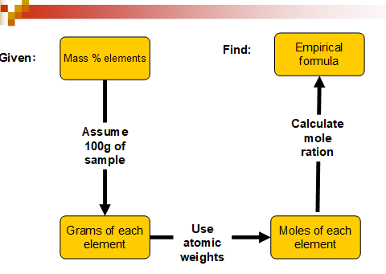
6. Determine Molecular Formula From Empirical Formula
a. Remember the short cut : n = Molecular Weight
Empirical Formula Weight

7. Mass-Mass Problems
a. Gram given à mol given à mol required à g required
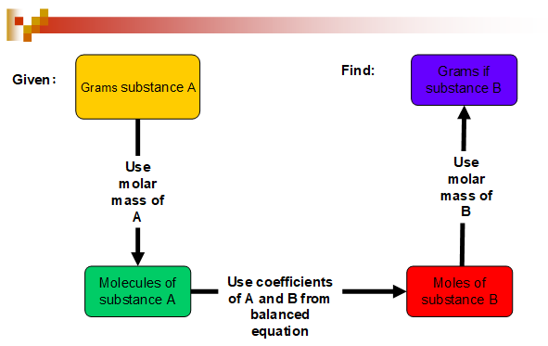
b. Mole ratios

8. Limiting Reactant
Theoretical yield
Chapter 4
Vocabulary to Know
Include any 5 in your chapter “one pager”
- Titration rxn  - Neutralization rxn  - Precipitate rxn  - Redox rxn  - Oxidation  - Reduction | - Precipitate  - Solubility  - Solution  - Electrolyte (strong, weak, non) | - Molarity  - Ionization  - Strong Acid/Base  - Weak Acid Base

1. Aqueous Chemistry
a. Solution Vocabulary

2. General Properties of Solutions
a. Solubility
b. Dissolve vs. ionize
C. Polarity of Water

3. Electrolytes (light bulb wks)
a. Identify electrolytes
b. Properties of electrolytes

4.Precipitate Reactions
a. Solubility rules

5. Predicting Precipitates
a. Chemical, complete ionic, net ionic equations (with phase designations!!!)

6. Acids/bases/salts
a. Properties, strong acids and bases
b. Nomenclature
c. Neutralization Rxn

7. Oxidation –Reduction Reactions
a. Rules

8. Concentrations of Solutions
a. Molarity (M)
b. Making solutions from powder (dry stuff equation)
c. Making solutions from stock solutions (dilutions)
d. Finding concentration of one type of atom

9. Stoichiometry of precipitation reactions
a. Determining mass of precipitate formed
b. Determining mass of reactant needed to form a precipitate.
c. Titrations

