Current Detector (Galvanometer)
Objective
The objective of this experiment is to demonstrate the relationship between electricity and magnetism. In this experiment we will also show how to create and detect magnetic fields.
Materials Required
about 8 feet of insulated wire (18-24 gauge)
metal sewing needle
3 feet of thread
permanent magnet
6 volt battery
a small strip of paper
scissors
How To Build It
Magnetize the needle by rubbing one side of the permanent magnet against it about 30 times in the same direction. Cut the paper into a small arrow. Stick the needle lengthwise into the paper arrow. Now put some thread through the top edge as shown. Using the wire, make a loop about three inches in diameter. Continue to wrap the wire in the same pattern as the original loop until you have a coil of about five loops. You should keep some wire free on both ends. Use the thread to tie the wires together. Now tie the thread attached to the paper to the top of the loop. The paper with the needle should hang freely inside the middle of the wire loop.
Experiment
Attach one end of the wire to the positive terminal of the battery, and the other wire end to the negative terminal. Notice what happens to the paper arrow. It should turn and point directly out from the middle of the loop. Now turn the loop. Notice that the arrow follows the loop and continues to point directly out of the loop.
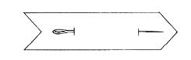 | 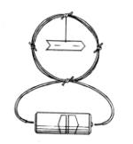  [Source: Munson] | 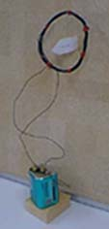

Troubleshooting
If your arrow does not seem to be affected when you attach the loop ends to the battery, try the following:
- Make sure the wires are snugly connected to the battery.
- Make sure that the needle is sufficiently magnetized. You might want to pull it out and stroke the magnet across it several more times. Make sure that you stroke only one pole of the magnet in only one direction across the needle. Do not simply rub the magnet back and forth across the needle.
- Try increasing the number of loops of wire.
- Replace the battery. Extended continual use of a battery can drain its power due to the low resistance of the wire.
Questions for Thought
- Why did the arrow turn out from the loop?
ANSWER: Current through a wire produces a magnetic field around the wire. When current is run through a loop, it produces a magnetic field inside of the loop. Since the needle is magnetized, it tries to align itself with the magnetic field produced by the current in the loop. This is the same way a compass works. The needle inside of a compass is magnetized. That needle tries to align itself with the magnetic field produced by the earth.
- What would happen if we change the direction of the current?
ANSWER: The needle would point in the opposite direction. This is because the direction of the magnetic field is dependent on the direction of the current. The direction can be "predicted" using the right-hand-rule. That is, by wrapping your right hand around the wire with the thumb in the direction of the current flow(from the positive to the negative battery terminal), the magnetic field is curled in the direction of the remaining four fingers of the right hand.
Additional Information
Several books explain this same experiment. They usually use a working compass, and simply wrap the wire into loops around the compass. The only difference is that here, we make our own "compass." This is because a needle is much easier to find and much less expensive than a compass.
- Science Activities With Simple Things by Howard R. Munson, Ed. D. Fearon-Pitman Publishers, Inc. 1962. p. 45.
- The Magic of Electricity by Sam Rosenfeld. Lothrop, Lee and Shepard, Inc. 1963. p. 67.


Last Updated: June 21, 2002
Original Page Development by: Matt Dayley and Keith Holbert
Return to WISE Investments in Electrical Engineering Lab Page 
More Power to You
Task with Student Directions
Contributed by: Council of Chief State School Officers (CCSSO)

TO THE STUDENT
Carefully read through these directions and the directions on the next page before you begin to work.
You may be part of a group for the first part of this exercise. If you are, the group should carry out the experiment and collect the data together, but each student must record the data in his or her own booklet. Be sure to record the data exactly as you observe them. After the data have been collected, each student should answer the questions independently.
After you have finished the experiment and have recorded all of the data, you will be asked to answer some questions about the experiment and the data you recorded. Your answers must be written in the space provided. Make sure that you understand each question before you begin to write. At any time while you are writing your answers, you may look back at the directions for the experiment and the data you collected. Be sure that your answers are written as clearly and neatly as possible.
Before you begin the exercise, read the list of materials given below and check to make sure that your group has everything listed.
Materials in the Kit
    - compass
    - cardboard tube (e.g. from roll of toilet paper)
    - bottom from cardboard box
    - one length of 22 gauge insulated magnetic wire marked galvanometer, the wire should have alligator clips on its ends.
    - one length of 22 gauge insulated magnetic wire marked generator, the wire should have alligator clips on its ends.
    - strong bar magnet with its north pole marked N
    - tape

(Caution: Keep the compass needle and your digital watch away from the magnet.)

More Power to You
The generation of electricity involves changing energy from one form to another. For example, coal contains chemical energy. Burning coal turns some of coal's chemical energy into heat energy. In a power plant, the heat energy from burning coal is used to turn water into steam and to give the steam mechanical energy. The mechanical energy of the steam is used to turn coils of conducting wire inside a magnetic field. Because the coils of wire are turning inside a magnetic field, the mechanical energy of the turning coils is converted into electrical energy in the wire, producing an electrical current in the wire.
In this event you will make a simple generator, consisting of a magnet and wire that is wrapped around a cardboard tube. Using the generator and a galvanometer, a device that can be used to measure small amounts of current, you will study the conversion of mechanical energy into electrical energy. (Note: the compass will be used to detect the presence of an electric current.)
To make the galvanometer:
Fold the flaps of the cardboard box as shown in Figure A below.
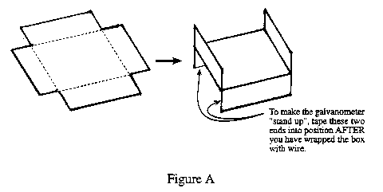
Wrap the box with the magnet wire marked galvanometer. Leave about 15 cm of unwrapped wire at each end, as shown in Figures B and C below.
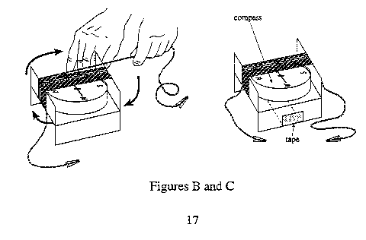
Place the compass in the wrapped cardboard box.
To make the generator:
Wrap 50 turns of the wire marked generator around the cardboard tube. Leave at least 15 cm of extra wire at each end, as shown in Figure D below.
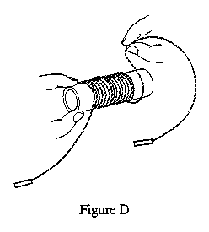
Using the alligator clips as shown in Figure E, clip one end of the galvanometer wire to one end of the generator wire. Clip the other end of the galvanometer wire to the other end of the generator wire.
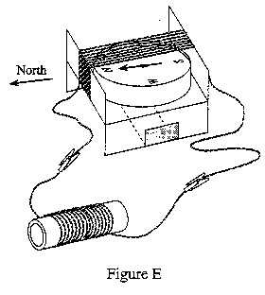

Observations
Before each of the following trials, separate the magnet and the galvanometer by several meters, and orient the galvanometer so that the compass needle points due north. Then, during each trial, note the direction and the amount (in degrees) of the needle's deflection (west of north or east of north) as the tip of the magnet enters or leaves the tube. As the amount of current flowing in the wire increases, the amount of deflection will increase. For example, figure F illustrates a deflection of 45 degrees east of north.
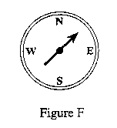
After each trial, record your observations in the Data Table on the following page.
For trials 1-3, place the tip of the North pole of the magnet just inside the cardboard tube. The tube should be held still during trials 1-3.
Trial 1. Hold the magnet still with the tip just inside the tube.
Trial 2. Move the magnet slowly toward the tube as shown in Figure G; when the tip of the magnet is just inside the tube, stop. Then move the magnet slowly away from the tube and, when the magnet is 2 meters away from the tube, stop.
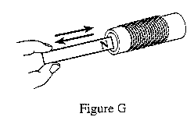
Trial 3. Move the magnet rapidly toward the tube; when the tip of the magnet is just inside the tube, stop. Then move the magnet rapidly away from the tube and, when the magnet is 2 meters away from the tube, stop.
For trials 4-6, place the South pole of the magnet inside the same end of the tube as before. The tube should be held still during trials 4-6.
Trial 4. Hold the magnet still with the tip just inside the tube.
Trial 5. Move the magnet slowly toward the tube until the tip of the magnet is just inside the tube, stop. Then move the magnet away from the tube and stop as in step 2.
Trial 6. Move the magnet rapidly toward the tube until the tip of the magnet is just inside the tube and stop. Then move the magnet rapidly away from the tube and stop as in step 3.

Data Table
Trial | Pole of magnet inside tube (N or S) | Motion of magnet relative to tube (none, slow, fast) | Amount of deflection (degrees) as magnet moves: |  | Direction of deflection (E for east of north; W for west of north) as magnet moves:
Trial | Pole of magnet inside tube (N or S) | Motion of magnet relative to tube (none, slow, fast) | toward tube | away from tube | toward  tube | away  from tube
1 | N | none
2 | N | slow
3 | N | fast
4 | S | none
5 | S | slow
6 | S | fast

Questions
Please answer the following questions by yourself.
- Based on your results, describe the relationship between: (a) how fast you moved the magnet and the amount of current that flowed in the wire; and (b) the pole of the magnet (north or south) that was inside the tube and the direction of the compass's deflection.

- You live along a moving river, and you have a wire, a paddle wheel, and a bar magnet. Describe how you could use these materials to produce an electrical current. Include a diagram of your setup in your description.

©1997-2002 SRI International, Center for Technology in Learning. All rights reserved. Terms of Use

