AP Physics - Galileo’s Lab
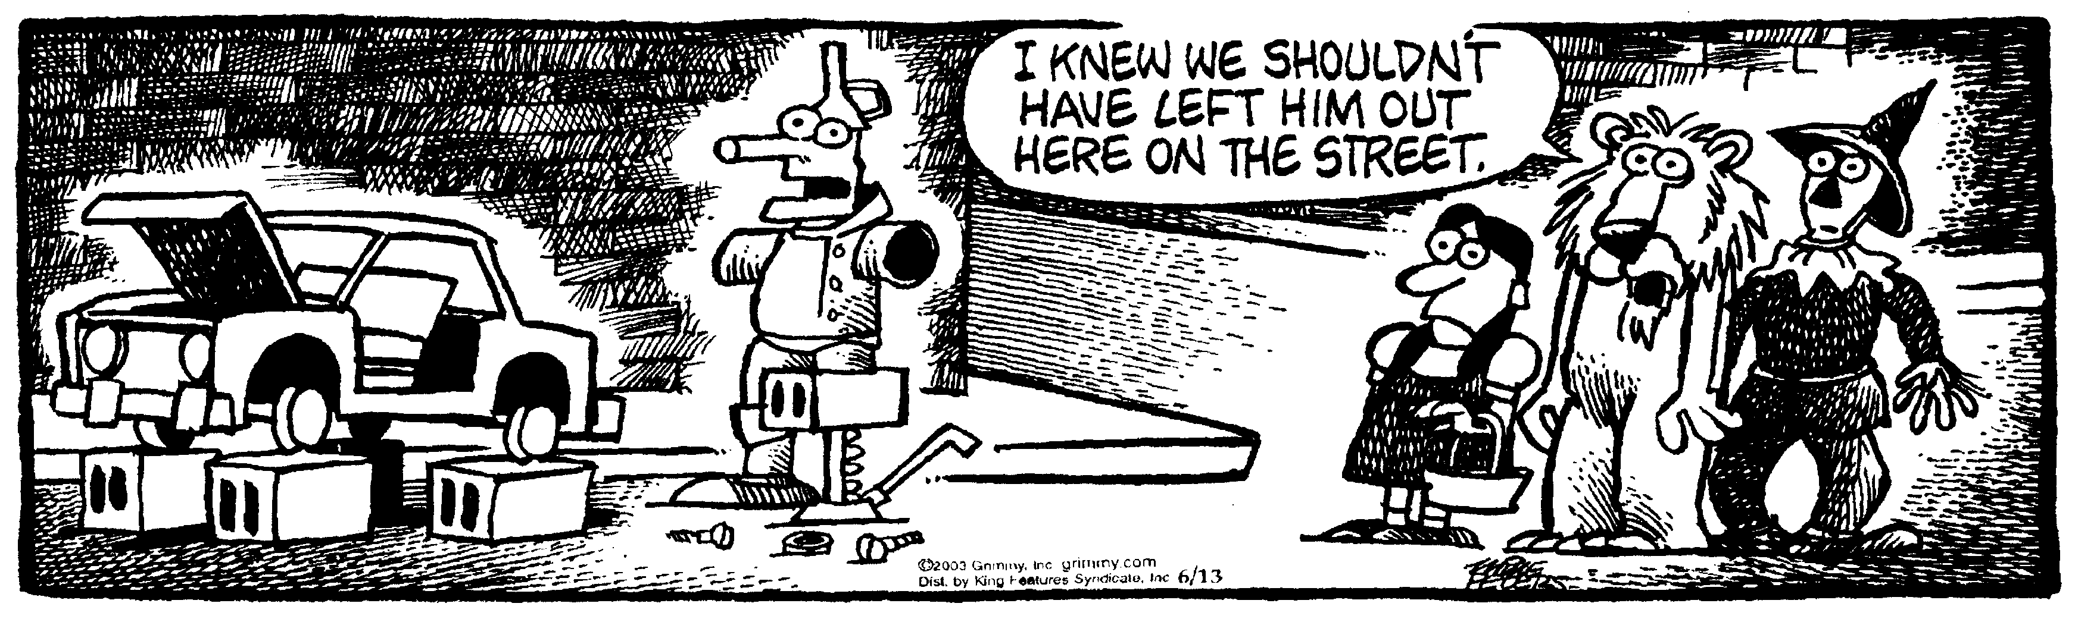
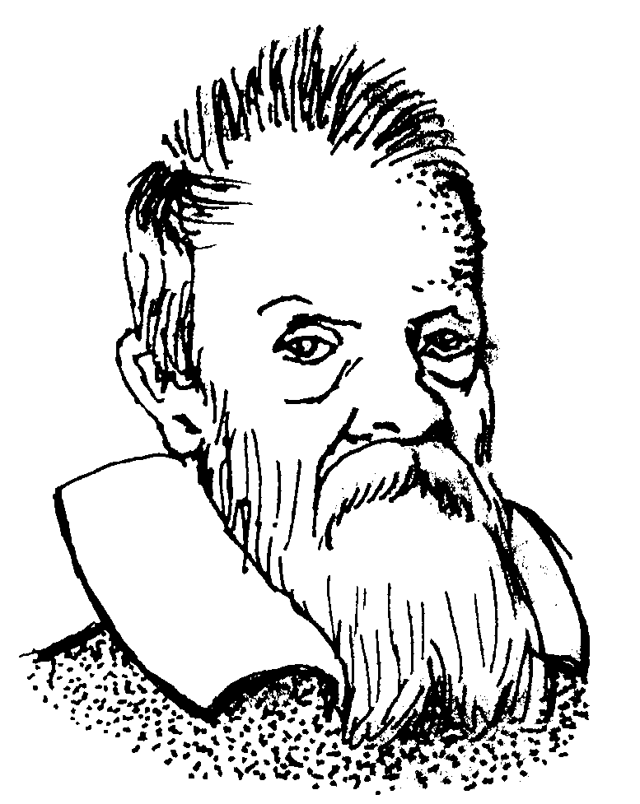It ain't what people don't know that gets them in trouble; it's the things they know that ain’t so. -- Will Rogers

Galileo was able to show that the distance that a ball would fall in a given time was proportional to the square of the time. Since he had no accurate way to measure the time it would take a ball to fall, he ended up “diluting” gravity by having things “fall” slowly down an inclined plane. I.e., he rolled balls down a ramp.

Your mission is to duplicate Galileo’s noble accomplishment. Figure out some way to get data and then manipulate it to show that distance is proportional to time.

The Physics Kahuna suggests that you consider using the following equipment: a piece of aluminum channel that can be used for a ramp, a steel ball, a stopwatch.

You can also use a graphing program called “Graphical Analysis”.

Anything else you need, you are on your own, dude (or dudess), but ask the Physics Kahuna. If he has the item, you can use it.

So turn to and get it done.

