Physics Fuel Rockets – Projectile Motion
- Tape a rocket fuel motor on the end of a piece of paper (hot dog style not hamburger). Roll the paper around the motor and tape the rocket body into place so that it will not unroll.

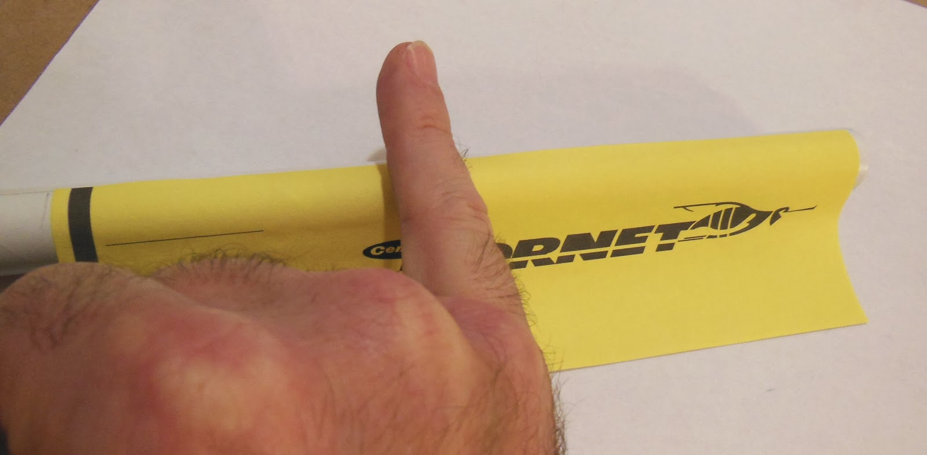

- Cut out a circle and put a cut halfway through. Twist the circle into a point and tape it on the rocket. The size of the circle used will determine the length of the nose cone. If you want a long, pointy nose cone then use a very large circle. If you want a short, pointy nose, then use a smaller circle.

- Cut out 3 to 4 fins. You need them to be less flimsy so use cardstock on this step. You might want to use 2 layers of cardstock for each fin to make them extra sturdy. Tape the two layers together. Fold down the edge of the fin (see picture below – the grey area is folded).

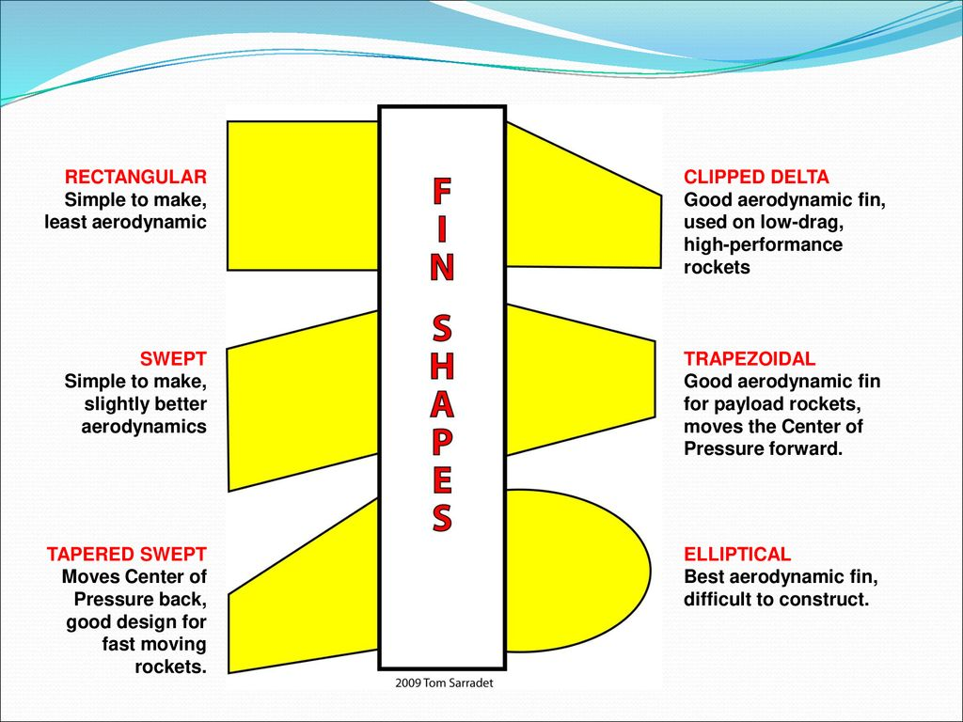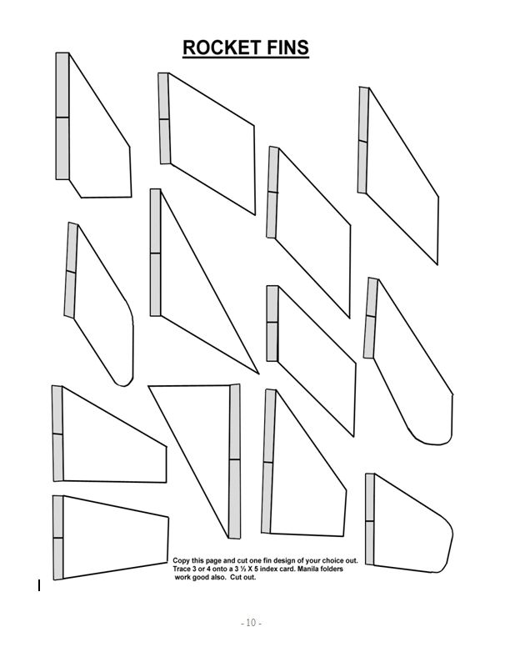

- Tape the fins to the rocket. It is very important that the fins are evening spaced apart. Use the picture below. Put your rocket body in the circle. Mark on your rocket where the lines are (use the dotted lines for 3 fins and the solid lines for 4 fins). Tape your fins to your rocket body.

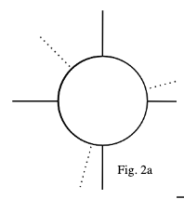

- Tape a straw to the side of the rocket. The straw will keep the rocket on the launcher rod.
- Have your teacher help you place a pin into the end of the motor.
- LAUNCH!!

Background:
- y = -1/2 g (t²)
- x = v_{x} (t)
- Gravity (g) = -9.8
Procedure:
- Build a rocket that you believe will stay in the air the longest (hang time), including a nose cone and fins.
- We will launch the rockets using electricity.
- We will use your cell phone to measure the time in the air. We will use a tape measure to measure the x (distance).
- You must then calculate the velocity and the height (y).
Data:
Measured time (t) Measured distance (x) Calculated Velocity (Vx) Calculated Height (y)
______________ __________________ ___________________ ________________

Show work below:
Calculated Velocity
Distance = Velocity (time)

Calculated Height
Height = -.5(-9.8)(time)²

