CLINTON HIGH SCHOOL
Food and Nutrition I

Instructor: Mrs. Angela Kaizer Phone: (978) 365-4208 ext. 3225 Email: kaizera@clinton.k12.ma.us

Materials & Resources

- Textbook: Food for Today, Glencoe/McGraw-Hill Pub. Co. 2008
- Worksheets
- Instructional and Educational DVDs
- Food preparation and laboratory demonstrations
- Web Assignments

Course Description:

Food and Nutrition I, is part of a collection of skills development courses offered by the Family and Consumer Science Department. It is hoped that the student will investigate the importance of nutrition through the life cycle as well as many issues relevant today. This is a single semester course. Students must pass Food and Nutrition I, before enrolling in Food and Nutrition II.

Major Objectives:

The following objectives are aligned with Family and Consumer Science National Standards

- To identify the diversity involved with our food choices and cultural patterns within our society
- To recognize the part of technology that plays in the worldwide availability of food products
- To appraise the relationships between nutrition and good health
- To identify the specific nutrient contributions that protein, fat, carbohydrates, vitamins, minerals and water make to our diet.
- To recognize the changes and needs of nutrients in the life cycle
- To develop preparation skills and techniques involved
- To become skillful at recognizing the standards of proper food handling, storage and sanitation
- To identify avenues where water and energy conservation and trash reduction may be implemented in daily life.

Major Units

􀂉 Exploring Food Choices
- Food and Health
- Influences of Food Choices and culture
- Food Science & Technology

􀂉 The Nutrients you Need
- The basic nutrients and their role in your diet
- How your body uses food

􀂉 Guidelines for Good Nutrition
- Dietary Guidelines
- Separating fact from Fiction

􀂉 Planning Daily Food Choices
- Improving your eating habits
- Eating out nutritiously
- Vegetarian food choices

􀂉 Food and Fitness
- A healthy weight and weight management
- Exercise basics
- Nutrition for sports and fitness

􀂉 Special Topics in Nutrition
- Food and the life cycle
- Managing Health Conditions
- Eating Disorders

􀂉 Kitchen Principles
- Introduction to and safety in the kitchen
- Importance of sanitation and proper food storage.

Absence:
It is the student’s responsibility to make up any work or assessments missed due to absences. Please adhere to the student handbook on the school policy.

Class Notes:
A binder is mandatory! There will be many notes and handouts from classroom discussions/lessons so the binder will be necessary for organizational purposes. This should be a 3-ring binder and organized by chapters! **At the end of the term your binder will be graded. Organization is essential.

Assessments:
Assessments will be scheduled and announced. If you miss an assessment (test or quiz) YOU MUST MEET WITH ME in order to discuss making up the assessment based on the guidelines in the Clinton High School Student Handbook. If you do not meet with me within three days of your return, you will receive a zero for any assessment missed.

Start and end of Class:
Everyone is EXPECTED to be in his or her assigned seat and ready to work when the bell rings. Students should be prepared for class- Students should have a pencil or pen, their book, binder and other organizational tools that are needed. All backpacks and purses should be placed under your desk, or next to your seat. Students are asked to remain seated until the bell rings!

Homework/Class Work:
Homework/ Class Work will be assigned and is worth 20% of your grade. If a student fails to complete their homework, they will receive a zero for that assignment, and may be assigned a teacher detention to complete their work. If a student fails to complete their assignments on a regular basis, or on the days we are doing a lab, they will receive a zero for the lab, and must complete any missed homework assignments before returning to the lab.

Additional Classroom Rules:

- Respect yourself, your fellow classmates and any adults in the class.
- Act professional
- Do not use our time together to gossip about others
- Bags and Purses must be placed on the floor.
- No FOOD or DRINKS (except water in a clear bottle) in class.
- No foul or inappropriate language.
- Use of your cell phone is not allowed unless permission has been given by the teacher.
  - (Please see attached policy)

Students Grades:
Student grades are earned each quarter by a breakdown of:

- Class Participation & Conduct –20%
- Homework/Class Work- 20%
- Lab Assignments 20%
- Quizzes- 15%
- Tests, & projects- 25%

“You are FREE to choose, but you are NOT free from the

Consequence of your CHOICE.”
- - Author Unknown
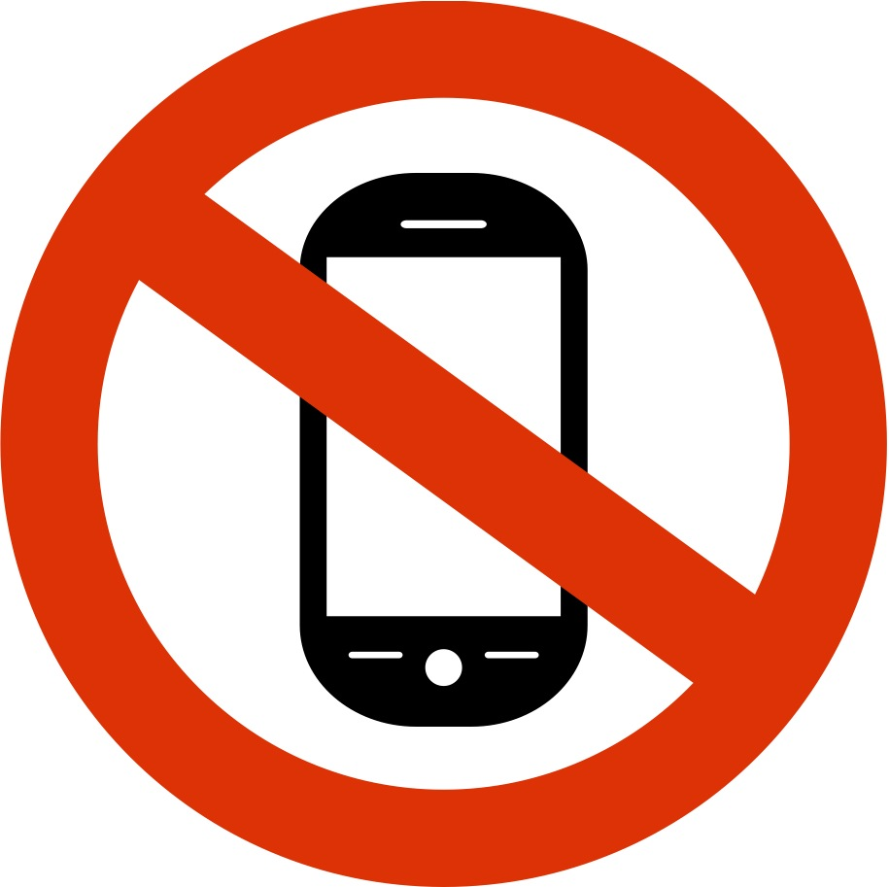
Cell Phone/Electronic Device Policy

ELECTRONIC DEVICES Students are not permitted to use/have inappropriate computer/cell phone applications, Ipods, headsets, earbuds, or laser pointers in their possession during the school day. Cell phones and electronic devices may be used before and after school, during passing times and lunch. While these devices may be used, they should be used appropriately; all ringers, speakers, and any other distracting noises should be silenced. Also, all students must be able to respond to a verbal request. Additionally, these devices may not be used, and should not be visible, in classes unless otherwise directed by the teacher. They should never be used during a quiz or a test, use of these during a quiz or a test will be considered cheating. These devices may never be used in the restroom, locker room, or gym areas. Additionally, recording capabilities, audio and/or video, may never be used during the school day. The use of these devices is not an acceptable reason for being tardy to class. Additionally, any use of these devices to violate any of the rules in this handbook, such as harassment, bullying, and/or academic dishonesty, may result in revoking these privileges as well as additional consequences based on the offense. Violation of CHS cell phone policy will result in the following disciplinary action: First offense: warning. Second offense: cell phone registration. Third offense: cell phone restriction for one week and general detention. Subsequent offenses: general detentions and/or suspension and/or cell phone restriction corresponding to the frequency and severity of the offense.

Clinton High School [Student and Parent Handbook 2018-2019] Students who are on cell phone restriction may not use their cell phone or any other electronic device. Students who refuse to comply with cell phone restriction are subject to suspension.

- - - - - - - - - - - - - - - - - - - - - - - - - - - -------------- - - - - - - - - - - - - - - - - - - - - - - - - - - - - - - - - -

Please print and sign your name acknowledging you have read and understand what to expect for this upcoming year.

__________________________________________
Class

___________________________________ _______________________________
Student’s name (Print) Student’s Signature

___________________________________ _______________________________
Parent/Guardian name (Print) Parent/Guardian Signature

