AP Physics - Pressure

Gas ≡ collection of small particles bouncing around independently of each other

Liquids ≡ particles are much closer together.

molecules attract each other

Solid ≡ particles are rigidly attatched to each other.\

Density ≡ mass per unit volume $ρ =\frac{m}{V}$

- kg per cubic meter, kg/m³

- denisty of water for example is 1.00 g/cm³, but it is also 1.00 x 10³ kg/m³.

- A rectangular chunk of granite measures 1.5 m by 0.75 m by 2.5 m. How much does the thing weigh? Densities for common substances are appended to this grand document at the end of the thing.

V = l w h V = 1.5 m (0.75 m)(2.5 m) V = 2.8125 m³

Solve for the mass: $ρ =\frac{m}{V}$ $m = ρV$ $m = 2\text{.}7 x {\text{10}}^{3}\frac{\text{kg}}{m^{3}}\left(2\text{.}\text{8125} m^{3}\right)$

m = 7.59 x 10³ kg

Find the weight of the stone:

F_{W} = mg $F_{W} = 7\text{.}\text{59} x {\text{10}}^{3}\text{kg} \left(9\text{.}8 \frac{m}{s^{2}}\right)$ F_{W} = 74.4 x 10³ N

F_{W} = 7.4 x 10⁴ N

Pressure ≡ force per unit area.

$\text{Pressure}=\frac{\text{Force}}{\text{Area}}$ or $P=\frac{F}{A}$

Scalar

Psi -- pounds per square inch or lb/in²

Atm

inches of mercury torr

Pa -- for Pascal
$1\text{Pa}=1\frac{N}{m^{2}}$
Pascal ≡ 1 Newton acting on 1 square meter surface.
kilopascal -- kPa = 10³ Pa.

Atmospheric pressure -- weight of the air

$P=\frac{F}{A}$ $P=\frac{\text{14}\text{.}7\text{lb}}{1{\text{in}}^{2}}$ p = 14.7 lb/in²

metric units,

1 atm = 1.013 x 10⁵ Pa or 1.013 x 10² kPa

101.3 kPa

- How much pressure do you exert on the ground when you stand on one foot? You weigh 550 N. Figure your foot has dimensions of 5.0 cm by 15 cm.

A = l w A = 0.15 m (0.05 m) A = 0.0075 m²

$P=\frac{F}{A}$ $P=\frac{\text{550}N}{0\text{.}\text{0075}m^{2}}$ P = 73333 Pa

P = 73 kPa

High heel Problem

- The atmospheric pressure is 1.013 x 10² kPa. What force does it exert on the top of a desk that measures 152 cm by 76 cm?

A = l w A = 1.52 m (0.76 m) A = 1.155 m²
$P=\frac{F}{A}$ F = P A

= 1.013 x 10⁵ Pa (1.155 m²)

F = 1.013 x 10⁵ N/m² (1.155 m²)

F = 1.2 x 10⁵ N

The Barometer:

1643 -- Evangelista Torricelli (1608 - 1647).

Italian physicist assistant to Galileo.

trouble with flooding in the old mine shafts.

pumps could not lift water more than 32 feet.
1648 Blaise Pascal (1623 - 1662),

sent his brother-in-law up mountain

Pressure Conversion Factors:

$1\text{Pa}=\frac{1N}{m^{2}}$ 1 torr = 1 mm Hg

1 torr = 133.3 Pa 1 atm = 1.013 x 10⁵ Pa

$1\text{atm}=\text{14}\text{.}7\frac{\text{lb}}{{\text{in}}^{2}}$ 1 atm = 29.921 in Hg

1 psi = 6.895 Pa 1 atm = 7.60 x 10² torr

Pressure and Density:

The weight of the water: F_{w} = mg

$ρ=\frac{m}{V}$ m = ρ V

Therefore

Plug in A h for V and you get:

Pressure is: $P=\frac{F}{A}$

substitute ρAgh for F

so

- What is pressure exerted by water at a depth of 45.0 m? The density of water is 1,000 kg/m³.

P = ρgh

P = 441000 Pa P = 441 kPa

Hydrostatics -- study of liquids at rest

hydraulic systems ≡ liquid is working fluid

pneumatic systems ≡ gases are working fluid

Pascal's Principle:

- when pressure exerted on a fluid in closed vessel
- Pressure transmitted throughout fluid
- Pushes at right angles to all surfaces
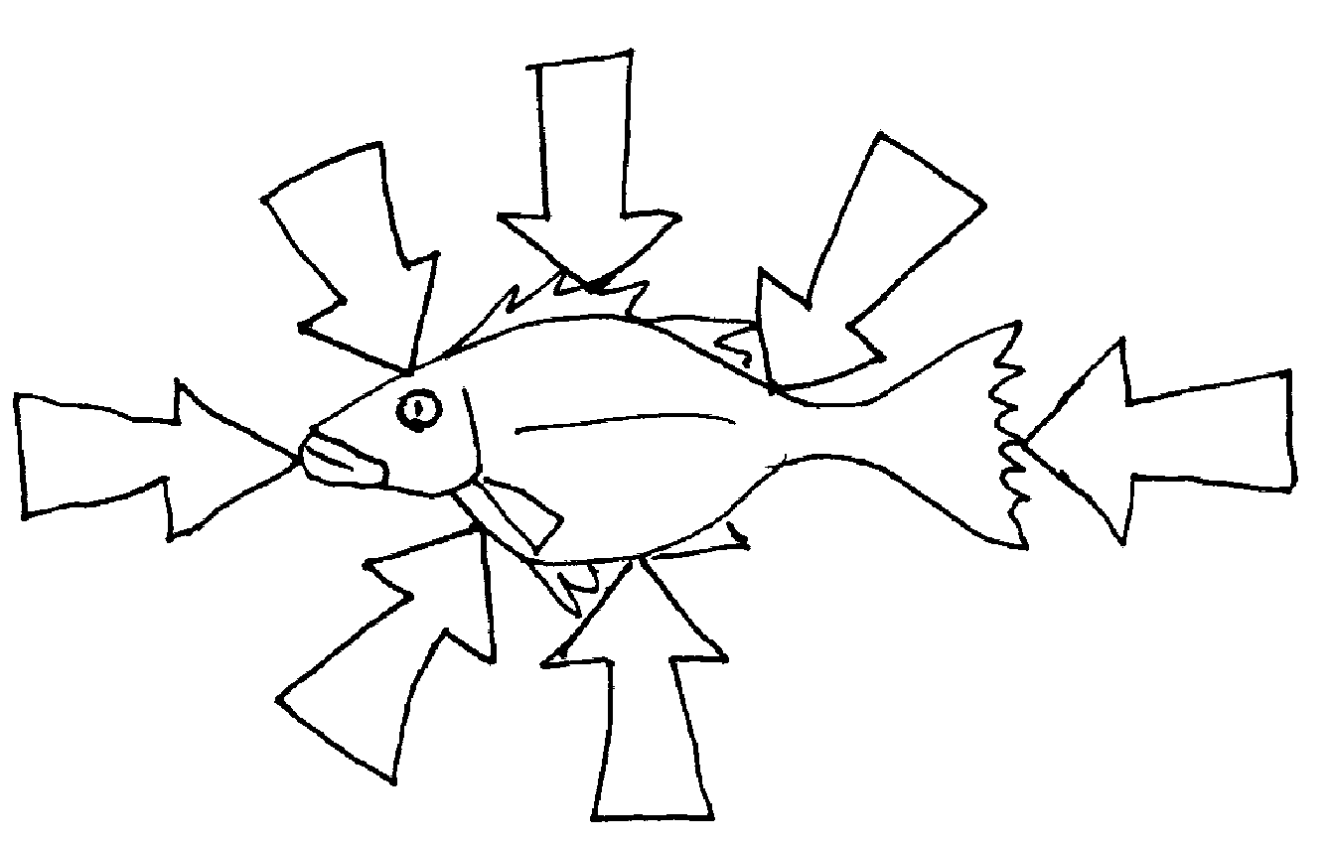

Squeeze tube of toothpaste

difference between way force acts on solid and fluid

force does not change solid shape

liquid can sustain a force only at an enclosed surface or boundary

Exert a force on fluid -- make it flow

If fluid restrained -- force increases pressure of fluid.

Useful Tables of Informations: Table of Density Values
for Various Substances
Substance | Density  kg/m³
Alcohol, ethyl | 0.791 x 10³
Aluminum | 2.70 x 10³
Copper | 8.9 x 10³
Gold | 19.3 x 10³
Granite | 2.7 x 10³
Ice | 0.917 x 10³
Iron | 7.8 x 10³
Lead | 11.3 x 10³
Mercury | 13.6 x 10³
Marble | 2.7 x 10³
Oil | 0.85 x 10³
Quartz | 2.65 x 10³
Rubber | 1.15 x 10³
Seawater | 1.025 x 10³
Styrofoam | 0.10 x 10³
Water | 1.000 x 10³
Wood | 0.50 x 10³
Gases | kg/m³
Air | 1.20
Carbon dioxide | 1.84
Helium | 0.17
Hydrogen | 0.084
Methane | 0.67
Nitrogen | 1.16
Oxygen | 1.33
Steam (100°C) | 1.99

Buoyancy -- fluid exerts an upward force that is opposite to the force of gravity

buoyant force.

Archimedes (ca 287 - 212 BC)

Archimedes' Principle:

An immersed object is buoyed up by a force equal to the weight of the fluid it displaces.

Rule true both for gases and liquids

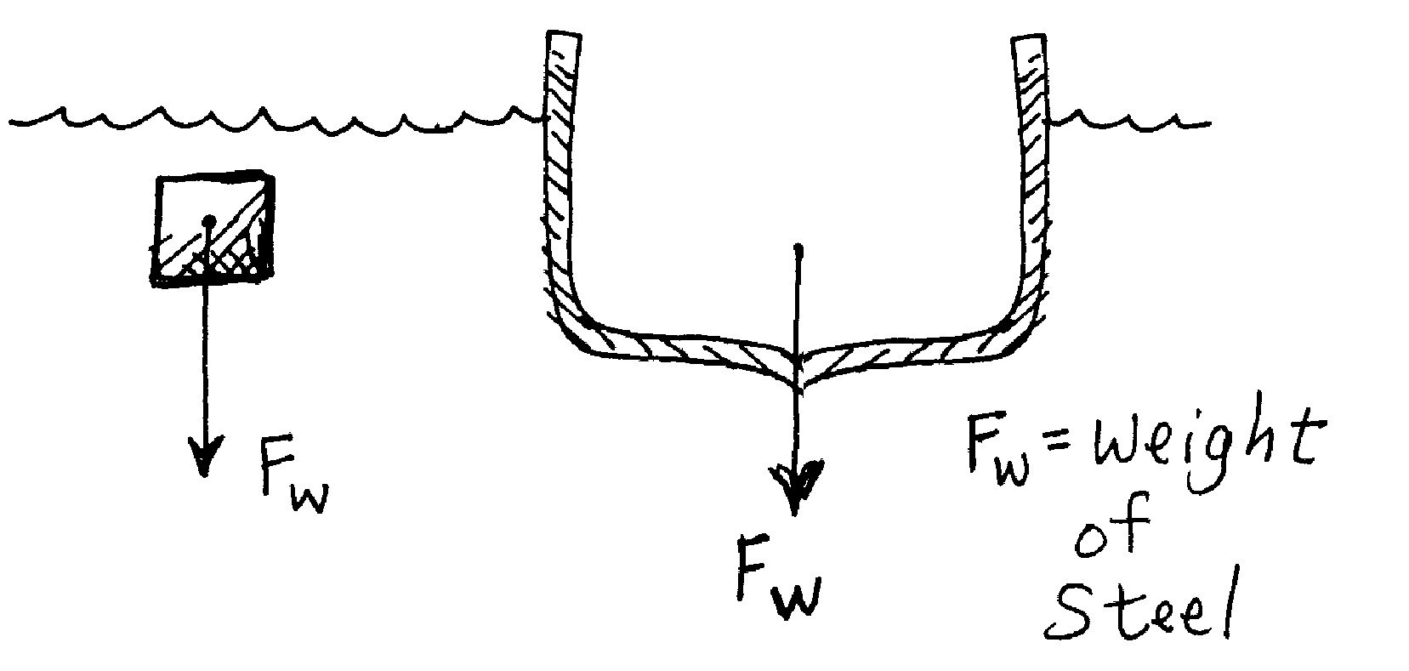

25,000 ton ship must displace at least 25,000 tons of water

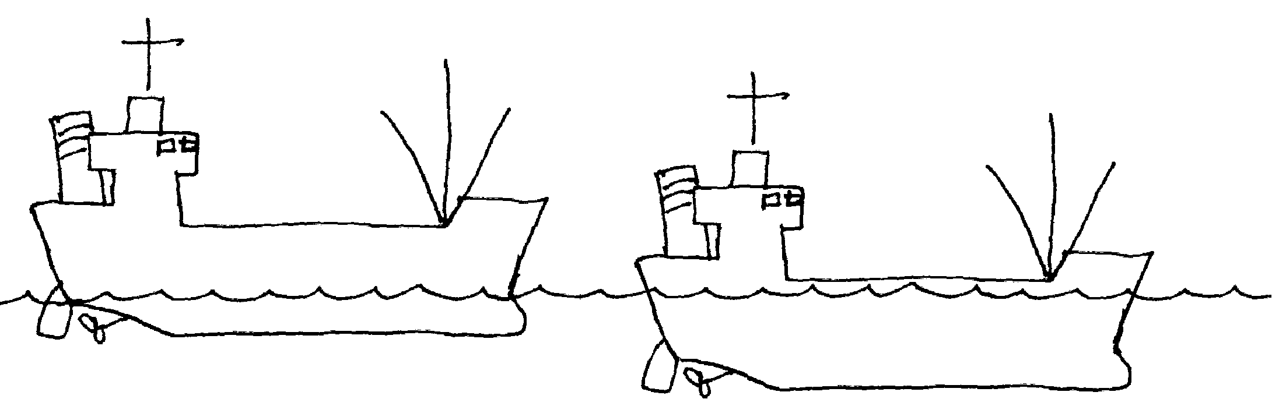
Empty Ship Loaded Ship

Buoyancy In Air

An object surrounded by air is buoyed up by a force equal to the weight of the air displaced.

Source of Buoyant Force:

Cube with area A on all sides

Force on cube:

Force on bottom greater than force on top

difference = buoyant force

area times the length = volume

F_{B} = ρVg

If weight less than buoyant force -- floats

F_{A} = F_{w} - F_{B} Apparent weight equation

- A cube of steel measures 0.10 m on each side. Density of steel = 9.0 x 10³ kg/m³. The density of water is 1.0 x 10³ kg/m³. What is buoyant force acting on cube and what is its apparent weight?

1. Find buoyant force.

V = (0.10 m)³ V = 0.0010 m³ = 1.0 x 10⁻³ m³

F_{B} = ρVg

F_{B} = 1.00 x 10³ kg/m³ (1.0 x 10⁻³ m³) (9.80 m/s²)

F_{B} = 9.8 N
2. Find apparent weight.
F_{w} = mg $ρ=\frac{m}{V}$

m = ρV = 9.0 x 10³ kg/m³ (1.0 x 10⁻³ m³)

= 9.0 kg

F_{w} = 9.0 kg (9.80 m/s²) F_{w} = 88.2 N

F_{A} = F_{w} - F_{B} F_{A} = 88.2 N - 9.8 N

F_{A} = 78 N

- A block is suspended at three different depths as shown in the drawing, at which point is the buoyant force greatest?

At A: F_{A} = ρVg At B: F_{B} = ρVg

buoyant force depends only on dimensions of the block.

does not depend on depth

The Famous Archimedes Story:

Syracuse -- third century BC.

King Hiero II.

New Gold Wreath or crown

Actual gold amount

Bath

Eureka!!!!

One Last Shot At A Problem:

- A cork float has a volume of 4.25 cm³. The density of cork is 207 kg/m³. [a] What volume of the cork is beneath the surface when the cork floats in water? [b] What downward force is needed to completely submerge the cork?

- floating cork displaces volume of water = to its own weight

V_{cork} = = 4.25 x 10⁻⁶ m³

$ρ=\frac{m}{V}$ $m=ρV$

= 879.8 x 10⁻⁶ kg

weight of cork: F_{w} = mg

$F_{W}=\text{ 879}\text{.}\text{8 x }{\text{10}}^{−6}\text{kg}\left(9\text{.}8\frac{m}{s^{2}}\right)$

F_{W} = 8622 x 10⁻⁶ N

Find the volume of water:
F_{B} = ρ V g $V=\frac{F_{B}}{ρg}$
= 879.8 x 10⁻⁹ m³

V = 8.80 x 10⁻⁷ m³ or 0.880 cm³

[b] Downward force to completely submerge the cork:

When the cork submerged - displace volume of water equal to cork’s total volume

Water volume exert upward buoyant force

F_{B} = ρ V g
$F_{B}= 1 \text{000} \frac{\text{kg}}{m^{3}} \left(4\text{.}{\text{25 cm}}^{3}\right) \left(9\text{.}8 \frac{m}{s^{2}}\right) {\left(\frac{1 m}{\text{100} \text{cm}}\right)}^{3}$

$F_{B}= 1 \text{000} \frac{\text{kg}}{m^{3}} \left(4\text{.}{\text{25 cm}}^{3}\right) \left(9\text{.}8 \frac{m}{s^{2}}\right)$

F_{B} = 0.0416 N

Subtract weight of cork:

F = 0.0416 N - 8622 x 10⁻⁶ N

F = 0.0416 N – 0.008622 N

= 0.0330 N

