AP Physics – Fluid Stuff

The Rise of Sir William Wallace: Edward I of England, called Edward Longshanks (he had very long legs, standing over six feet tall) took advantage of the confusion among the Scots that followed the death of Alexander III. Scotland, under his heavy fist, was reduced to the status of a fief of England; a country in name only. The land was occupied by English troops and governed by British barons. The English Lord High Justice required that all Scots take an oath of loyalty to King Edward. The Scottish lords who refused the oath were called into the courts of justice, fined, and stripped of their estates. These were bad times for Scotland, which was in great distress, suffering under the heel of English tyranny. It was at this point, one of despair and suffering, that a true hero emerged to try to lead Scotland from the yoke of English subjugation. This was the noble William Wallace.

... I would relate
How Wallace fought for Scotland; left the name
Of 'Wallace' to be found like a wild flower
All over his dear country; left the deeds
Of Wallace, like a family of ghosts
To people the steeps rocks and river banks
Her natural sanctuaries, with a local soul
Of independence and stern Liberty.
-- William Wordsworth

Sadly, little is known of Wallace’s early days. One of the things that is known was that he was the son of a private gentleman, a man called Wallace of Ellerslie, in Renfrewshire near Paisley. The lad grew to be a very tall, powerfully built man and had a reputation as a first class fighting man.

Sir Walter Scott in The Story of Sir William Wallace tells the tale of how a young William Wallace, trout fishing, was set upon by three English soldiers.

“Two or three English soldiers, who belonged to the garrison of Ayr, came up to Wallace, and insisted, with their usual insolence, on taking the fish from the boy. Wallace was contented to allow them a part of the trouts, but he refused to part with the whole basketful. The soldiers insisted, and from words came to blows. Wallace had no better weapon than the butt-end of his fishing rod; but he struck the foremost of the Englishmen so hard under the ear with it that he killed him on the spot; and getting possession of the slain man’s sword, he fought with so much fury that he put the others to flight, and brought home his fish safe and sound.”
Wallace took up arms against the English after the English governor of Lanark burned Wallace’s house and put his wife and servants to death and

Blast! It has happened again! The Physics Kahuna apologies for the intrusive appearance of a history lesson in the middle of a work on the physics of fluids. He has no idea how this could have taken place. Rest assured that it will not happen again!

Matter: Matter is your basic stuff. You probably agonized over what it was in chemistry. Pretty simple though. Matter is just stuff – anything with mass that takes up space. We often keep track of matter via its mass and the volume it occupies.

Density: An important property of matter is density. Density is defined as mass per unit volume. The symbol for density is ρ.

The equation for density is:

Where m is the mass, V is the volume and ρ is the density.

- A rectangular chunk of granite measures 1.5 m by 0.75 m by 2.5 m. How much does the thing weigh?

First, we can get the density of granite for the table that the Physics Kahuna has kindly placed in this very handout. Granite’s density is 2.7 x 10³ kg/m³. Then let’s find the volume of the stone. V = l w h

V = 1.5 m (0.75 m)(2.5 m) V = 2.8125 m³

Solve for the mass:

Find the weight of the stone:

The Physics Kahuna is relatively certain that you probably dabbled around a bit with good old density in your chemistry studies.

Fluids: A fluid is any material that flows and offers little resistance to changing its shape. Essentially, what we’re talking about here, is a gas or liquid. A gas is a collection of very small particles that are rapidly moving around, independently of each other. Gases have an indefinite shape and an indefinite volume.

In a liquid the particles are much closer together and exert attractive forces on each other. The attraction isn't great enough to make the collection rigid, like we would see in a solid, but loose enough so that the particles can move around fairly freely, but not loose enough that they can easily separate. Thus a liquid can flow, but it all stays together. Liquids have a definite volume and an indefinite shape.

Gases can be compressed or expanded - the volume can be easily changed. This is not true for liquids. Liquids are basically incompressible. This is because they are about as close to one another as they can get so squeezing them together doesn’t make much of a difference.

Pressure: There’s a good chance that you have studied pressure in a chemistry class, so we’ll quickly review the important points about it. Firstly, pressure is a scalar quantity.

Pressure ≡ force per unit area.

Mathematically: or

The unit for pressure in the United States is the psi, which stands for pounds per square inch or lb/in². Other common units are the atm, which stands for atmosphere, and inches of mercury. These are the ones that you probably dealt with in chemistry.
The metric system uses the pascal which is abbreviated as Pa.
Naturally we will use the pascal.

- What pressure does a force of 1125 N exert on a surface that measures 2.0 cm by 1.1 cm?

A pascal is one Newton of force acting upon a 1 square meter surface. Turns out that these here pascals is most definitely small – kinda like they’re tiny or something - so the kilopascal (kPa) is commonly used.

Atmospheric pressure is caused by the weight of the air pressing down on the earth's surface. Imagine a column of air that measures one inch by one inch, this means it has a cross sectional area of one square inch. The column soars upward to where the atmosphere ends and the vacuum of space takes over. (This would make it be around 100 000 feet high.) So, imagine weighing this 100 000 foot high by one inch by one inch column on a handy bathroom scale. It would, at sea level, weigh around 14.7 lb.

Its pressure would be:

Table of Density Values for Various Substances

Substance | Density  kg/m³
Alcohol, ethyl | 0.791 x 10³
Aluminum | 2.70 x 10³
Copper | 8.9 x 10³
Gold | 19.3 x 10³
Granite | 2.7 x 10³
Ice | 0.917 x 10³
Brass | 4.70 x 10³
Iron | 7.8 x 10³
Silver | 10.5 x 10³
Lead | 11.3 x 10³
Mercury | 13.6 x 10³
Marble | 2.7 x 10³
Oil | 0.85 x 10³
Quartz | 2.65 x 10³
Rubber | 1.15 x 10³
Seawater | 1.025 x 10³
Styrofoam | 0.10 x 10³
Water | 1.000 x 10³
Wood | 0.50 x 10³
Gases | kg/m³
Air | 1.20
Carbon dioxide | 1.84
Helium | 0.17
Hydrogen | 0.084
Methane | 0.67
Nitrogen | 1.16
Oxygen | 1.33
Steam (100°C) | 1.99

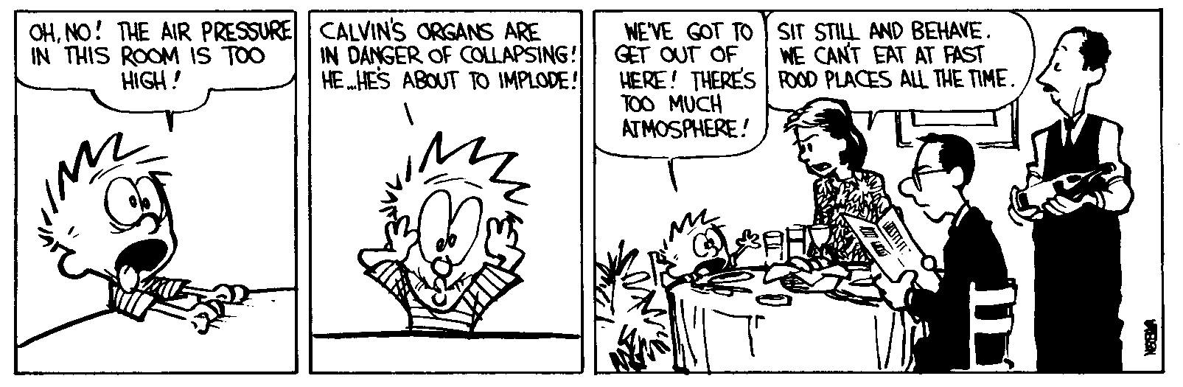
In metric units, a column of air with an area of one square meter weighs 1.013 x 10 ⁵ N (at sea level). Therefore, atmospheric pressure would be 1.013 x 10⁵ Pa or 1.013 x 10² kPa (or 101.3 kPa).

- A 115 lb woman wearing high heel shoes is at a dance. Also attending the dance is a rather large 325 lb man m (maybe a football player or a professional wrestler or some other large man type of profession). You, clumsy as always, trip and fall. The woman and the man both step on one of your hands, placing all their weight on a heel of their respective shoe (which is on your hand). Which would cause the greatest damage? The man's heel measures 3.0 in by 3.5 in and the woman's heel measures 0.50 in by 0.50 in (she’s into those high fashion stiletto high heel type shoes).

The heel that exerts the greatest pressure is the one that will cause the most damage to your hand. First, we calculate the area of each heel.

A = l w A_{w} = 0.50 in(0.50 in) = 0.25 in²

A_{m} = 3.0 in (3.5 in) = 10.5 in²

The woman exerts a pressure that is seventeen times greater than that of the man. So avoid high heel wearing women when you are lying about on the deck at fancy dances!

- The atmospheric pressure is 1.013 x 10² kPa. What force does it exert on the top of a desk that measures 152 cm by 76 cm?

A = l w A = 1.52 m (0.76 m) A = 1.155 m²

The study of liquids at rest is called hydrostatics.

If you dive under water, as you get deeper, the weight of the water above you exerts pressure on you. As you go deeper, the pressure increases - more water above you, right? The pressure increases by roughly 1 atm for every 32 feet of depth.

How does the pressure act on you?

The way a force acts on a solid is different than the way it acts on a fluid. Since a solid is a rigid body, the force does not change its shape. The force mostly tries to move the object. A liquid cannot sustain a force in this way. Push on the water in a wading pool and you makes a splash – you make the water flow. If the fluid is restrained so that it can’t flow, and a force is exerted on it, the force will increase the internal pressure of the fluid. The pressure exerted on a fluid in a closed vessel is transmitted throughout the fluid and pushes at right angles to all surfaces that it touches. This is called Pascal's Principle.
Pascal’s principle ≡ The force exerted by a fluid on the walls of its container always acts perpendicular to the walls.

When you are under water the water’s pressure pushes in on you from all sides. The force is perpendicular to your body. The clever drawing to the right shows you some of the force vectors acting on the intrepid snorkel diver. (Although she appears to have lost her snorkel.)

The Barometer: The barometer is a device used to measure air pressure.

If you fill a glass with water in a tub and then invert the glass and partially pull it out, the water will stay in the glass. Why?
The weight of the atmosphere pushes down on the surface of the water – the old atmospheric pressure. The water in the tub is confined so the pressure exerted on the surface is transmitted throughout the liquid. The pressure exerts a force perpendicular to the surfaces in the tub and in the glass. So the water in the glass is pushed upward.

The water in the glass wants to run out because of its weight, so it exerts a force throughout the water that acts perpendicular to the various surfaces. It acts on the water surface, pushing it up. This can be seen in the lovely drawing above.
The effect of this is that the two sets of forces cancel out. The water wants to run out of the glass and raise the surface in the tub but the weight of the air pushes down and that force is greater, so the water is pushed up the glass. We end up with a static column of water in the glass.

This is how a barometer works. The atmosphere can support a tall column of water. If we have a column of air that has a cross sectional area of one square meter, it weighs 1.013 x 10⁵ N. It turns out that it can support a column of water of the same cross sectional area so long as the water weighs the same or less than the air. For sea level, this works out to about a ten-meter tall column. This is about 32 feet.

Minor variations in the atmospheric pressure cause the water column height to vary slightly. The height of the column could then tell you what the atmospheric pressure is.

Well, barometers don’t use no water, instead they use mercury. Why?
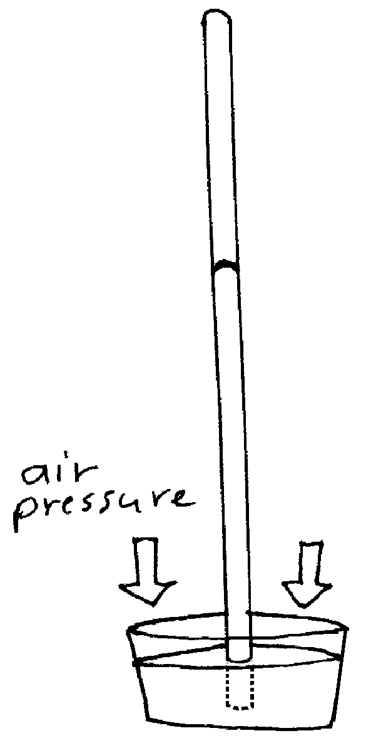
Mercury is very dense – about 13.5 times denser than water. So a barometer using mercury as the working fluid doesn’t have to be as tall as a water barometer. It turns out that at sea level, the column of mercury will be around 760 mm high (which is around 30 inches). 30 inches high is a lot more handy and practical than 32 feet.

So how do you make a barometer? You takes you a glass tube, closed at one end, that is around 80 cm in length or so and fill the thing with mercury. Plug up the open end and turn the whole thing upside down. The open end, now on the bottom is placed into a reservoir of mercury and the plug is removed. The mercury will run out of the tube until the weight of the mercury is equal to the weight of the air column. The area above the mercury in the tube is essentially a vacuum (it will have a small amount of mercury vapor that has evaporated, but there isn’t much vapor in there).

A common pressure unit when using barometers is the height of the mercury column. At sea level, this is around 760 mm or 76 cm. In America we use inches. The height of the mercury column at sea level is around 29 inches. Thus, when you hear the weather report the weather person might say that the barometric pressure is 29.2 inches of mercury. In Gillette the atmospheric pressure is less because of the altitude. The meteorologists give us a relative air pressure. They pretend that the normal mercury column height is 30 inches and give us readings based on that.

Dear Doctor Science,
Why is barometric pressure given in inches of mercury?
-- Hugh Grant from Ardmore, PA

Dr. Science responds:
Back in the 1840's, when barometric pressure was first discovered, it was considered vulgar to make a direct statement about the laws of nature. The phases of the moon were called "Lunar Melancholic Waning" and even rainfall was referred to as "The Lamentations of the Firmament." Everyone was a long-winded poet, including Gilbert Shelton, the English amateur meteorologist, who coined the metaphor "Mercuric Altitude" to describe his mental condition just before a storm. Today, even when half the nation is on anti-depressants, we continue this proud tradition.

Back to Barometers: Barometers are useful in forecasting the weather. The rule of thumb is that falling air pressure means bad weather, and rising air pressure means good weather. A steady air pressure also means good weather. This is because weather is caused by huge, moving masses of air which have different pressures. So pressure changes signal the movement of air masses that have different temperatures which means weather. A low pressure means that weather is coming towards you. A high pressure means that the weather is somewhere else, but not where you are.

Today, any device that measures air pressure is called a barometer, so not all instruments use mercury columns. Aneroid barometers use little bellows (like accordions have) to measure the air pressure.

Pressure and Density: As mentioned before, when one is swimming under water, the deeper you go, the greater the pressure you are exposed to.

The weight of the water above you is:

Recall that density, ρ, is equal to:

so, Plug this in for mass:

Volume is equal to the area multiplied by the height, or:

Plug in A h for V and you get:

Pressure is: We can substitute ρAgh for F since the weight is the force

so

Thus the pressure in a fluid column can be found using this equation:

This equation is provided you in a slightly different form for the AP Physics Test. It looks like this:

Here the only new thing is - this simply stands for the initial pressure.

The pressure is proportional only to the depth and density of the fluid. The shape of the container or the object has no effect on pressure.

- What is the pressure exerted by water at a depth of 45.0 m?

Unit wise, you have a kg m/s² (which is a N) over a m², which makes the thing a Pascal.

Dear Doctor Science,
Why does nature hate a vacuum?
-- ? from The Internet

Dr. Science responds:
Nature hates a lot of things and, actually, a vacuum is far down the list -- behind perpetual motion machines and lemon-lime flavorings. The older Creation gets, the crankier Nature becomes. Some say that Nature has simply lost her joie de vivre and is looking to spend her autumn years railing against a long list of modern developments and voting against school bond issues. Nature's first vacuum cleaner was an old upright Hoover. It lasted 50 years. Nowadays, it's tough to find one of these new plastic machines that'll make it five. Nature hates that, and come to think of it, I'm not too happy about that, either.

Dear Doctor Science,
What is the given length for a Mercury-filled Torricelli tube?
-- Gern Sabourin from Sherwood Park, Alberta, Canada

Dr. Science responds:
It varies, depending on nose shape and hair color. Black haired people with small, upturned noses have very short Torricelli tubes. Fortunately, the amount of mercury in each tube remains constant,
independent of tube length. Blondes with sharp noses have the longest Torricelli tubes of all, but compensate with decreased general libido and affect a cowering, groveling demeanor. Many of them dye their eyebrows to appear more interesting, and disguise their essential blandness by adopting an artificial manner of speech, punctuated by loud belching.

Dear Cecil:
How does one suck in a piece of spaghetti? Think about it. How one sucks milk through a straw is easy. The lowered pressure in the mouth due to sucking causes the air pressure over the milk to force the liquid up. But if one pushes on the end of a piece of spaghetti it just buckles. The mouth is closed and sealed over the sides of the spaghetti, so passing air doesn't drag it along. Somehow the air very close to the mouth must obliquely communicate a force along the length, and it's far from clear how it's possible. --Berg [I guess; kind of scrawled], El Cerrito, California

Cecil replies:
You're thinking, this is the lamest question Cecil has ever answered. However, this is because you lack an appreciation of the scientific issues. I blame myself. It took me a

while to get the regulars on the Usenet newsgroup sci.physics to focus on this too. Apart from the one lamer who said the partial vacuum inside your mouth exerted a positive force that pulled the spaghetti in, most reasoned as follows:

- Air pressure is customarily conceived of as acting perpendicularly to the surface on which it bears. In other words, it presses straight down.

- Air pressure at any point on the side of a strand of spaghetti is exactly counteracted by the air pressure on the opposite side.

- The one place where the air pressure is not counteracted is on the end of the spaghetti. The pressure on the outside end is much greater than the pressure on the inside (mouth) end.

- Therefore, the force on the spaghetti is equal to outside air pressure minus the pressure inside your mouth times the cross section of the spaghetti.

You're not getting this, I said. I know how much pressure is exerted. What I want to know is where it's exerted, since it seems pretty obvious that literally pressing on the end of a strand of limp spaghetti doesn't do jack.

What do we care where it's exerted? said the sci.physics regulars. We are scientists. We deal in the world of quantifiable effects. It is enough to know that the air bears somewhere, and that the pressure differential in aggregate is some mathematically determinable amount, as a consequence whereof the spaghetti is sucked, or rather forced, into your mouth.
Freaking gearheads, I said. Screw the mathematics. I want to know, what is actually happening at the level of individual particles?

"Heisenberg tells us . . . ," the sci.physics types began.

Screw Heisenberg, I replied.

Finally a few of the scientific types conceded that the question had a certain practical interest. After some discussion we concluded that whereas it is customary to think of air as pressing straight down, most individual air particles, in fact, strike the surface of the spaghetti obliquely. Those particles striking the spaghetti close to the point where it entered the mouth, and whose vector had some inward-pushing component, would force it in. Exactly how close to the mouth the particles would have to hit would of course depend on whether the spaghetti was al dente or boiled to within an inch of its life. You want to take it up with the sci.physics crowd, be my guest.

Dear Cecil:
Mama mia, Cecil! The sci.physics crowd's pathetic shot at explaining how anyone can suck up spaghetti makes one wonder why our tax dollars are still subsidizing hopeless efforts at science education. We might as well be funding pictures of naked thermocouples. These wonks have missed the point entirely. Spaghetti sucking is not merely a function of the difference in pressure between the outside of the mouth and the inside. You can easily recognize this using a simple thought experiment. Imagine that a physicist--Erwin Schroedinger will do as an example--places the end of a strand of cooked spaghetti in his mouth. Then, instead of sucking, imagine that he turns on a pump that rapidly increases the air pressure surrounding his head. The air-pressure differential will, according to probability, crush Schroedinger's skull like an eggshell long before it neatly forces the limp spaghetti through his pursed lips. (I encourage any sci.physics wonks who doubt this to try the experiment at home.) Ergo, it's not just air pressure.

A closer approximation to the right answer is that the spaghetti strand has its own density and cohesion. When you suck, the difference in density between the spaghetti strand and the air inside your mouth pulls the molecules on the surface of the spaghetti into your mouth; because the spaghetti's cohesion holds it together, the rest of the spaghetti is pulled in too. But then, I'm sure you knew that all along. --Harry Doakes, Portland, Oregon

Dear Harry:
When will I learn? I thought this question, while not without interest, was too esoteric to get much reaction, forgetting that giving the Teeming Millions a question that's esoteric is like throwing the piranhas raw meat. I got rants about spaghetti sucking from every unemployed Ph.D. in North America, plus a few who aren't unemployed but who--how shall I put this?--probably ought to keep their resumes up-to-date. A sampling of alternative theories, starting with yours:

"When you suck, there is a difference in density between the spaghetti strand and the air inside your mouth."

I never suck, although I have my off days. What does "a difference in density" have to do with it? There is a difference in density if the stuff just lies there on the freaking table. We're talking about spaghetti, not an ideal gas.

"Spaghetti isn't a solid (although one can use air pressure differential to pull a round solid into the mouth, but at nowhere near the spectacular rate at which spaghetti can be sucked, as it were) but a starchy gel and so subject to physical laws that govern both solids and liquids. When subjected to a pressure differential, the spaghetti strand necks down slightly and . . ." (Brian).

OK, the spaghetti isn't solid but mushy. So what? You can suck solid things too. Cecil has been . . . well, I was about to say Cecil has been sucking various cylindrical objects, but I recognize that a certain element will find this comical. Let us pause while the lads get it out of their systems. Very well. By process of experiment, we learn that the speed at which something can be sucked depends very little on whether it's solid or spongy--mostly it's a

matter of its weight relative to its cross section. I therefore feel entitled to ignore the fluidic aspects of the situation.

"The air pressure around the spaghetti causes an internal pressure in the spaghetti. At the interface between outside and inside your lips, the internal pressure of the spaghetti drops; the spaghetti flows down this pressure gradient" (Bruce Kline).

Bruce. It's "spaghetti." Quite a few people persuaded themselves that spaghetti exhibits characteristics of flow and that it somehow extrudes into your mouth. But this could not result in motion of the spaghetti without loss of structural integrity or at least permanent deformation, which does not occur, and in any case would be slow. This is spaghetti, not lava.
"I'm going with the dragging-it-along theory, wherein the seal of the lips around the strand is not perfect but allows some air or, more probably, a thin layer of spaghetti sauce to be sucked in, dragging the strand along with it" (J. Ebert).

First thing I thought of. First thing I rejected. The sauce acts as a lubricant, sure. However, from our experiments with nonpasta above, we conclude that an extremely thin film of spit is sufficient to facilitate sucking. Given the minute amount of fluid and the minimal cross section it presents, it's implausible to suggest that the sauce or whatever is the sole or even the primary medium of propulsion.

Cecil must be really desperate if he's consulting the noodleheads on Usenet.

Not at all. Cecil loves the noodleheads on Usenet. It's like consulting the regulars at the local bar. The quality of advice is easily as good, and you don't have to stand for the price of drinks.

--CECIL ADAMS

The Naughty Doll
MY dolly is a dreadful care,--
Her name is Miss Amandy;
I dress her up and curl her hair,
And feed her taffy candy.
Yet heedless of the pleading voice
Of her devoted mother,
She will not wed her mother's choice,
But says she'll wed another.

I'd have her wed the china vase,--
There is no Dresden rarer;
You might go searching every place
And never find a fairer.
He is a gentle, pinkish youth,--
Of that there's no denying;
Yet when I think of him forsooth,
Amandy falls to crying!

She loves the drum--that's very plain--
And scorns the case so clever;
And weeping, vows she will remain
A spinster doll forever!
The protestations of the Drum
I am convinced are hollow;
When once distressing times should come,
How soon would ruin follow!

Yet all in vain the Dresden boy
From yonder mantel woos her;
A mania for that vulgar toy,
The noisy drum, imbues her!
In vain I wheel her to and fro,
And reason with her moldly,--
Her waxen tears in torrents flow,
Her sawdust heart beats wildly.

I'm sure that when I'm big and tall,
And wear long trailing dresses,
I sha'n't encourage beaux at all
Till mama acquiesces;
Our choice will be a suitor then
As pretty as this vase is,--
Oh, how we'll hate the noisy men
With whiskers on their faces!
------ Eugene Field

