AP Physics – Fluidity of Homework – 1

Gnome ______________________________________________________________________Per___
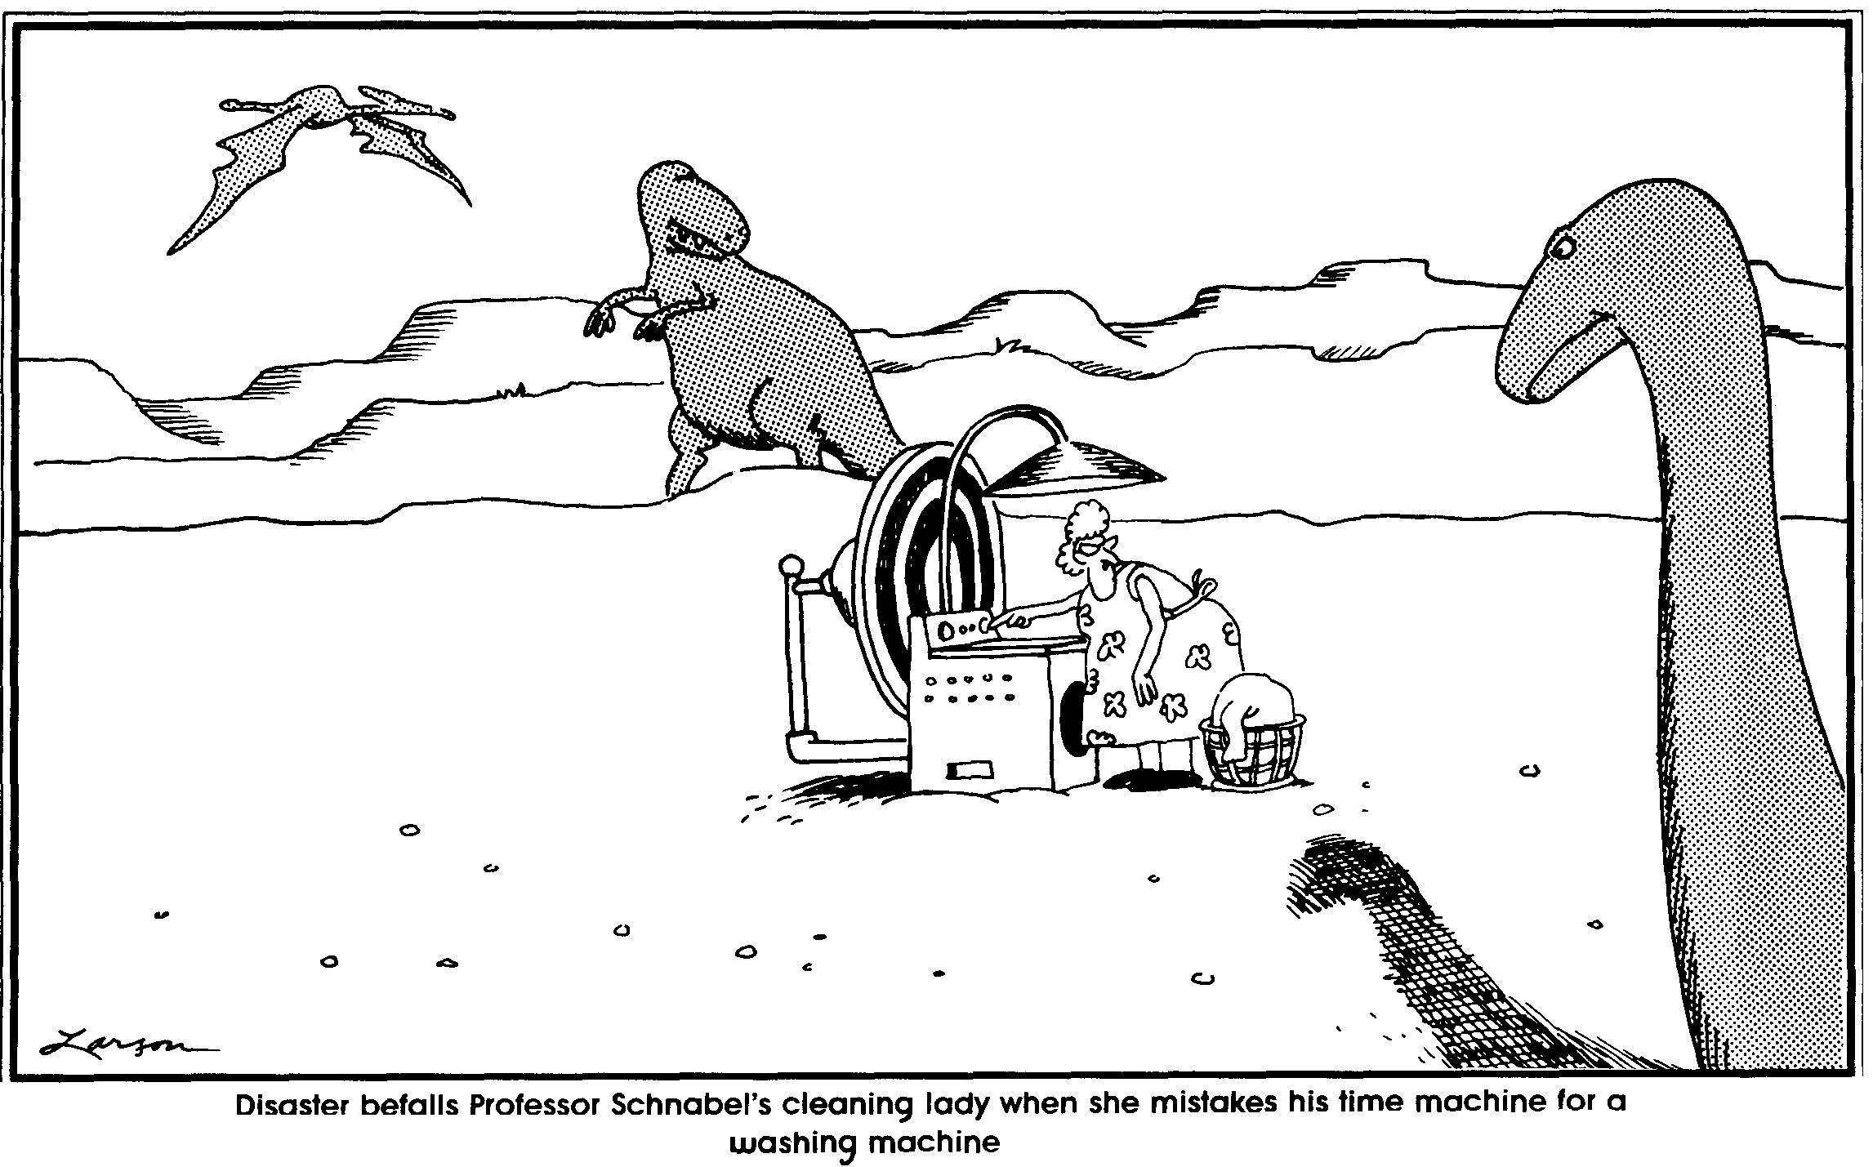
I hope you will also find time to read and improve your mind. Read history, works of truth not novels and romances. Get correct views of life, and learn to see the world in its true light. It will enable you to live pleasantly, to do good, and, when summoned away, to leave without regret.
– Robert E. Lee
- A marble cylinder that has a diameter of 42.0 cm and stands 1.25 m tall rests on a flat tile deck. What is the pressure exerted on the deck by the cylinder?

- What is the force exerted on the surface of a bowling ball that has a diameter of 32.0 cm immersed in water to a depth of 555 m?

- A man weighs like 786 N. He lies on a bed of nails. Find the average pressure exerted on him by each of the nail heads. Figure that there are 950 nails in contact with the man and that the point of each is slightly flattened and has a diameter of 2.00 mm.

- A sheet of paper lies on a table. The paper measures 20.0 cm by 30.0 cm. Calculate the force exerted on the paper by the atmosphere. Figure that the pressure exerted by the atmosphere is 1.013 x 10⁵ Pa.

- A certain metal is illuminated with electromagnetic waves of frequency 2.51 x 10¹⁵ Hz, the stopping potential is found to be 7.00 V. What is the work function for the metal?

- What is the (a) buoyant force acting on a cube of copper that measures 2.00 cm on its each side if it is immersed in water and (b) the apparent weight of the cube?

- An atom has a ground state energy level of –6.00 eV. A 345 nm photon is absorbed. Following this a 345 nm and a 625 nm photon is emitted by the atom. (a) What is the energy level of two emitted photons in eV? (b) Draw and label an energy level diagram. (c) What other possible photons could be emitted? (d) Which of the emitted photons would be visible to the humanoid eyeball/brain system?

