Flash of Genius
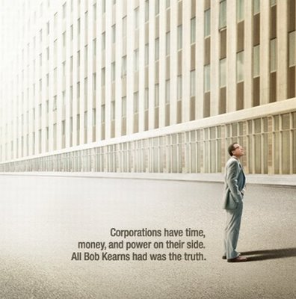
Based on the true story of college professor and part-time inventor Robert Kearns’ (Greg Kinnear) long battle with the U.S. automobile industry, Flash of Genius tells the tale of one man’s fight to receive recognition for his ingenuity no matter the cost. After inventing the intermittent windshield wiper, Kearns’ creation is stolen and passed off as a new feature by the major automotive companies. Despite being discouraged by those around him, including his business partner Gil (Dermot Mulroney), his lawyer Lawson (Alan Alda), and his wife Phyllis (Lauren Graham), Kearns refuses to be silenced, and he takes on the mighty corporations in a battle that nobody thought he could win.
Discussion Questions:

- Bob gets his sons to help him work on the intermittent windshield wiper. What are some projects that you have helped your family work on? How did it make you feel?

- While teaching, Bob notes that engineers made both the aortic heart valve, which saved lives, and the gas chamber, which slaughtered thousands. What factors influence how inventions are used?

- What did you think of the extensive security that Bob went through to keep his design a secret?

- Throughout the movie Bob says, “This is not about money, it’s about right and wrong.” What do you think? What was Bob’s lawsuit really about?

- Bob does business with his friend Gil, benefiting them both in the beginning, but after the legal problems start, it turns sour.

- What do you think about doing business with a good friend? If you decided to do it, how would you approach it?

- Bob tells his wife, “This makes you wonder what makes a man successful.” What do you think makes someone successful?

- At one point, Bob becomes so obsessed with proving that Ford stole his design that he steals parts from someone else’s car. What do you think of what Bob did? How far would you go to prove a point?

- Bob gets so focused on his job and the lawsuit that his relationship with his family begins to deteriorate and he begins missing important events in their lives. When you get a full-time job, how will you balance work, family, and life?

- Lawson tells Bob, “This is how justice is dispensed in this country – with checkbooks.” What do you think about that statement?
- Bob continues fighting his legal battle even after Gil, Lawson, and Phyllis leave him. What does that tell you about Bob?

- What are some things that you would fight that vigorously for? Why?

- Throughout the film Ford offered Bob money to settle the lawsuit. The dollar amounts kept getting higher – up to $30 million. Would you have settled? Why or why not?

- During the trial Bob explains that the U.S. Supreme Court said that there must be a “flash of genius” in the inventing process for a new invention to qualify for a patent. What do you think about this?

- Bob says, “I thought I was put on this earth for a purpose.” Do you agree with that idea? If so, what do you think is your purpose and how will you make it happen?

