AP Physics – Final Examination

Name ___________________________________________________________Per___

Note: 10 m/s² may be used for the acceleration of gravity for the multiple choice questions.

- On a displacement-time graph, a horizontal straight line corresponds to motion at:
- zero speed
- constant, non zero speed
- increasing speed
- decreasing speed
- decreasing acceleration

- Ball A is thrown horizontally and ball B is dropped vertically from the same height at the same moment. Which of the following is true?
- Ball A reaches the ground first
- Ball B reaches the ground first
- Ball A has a greater speed when it reaches the ground.
- Ball B has the greater speed when it reaches the ground.
- Both balls have the same speed when they reach the ground.

- An airplane is flying horizontally at an altitude of 490 meters when a wheel falls from it. If there no air resistance, the wheel should strike the ground in:
- 10 s
- 30 s
- 50 s
- 80 s
- 100 s

- A stone is dropped from a cliff. After it has fallen 30 m, its speed is:
- 17 m/s
- 24 m/s
- 44 m/s
- 74 m/s
- 588 m/s

- An object traveling in a circle at constant speed:
- has a constant velocity
- is not an accelerated motion
- has an inward, radial acceleration
- has an outward, radial acceleration
- has a constant tangential acceleration

- The moon’s mass is about one sixth of the earth’s mass. Compared to the gravitational force the earth exerts on the moon, the gravitational force the moon exerts on the earth:
- is one sixth as much
- is one half as much
- is the same
- is twice as much
- is six times as much

- A horizontal force of 40 N is needed to start a 10 kg steel box moving across a wooden floor. The coefficient of static friction is:
- 0.08
- 0.25
- 0.4
- 0.8
- 2.5

- Rank the following forms of electromagnetic radiation by their wavelengths, from shortest to longest:
- visible light
- radio waves
- gamma rays
- x rays
- 2, 1,3, 4
- 3, 4, 1, 2
- 2, 1, 4, 3
- 1, 3,4, 2
- 4,3,2,1

- A beam of laser light in a room of air is pointed at a diamond, index of refraction n = 1.4. What is the critical angle for the light entering the diamond?
- 48.6 °
- 2.42°
- 24.4°
- There is no critical angle for light going from air into a diamond
- 0.41°

- Which of the following is an application of concave mirror applications?
- the word AMBULANCE written backwards on the front of the vehicle.
- Satellite dishes
- Convenience store overhead security mirrors.
- Automobile mirrors on the passenger side that say “objects in mirror are closer than they appear”.
- Rear view mirrors in a car that can be tilted at night to make headlights less bright.

- Which of the following contributes to the interference patterns formed in thin film interference?
- Thickness of the film
- Change in frequency of the light entering the film
- Difference in wavelength of light in the two media.
- I only
- III only
- I and III
- II and III
- I, II, and III

- An ideal gas in a sealed container is heated so that the temperature of the gas increases with no change in volume. Which of the following is true?
- pressure of gas increases
- work is done on the gas
- average kinetic energy of the molecules remains constant
- I only
- II only
- III only
- I, II, and III
- I and II

- What is true of all combinations of resistors arranged in parallel?
- Current splits down each leg of the combination
- Voltage is constant across each leg of the combination
- Resistance is the same for each leg of the combination
- I and II
- I and III
- II and III
- II only
- I, II, and III

- Two charges of +Q are 1 cm apart and exert forces on each other. If one of the charges is replaced by a charge of –Q, the magnitude of the force between the two charges is now:
- zero
- smaller
- larger
- the same
- changed only if the magnitudes of the charges are equal to each other.

- A long wire carries a current to the right, as shown below. What is the direction of the magnetic field at point P?

P

I

- to the right
- to the left
- into the page
- upward on the page
- out of the page

Part 2: Free Response Section

- (15 points) A pellet gun fires a bullet into a stationary block of wood that is attached to a spring on a frictionless surface. When the bullet enters the wood, it remains inside, and the bullet and block enter into simple harmonic motion with amplitude = 11.0 cm. The bullet (m = 5 g) was initially traveling at 650 m/s before hitting the block of wood (m = 2.5 kg).
- (6 points) What is the spring constant of the spring?

- (2 points) What is the total energy of the system after the collision?

- (4 points) What is the maximum acceleration of the bullet/block system once it begins its oscillations?

- (3 points) Where will the bullet and block have zero velocity?

- (15 points) In the diagram below, an elementary charge is accelerated between two charged plates into a magnetic field.

(a) (2 points) What is the sign of the particle? Provide an argument to explain your choice.

- (4 points) If the charge is traveling at a speed of 2.00 x 10⁵ m/s when it passes through the opening, what is the voltage charging the two plates?

- (5 points) Find the distance from the entrance point to where the charge leaves the magnetic field.

- (4 points) Draw the path onto the drawing above.

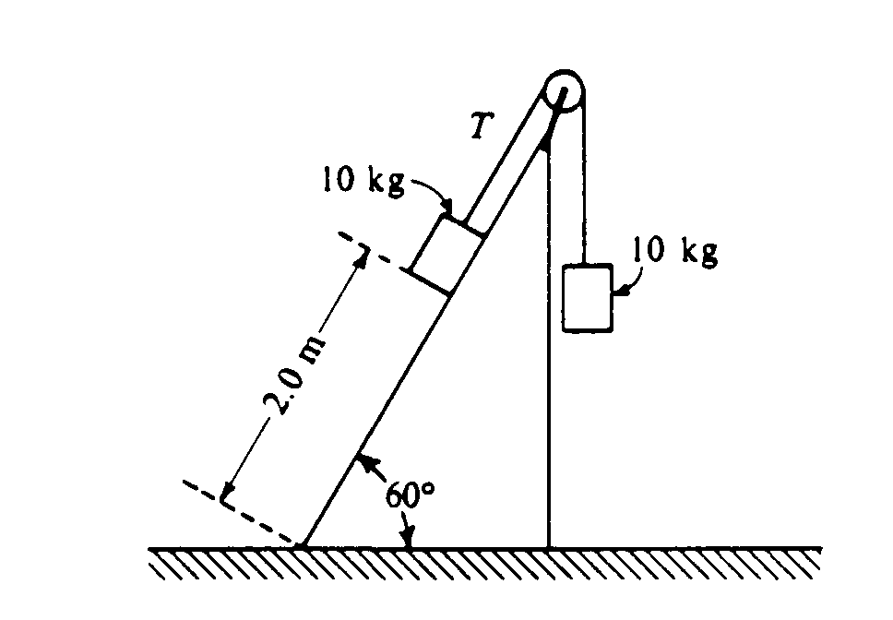
- (15 points) Two 10 kilogram boxes are connected by a massless string that passes over a massless frictionless pulley as shown below. The boxes remain at rest, with the one on the right hanging vertically and the one on the left 2.0 meters from the bottom of an inclined plane that makes an angle of 60° with the horizontal. The coefficients of kinetic friction and static friction between the Ieft-hand box and the plane are 0.15 and 0.30, respectively. You may use g = 10 m/s², sin 60° = 0.87, and cos 60° = 0.50.
  - What is the tension T in the string?

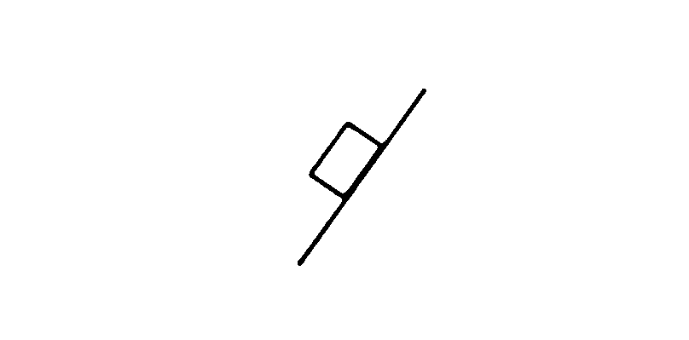
  - On the diagram below, draw and label all the forces acting on the box that is on the plane.

  - Determine the magnitude of the frictional force acting on the box on the plane.

The string is then cut and the left-hand box slides down the inclined plane.
  - Determine the amount of mechanical energy that is converted into thermal energy during the slide to the bottom.

  - Determine the kinetic energy of the left-hand box when it reaches the bottom of the plane.

