JURY JAGUAR
2016 FIELD DAY INFORMATION

- Field Day is scheduled for Friday, May 6th. Teachers and students will be involved the entire day, from 9:55 to 2:00.

- Field Day will begin when the music is played over the intercom at approximately 9:55. All classes will stay together as a team.

- The games will be only FOR FUN. Each grade level will be at a different event and all will be busy. IF TIME ALLOWS, PLAY THE GAME AGAIN!! Each teacher will remain with his/her class to encourage participation and enthusiasm. Each teacher will control discipline and help the supervisor in charge of that station.

- Ms. Randolph will be supervising time out for all grades in the cafeteria. MRS. PRATHER CAN ONLY MAKE TIME OUT ASSIGNMENTS. TEACHERS CANNOT ASSIGN TIME OUT! Please make official time-out requests directly to Mrs. Prather. Teachers are allowed to personally time-out students for individual events, or a specific amount of minutes, but you are responsible for student supervision, in these cases.

5. The ice cream truck is a station that each grade level will get to visit (it is partnered with the Hydration Station). STUDENTS NEED TO BRING MONEY TO PURCHASE ICE CREAM. A flyer will be sent home, outlining this. The truck is scheduled from 10:00-2:00, but feel free to make an extra stop, right before the 2:00 kickball game. Teachers/parent volunteers are encouraged to purchase ice cream treats as well. If the school spends over $500, 10% will be donated back to Jury!

STATION #1
HULK FEET RELAY RACE
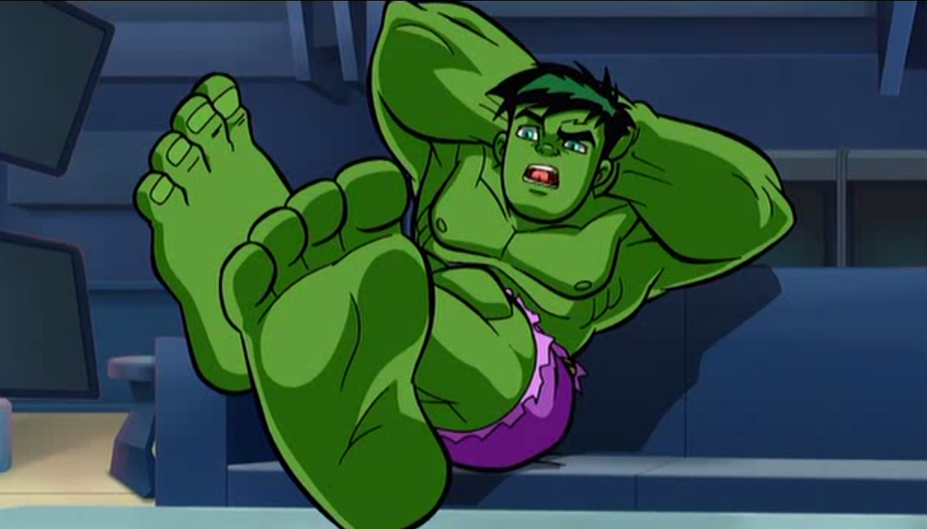

TEACHERS: MR. DELLARD AND MR. SANDERS
LOCATION: FIELD BETWEEN 2 BACKSTOPS
SUPPLIES: MONSTER TRAX WALKING FEET, CONES
DESCRIPTION OF STATION:
RELAY RACE, USING THE LARGE MONSTER TRAX FOAM WALKING FEET. FIRST STUDENT USES THE FOAM FEET TO WALK AROUND THE CONE, THEN PASSES THE FEET TO THE NEXT PERSON IN LINE. STUDENTS SHOULD SIT DOWN AFTER THEIR TURN IS OVER, SO TEACHERS CAN TELL HOW MANY STUDENTS ARE LEFT. FIRST TEAM TO FINISH IS THE WINNER!

STATION #2
CAPTAIN AMERICA SHIELD TOSS
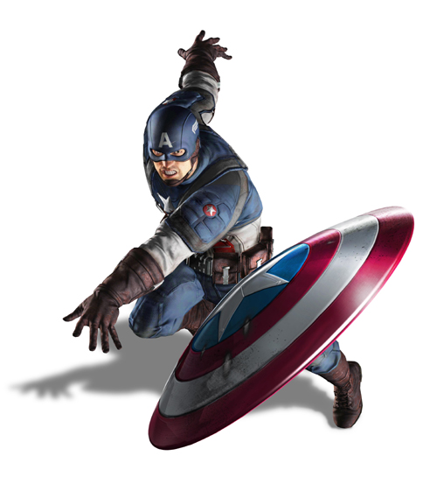

TEACHERS: MRS. GREER, MS. BURT, AND MS. FOLKERTS
LOCATION: BASKETBALL HOOP NEAREST TO THE TRACK
SUPPLIES: FRISBEES, FRISBEE GOAL

DESCRIPTION OF STATION:
EACH CLASS LINES UP BEHIND A CONE. WHEN THE WHISTLE BLOWS OR “GO” IS YELLED, THE FIRST PERSON GOES TO THE THROWING LINE. THEY WILL THROW THE FRISBEE ONE TIME. IF THEY MAKE IT INTO THE GOAL, THEY WILL RECEIVE A POINT. IF THEY MISS, THEY RETRIEVE THE FRISBEE, AND PASS IT TO THE NEXT PERSON. OBSERVING TEACHERS: YOU CAN CONTINUE THE GAME FOR A SPECIFIC TIME LIMIT, OR YOU CAN CONTINUE THE GAME UNTIL A CERTAIN SCORE IS REACHED (FOR EXAMPLE, FIRST TEAM TO SCORE 15 POINTS).
STATION #3
NINJA TURTLES PIZZA RELAY
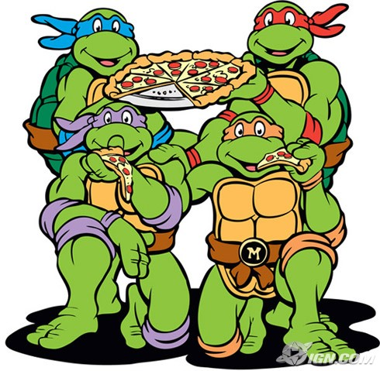

TEACHERS: MS. MCNICHOLS, MS. WILKINSON, & MS. LENNINGTON
LOCATION: BLACKTOP, NEAR THE FENCE
SUPPLIES: PIZZA BOXES, CONES

DESCRIPTION OF STATION:
RELAY RACE, BALANCING PIZZA BOXES ON THEIR HEADS. NO HANDS!!! FIRST STUDENT BALANCES THE PIZZA BOX ON THEIR HEAD AND WALKS AROUND THE CONE, THEN PASSES THE PIZZA BOX TO THE NEXT PERSON IN LINE. STUDENTS SHOULD SIT DOWN AFTER THEIR TURN IS OVER, SO TEACHERS CAN TELL HOW MANY STUDENTS ARE LEFT. FIRST TEAM TO FINISH IS THE WINNER! IF STUDENTS USE THEIR HANDS, MAKE THEM INCURE SOME KIND OF PENALTY (THEY HAVE TO TAKE 3 STEPS BACK, FOR EXAMPLE).

STATION #4
BATMAN V. SUPERMAN TUG OF WAR

TEACHERS: MR. RYNO

LOCATION: IN GRASS ON THE INSIDE OF THE TRACK NEXT TO HILL
SUPPLIES: TUG OF WAR ROPE, CONES

DESCRIPTION OF STATION:
TWO CONES SET AT A SPECIFIC DISTANCE APART. CENTER OF ROPE CENTERED BETWEEN CONES. EACH TEAM LINES UP ON OPPOSITE SIDES OF THE ROPE BEHIND THE CONE (NO ONE IN THE HOOP OF ROPE). ON THE SIGNAL, EACH TEAM TRIES TO PULL THE OTHER TEAM OVER THEIR CONE.

STATION #5
ICE CREAM TRUCK/HYDRATION STATION
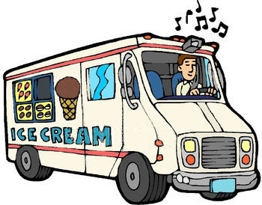

TEACHERS: MR. HACKMEISTER AND VOLUNTEERS

LOCATION: LOWER LEVEL PARKING LOT
SUPPLIES: CUPS, CONTAINERS, TABLE

DESCRIPTION OF STATION:
THIS STATION IS DESIGNATED FOR A WATER BREAK, BUT STUDENTS WILL ALSO HAVE THE OPPORTUNITY TO PURCHASE TREATS FROM THE ICE CREAM TRUCK. PLEASE MAKE SURE STUDENTS HAVE FINISHED THEIR TREATS, AND THROWN AWAY THEIR TRASH, BEFORE MOVING TO THE NEXT STATION. STUDENTS NEED TO HAVE BROUGHT THEIR OWN MONEY, TO BUY ICE CREAM TREATS.

STATION #6
AGENTS OF S.H.I.E.L.D. TRAINING COURSE


TEACHERS: MS. KIRKWOOD AND MRS. DEIST

LOCATION: GYM
SUPPLIES: TIRES, CONES, MATS, ROPE, HURDLES, SCOOTER, TUNNEL

DESCRIPTION OF STATION:
EACH CLASS WILL SIT ON A DIFFERENT SIDE OF THE GYM. THEY WILL BE SEATED AGAINST THE WALLS IN THE WHITE SECTIONS. EACH CLASS WILL GO THROUGH THE OBSTACLE COURSE. THEY WILL BE JUMPING OVER HURDLES, SWINGING FROM THE ROPE, WALKING OVER THE CONES, GOING THROUGH THE TUNNEL, AND USING THE SCOOTER. WHEN THE 1ST PERSON IN THE CLASS GOES THE TIME WILL START, IT WILL STOP WHEN THE LAST PERSON CROSSES THE FINISH LINE. THE TEAM WITH THE FASTEST TIME IS THE WINNER. TEACHERS ARE ENCOURAGED TO TRY THE COURSE, AS WELL!

FIELD DAY SCHEDULE
10:00 EVENTS BEGIN
GRADE 5 * ICE CREAM TRUCK/HYDRATION STATION
GRADE 4 * HULK FEET RELAY RACE
GRADE 3 * BATMAN V. SUPERMAN TUG OF WAR
GRADE 2 * CAPTAIN AMERICA SHIELD TOSS
GRADE 1 * NINJA TURTLES PIZZA RELAY
GRADE K * AGENTS OF SHIELD OBSTACLE COURSE

10:30 EVENTS BEGIN
GRADE 5* HULK FEET RELAY RACE
GRADE 4 * BATMAN V. SUPERMAN TUG OF WAR
GRADE 3 * CAPTAIN AMERICA SHIELD TOSS
GRADE 2 * NINJA TURTLES PIZZA RELAY
GRADE 1 * AGENTS OF SHIELD OBSTACLE COURSE
GRADE K * ICE CREAM TRUCK/HYDRATION STATION

11:00 EVENTS BEGIN
GRADE 5 * BATMAN V. SUPERMAN TUG OF WAR
GRADE 4 * CAPTAIN AMERICA SHIELD TOSS
GRADE 3 * NINJA TURTLES PIZZA RELAY
GRADE 2 * AGENTS OF SHIELD OBSTACLE COURSE
GRADE 1 * ICE CREAM TRUCK/HYDRATION STATION
GRADE K * HULK FEET RELAY RACE

11:30 EVENTS BEGIN
GRADE 5 * CAPTAIN AMERICA SHIELD TOSS
GRADE 4 * NINJA TURTLES PIZZA RELAY
GRADE 3 * AGENTS OF SHIELD OBSTACLE COURSE
GRADE 2 * ICE CREAM TRUCK/HYDRATION STATION
GRADE 1 * HULK FEET RELAY RACE
GRADE K * BATMAN V. SUPERMAN TUG OF WAR

12:00 LUNCH – SACK LUNCHES ARE EITHER PURCHASED FROM THE CAFETERIA OR BROUGHT FROM HOME!

1:00 EVENTS BEGIN
GRADE 5 * NINJA TURTLES PIZZA RELAY
GRADE 4 * AGENTS OF SHIELD OBSTACLE COURSE
GRADE 3 * ICE CREAM TRUCK/HYDRATION STATION
GRADE 2 * HULK FEET RELAY RACE
GRADE 1 * BATMAN V. SUPERMAN TUG OF WAR
GRADE K * CAPTAIN AMERICA SHIELD TOSS

1:30 EVENTS BEGIN
GRADE 5 * AGENTS OF SHIELD OBSTACLE COURSE
GRADE 4 * ICE CREAM TRUCK/HYDRATION STATION
GRADE 3 * HULK FEET RELAY RACE
GRADE 2 * BATMAN V. SUPERMAN TUG OF WAR
GRADE 1 * CAPTAIN AMERICA SHIELD TOSS
GRADE K * NINJA TURTLES

2:00 SAFETY PATROL VS. STUDENT COUNCIL KICKBALL GAME
(CLASSES ARE WELCOME TO STAY AND WATCH FROM THE HILL)

EACH ROOM IS ASSIGNED A COLOR BELOW. THIS IS THE COLOR CONE YOUR CLASS NEEDS TO LINE UP BEHIND AT EACH STATION.

RM. 26-YELLOW
RM. 25-RED
RM. 24-BLUE

RM. 23-YELLOW
RM. 22-RED
RM. 20-BLUE
RM. 15- GREEN

RM. 18-YELLOW
RM. 17-RED
RM. 16-BLUE

RM. 14-YELLOW
RM. 13-RED
RM. 11-BLUE

RM. 8-YELLOW
RM. 6-RED
RM. 4-BLUE

RM. 12-YELLOW
RM. 10-RED
RM. 9-BLUE

THANK YOU,
MR. RYNO

