Family Fun Math Resouces

http://bedtimemath.org/

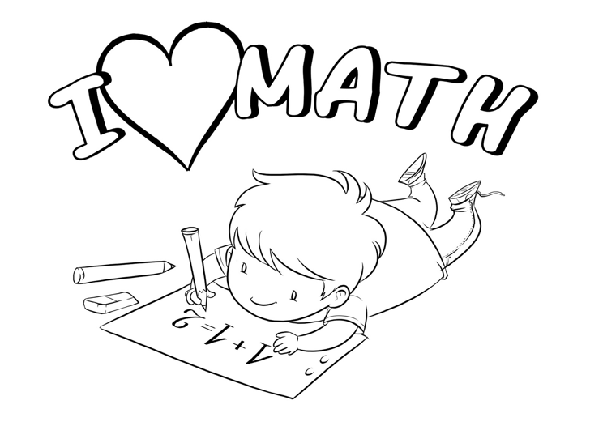
https://www.youcubed.org/tasks/

http://www.sheppardsoftware.com/

http://softschools.com/

http://www.math-play.com/

gregtangmath.com

http://www.arcademics.com/

http://www.pedagonet.com/Maths/mathtricks.htm

www.mathlearningcenter.org/resources/apps

http://sheppardsoftware.com/

mathplayground.com

http://mrnussbaum.com/math-for-kids/

https://padlet.com/math_prof_dev/early_numeracy

http://mathbeforebed.com/

https://www.stmath.com/parent-math-resources

https://www.mathlearningcenter.org/web-apps/number-rack/

www.zearn.org

Xtramath.org

www.sumdog.com

prodigygame.com

https://www.mathlearningcenter.org/web-apps/number-rack/

abcya.com

https://www.mathplayground.com/mobile_thinking_blocks.html

http://m.coolmath-games.com/

http://www.mathtricks.ca

Math Doodles- iPad apps

