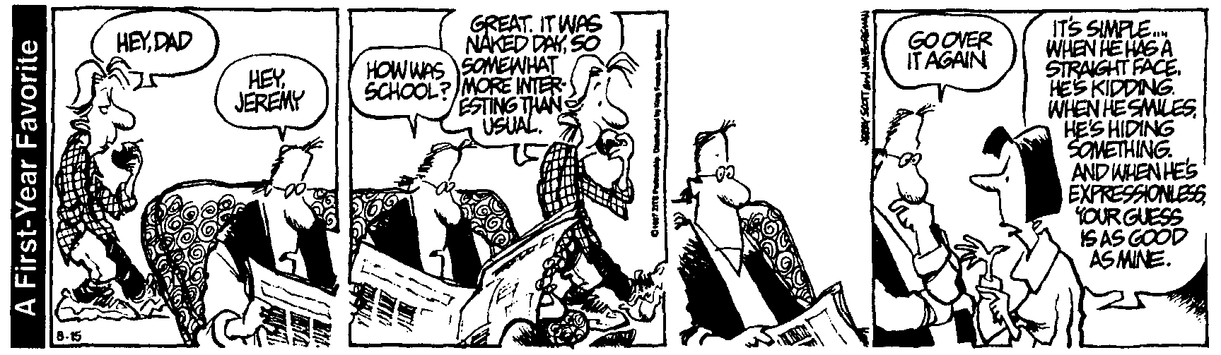
AP Physics – Falling washer lab
Seize the moment. Remember all those women on the "Titanic" who waved off the dessert cart. -- Erma Bombeck
Purpose: The purpose of this activity is to utilize your understanding of motion to analyze the motion of a falling object.
Materials: Six metal washers, string, tape, pan, meter stick, calculator, computer, Sound 3.01 software, Universal Lab Interface (ULI) box, microphone-amplifier sensor.
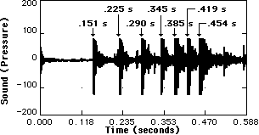Background: You takes you several washers and tie them up to a long piece of string at regularly-spaced intervals - for example, 20 centimeters apart. One end of the string is held near the overhead directly above the surface of a metal pan, which has been stuck on the deck below. You let go of the string and washers fall onto the pan, one after the other, making really loud clangy sound as they hit. Will the washers strike the pan at evenly-spaced time intervals? A bit of your basic serious thought process ought to convince you that they won’t do that. The washers accelerate as they fall so the time between bonks becomes less and less as each consecutive washer strikes the pan. In fact, if a microphone and a computer are used to detect the intervals between bonks, a plot of the noise with vs time would look like the one to the right.

The goal of this activity is to tape or tie metal washers onto a piece of string in such a way that when the string is held vertically and dropped, the washers will hit the pan at equally-spaced time intervals. For example, if the first washer strikes the plate at 0 seconds and the second one strikes the plate at 0.080 seconds, then the third washer must be positioned so that it strikes the plate at 0.16 seconds; the fourth one must be positioned so that it strikes the plate at 0.24 seconds; &c.

The Physics Kahuna will have a computer and microphone set up so that when you have completed the task, you can verify that the bonks occur at equally spaced time intervals and provide physical evidence that you have accomplished the goal.

The computer will make a time versus pressure graph of sound intensity. Print out the graph and include it with your lab report. Also make sure that you use the cursor to find the time difference between the various sound peaks on the graph. These should go in the data section of your report.

Then explain the whole thing.

