Expansion and Contraction of a Marble

Materials: Bunsen Burner, Striker, Marbles, Tongs, GOGGLES

Procedure:
- Turn on your Bunsen burner and adjust until you have a perfectly blue flame.
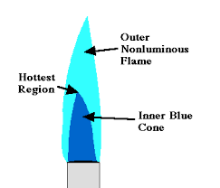
- Use the tongs to put a marble in the hottest part of the flame. Rotate the marble in the flame and count to approximately 100.
- Then put the marble immediately under running water (your faucet).
- Repeat this over and over until the marble finally can’t take it and cracks.
- How many heating and cooling cycles did the marble make? ___________
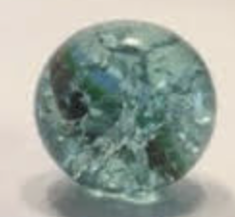

Procedure 2:
- Make another cracked marble by placing it in the flame for 100 seconds and then placing it in the water.
- After cooling it for a bit longer hold it under your phone flashlight and observe.
- Place it back in the flame and water a 2nd time and then view with your flashlight.
- What do you see?
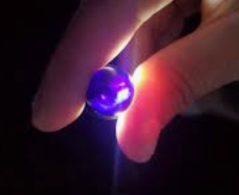
Procedure 3:
- Drop a non-heated marble and observe what happens.
- Drop a heated and cooled marble and observe what happens.
- What happens with each and why?

If you want to keep one for yourself, heat and cool one and then wrap it using the metal wire. Clean up your station by wiping up any broken glass and return your equipment.

