Exam Unit A – KMT A
Useful Information:
1 atm = 760 mmHg = 760 torr = 101.3 kPa (Temperature) K = °C + 273

P₁V₁ = P₂V₂; ; ;

Part 1: Multiple Choice: Choose the single most correct response.

- Which of the following is NOT one of the four variables used to describe gases?
  - pressure b. temperature c. amount of gas d. volume e. mass

- If a rock is heated above a fire, the rock becomes slightly larger. Which explanation is most accurate?
  - The atoms in the rock have become larger.
  - The atoms in the rock have moved further apart.
  - The atoms in the rock have greater mass.
  - The atoms in the rock have become denser.

- If a substance is heated, which statement is true about its particles?
  - The particles have greater average kinetic energy. d. Both a and b.
  - The particles increase in mass. e. Both a and c.
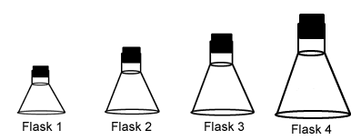
  - The particles are moving more quickly.

- Each of these flasks contains the same number of molecules. In which container is the pressure highest?
  - Flask 1 c. Flask 3
  - Flask 2 d. Flask 4

- The average kinetic energy of water molecules is greatest in _____.
  - steam at 100°C b. liquid water at 90°C c. liquid water at 50°C d. ice at 0°C

- For a liquid to vaporize into a gas, which of these must take place?
  - The particles of the liquid must increase in kinetic energy.
  - The particles of the liquid must break their attractions to one another.
  - The particles of the liquid must move apart from one another.
  - All of the above.

- Increasing the volume of a given amount of gas at constant temperature causes the pressure to decrease because
  - the molecules are striking a larger area with the same force.
  - there are fewer molecules.
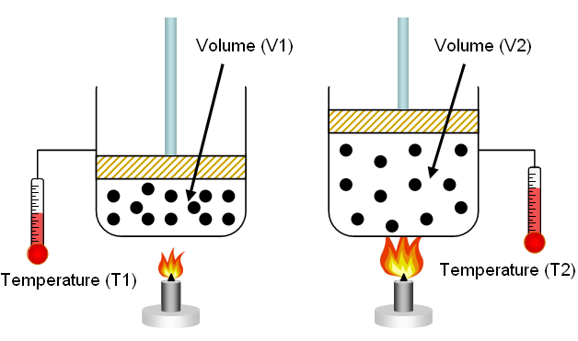
  - the molecules are moving more slowly.
  - there are more molecules.

- Which of the following statements does the figure to the right demonstrate?
  - Volume and temperature are directly related.
  - Temperature and pressure are directly related.
  - Pressure and volume are inversely related.
  - None of the above.

- After dropping a small amount of blue food coloring into a beaker of hot water…
  - the color will not disperse in the water, no matter how long we wait.
  - the color will disperse after a short time because the low kinetic energy of the molecules in the beaker.
  - the color will disperse after a short time because the high kinetic energy of the molecules in the beaker.
  - the color will disperse after a long time because the high kinetic energy of the molecules in the beaker.

- Each of the following would increase the pressure of a gas in a closed container except _____.
  - adding more gas to the container
  - increasing the temperature of the gas in the container
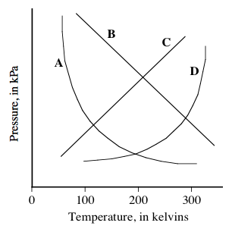
  - increasing the volume of the container

- Using the figure at the right, which graph represents the relationship between the pressure and temperature of a gas at a constant volume?
(Select either a, b, c, or d)

- When a liquid is cooled, its volume decreases. Which explanation is best?
  - The particles are closer to together when it’s cool.
  - The particles decrease in size when they are cool.
  - The particles decrease in mass when it’s cool.
  - The particles speed up when they are cooled.

- Mark the letter of the sentence that is FALSE.
  - Liquids are much denser than gases because intermolecular forces reduce the amount of space between the particles in a liquid, holding them tighter.
  - Increasing pressure on a liquid has almost no effect on its volume.
  - Liquid particles are free to slide past one another.
  - Liquids are denser than gases because their molecules are larger than gas molecules.

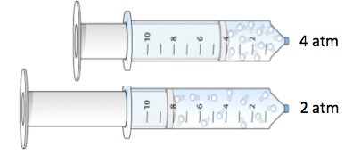
- Which of the following statements does the figure demonstrate?
  - Volume and temperature are directly related.
  - Temperature and pressure are directly related.
  - Pressure and volume are inversely related.
  - None of the above.

- Why does air leave a tire when the tire valve is opened?
  - The pressure outside the tire is lower than the pressure inside the tire.
  - The temperature is higher outside the tire than inside the tire.
  - The pressure outside the tire is greater than the pressure inside the tire.
  - There are more gas particles outside the tire than inside the tire.

