ES Quiz 3A Multiple Choice (1 pt ea.)

1. _____A deep oceanic trench is found

A. at mid-ocean ridges B. at subduction zones
C. at transform boundaries D. all of the above

2. _____Which best defines the lithosphere?

A. the rigid, rocky, outermost layer of earth B. a rocky layer within the mantle
C. a rocky layer in the mantle capable of flowing D. the outer, liquid portion of the earth's core

3._____ Which of the following is found at a convergent boundary where 2 plates carrying continental plates are colliding?

A. the Appalachian mountains B. the Himalaya mountains
C. the Andes mountains D. the Rocky mountains

4._____ A divergent boundary could be recognized by

A. a high mountain belt B. a volcanic island arc
C. a rift valley D. all of the above

5.____What happens when an oceanic plate converges with a continental plate?

A. The denser oceanic plate converges with a continental plate

B. The less dense oceanic plate slides under the denser continental plate

C. The less dense oceanic plate slides past the denser continental plate

D. The denser oceanic plate slides under the less dense continental plate

6._____What is a transform boundary?

A. a transform boundary is when two plates slide past one another

B. A transform boundary is when two plates pull away from each other

C. A transform boundary is when two plates move towards each other

D. A transform boundary is when two plates collide

7. _____What tool does a scientist use to detect magnetic fields?

A. a thermometer B. a magnetometer

C. a fieldometer D. a meter stick

8. _____ What do scientists believe is the force moving the plates?

A. the movement of the planets B. the sun’s gravity

C. convection currents D. Slab pull

9. _____ At a divergent boundary:

A. Plates move away from each other

B. Plates move toward each other

C. Plates slide past each other

D. Plates are subducted
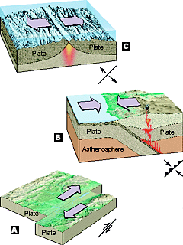
Put the letter of the correct plate boundary in the space provided. (1 pt ea)

10. Convergent_____
11. Divergent_____
12. Transform _____

13. Use the following terms to correctly identify the following features/processes: (6 pts)
Subduction, convection current, mid ocean ridge, deep sea trench, island arc volcanoes, sea floor spreading

A. ___________________ B. ________________________ C. _________________________
D. ________________________ E. ________________________ F. __________________________
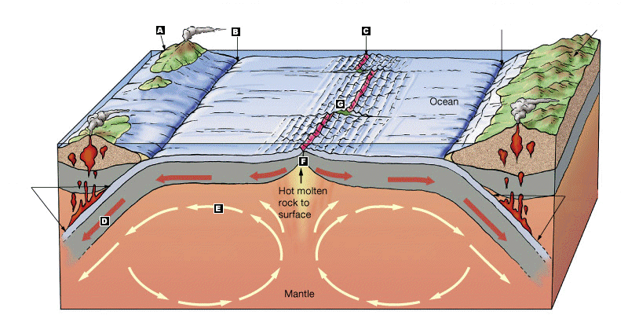

- Sea floor spreading results in the formation of new oceanic crust. In 2-3 complete sentences, explain why the size of the earth is not changing if new ocean crust is constantly being created. (3 pts)

- Name two pieces of evidence that supported Wegner’s Theory of Continental Drift, and provide one example for each. (4 pts)
Evidence 1: ______________________________________________________

Example: ____________________________________________________

Evidence 2: ________________________________________________________

Example: _____________________________________________________

