Energy Facts Web Quest
Directions: Go to Google and find the following answers

- Nonrenewable Resources
  - List the four nonrenewable resources below.
a.
b.
c.
d.

  - Nuclear energy can be used to make electricity. But first the energy must be released. What are the two ways it can be released?
a.
b.

  - Most nuclear waste is low-level nuclear waste. What waste is the principal environmental concern for nuclear power?
__________________________________________________________

  - Fill in the blank
Oil was formed from the remains of______________ and ___________that lived millions of years ago in a marine (water) environment before the dinosaurs. Over the years, the remains were covered by layers of mud. ________________and _________________ from these layers helped the remains turn into what we today call ____________ oil . The word "petroleum" means "rock oil" or "_________________________________________________."

5. Re-create the pie chart. Label it carefully.
Who puts the most petroleum in North American Waters?

Who puts the least amount of petroleum in North American Waters?
__________________________

6. Coal is what type of rock? _____________________________________
7. True or false: Coal is the most abundant fossil fuel produced in the United States.
8. Fill in the blank:
Power plants use "____________________" to clean sulfur from the smoke before it leaves their smokestacks. In addition, industry and government have cooperated to develop "clean coal technologies" that either remove ____________________ and n_______________ o________________ from coal, or convert coal to a gas or liquid fuel.
9. Pressure and heat changed organic material into coal, some into oil (petroleum), and some into natural gas -- tiny bubbles of odorless gas. The main ingredient in natural gas is _______________________.
10.
a. Who uses the most natural gas? ____________________________
b. What percentage is used for vehicle fuel? ____________________
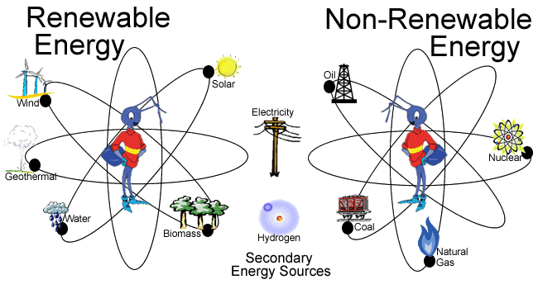

11. What are four (4) uses of solar energy?
a.
b.
c.
d.
12. Why is the use of hydropower criticized?
13. Wind energy is mainly used to generate electricity. Why is wind called a renewable energy source?
14. What is one drawback to the use of wind power?
______________________________________________________________________________________________________________________
15. Biomass is organic material made from ______________ and _____________.
16. An example of biomass is ________________________.

