AP Physics – Do Energy Really Get Conserved Lab
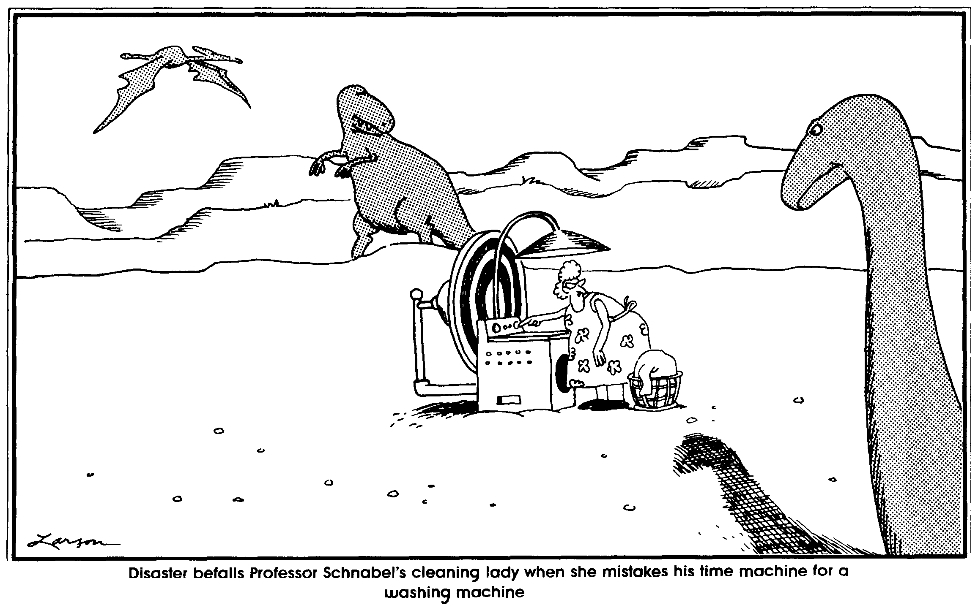

To do good is noble, to tell others how to do good is nobler; and no trouble. -- Mark Twain

In this ever so loverly lab, you are going to confirm the universality of the good old law of conservation of energy.

As you now realize, energy is conserved in any closed system.

So here’s your mission. Prove it.

Devise you up an experiment that you can do in the lab that will show that energy is conserved.

Feel free to consult with the beloved Physics Kahuna about any equipment or instruments that you think might help you in your endeavor.

As always, may the force be with you.

