The End of the Line
Name:
Per: Date:

Cod Overfishing
- What was the main source of income for Newfoundland?
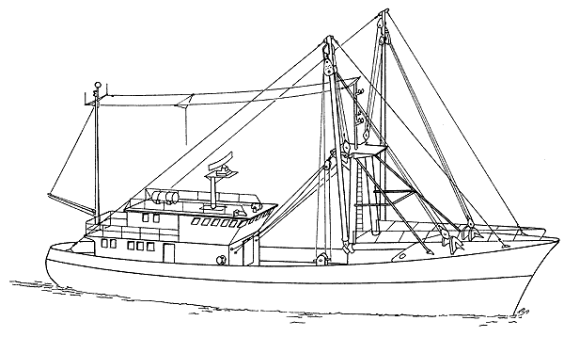

- What significant event occurred in 1992?

- Explain the term 'moratorium' in the context used in the clip.

- Why do you think this moratorium was brought in? What were the consequences?

Technology
- How could you describe the impact of hi-tech fishing vessels on the 'world catch'?

- Did you find the scale of the technology employed (lines, nets, monitoring etc.) surprising?

- Think about this statement: 'The thing is we're too good right now. Technologically not a single hunted animal on this earth has a chance.' (Professor Jeffrey Hutchings)
- What evidence does the sequence/film provide to support this statement?

Senegal
- How many of the global population identify fish as a key part of their diet?

- How much of the 'world catch' is returned dead to the sea?

Fish Farming
- What do you think the attractions of fish farming are?

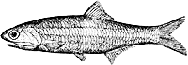
- What is used to feed farmed fish?

- What are the potential consequences of fish farming?

- The voiceover says that 'On average five kilos of anchovy makes only one kilo of salmon.' Could you describe this process as sustainable?

Marine Reserves
- What is the purpose of marine reserves?

- Should we implement a global marine reserve network?
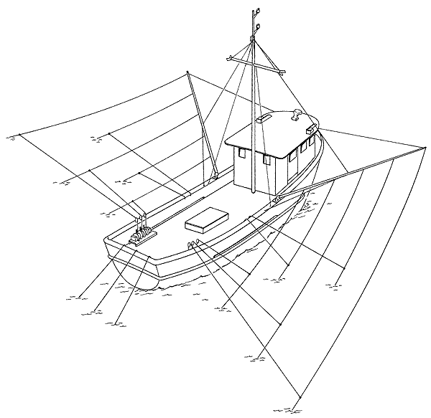

Explain why.

