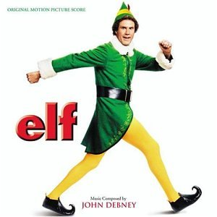
Product Placement

Fill in the questions while watching the movie Elf. During the movie, use the back of this page to record as many examples of product placement as you can. You must have a minimum of 20!

- Provide an example of an advertisement placement used in the film.

- Why use product placement in movies or TV?

- Do you think that product placement works? Why? Give examples.

- After watching the movie, did you ever realize there were so many products placed in movies? What do you think?

Brand
Directions: Write at least 20 products that you see in the movie. ½ point bonus for each additional product listed.
1. |  | 25.
2. |  | 26.
3. |  | 27.
4. |  | 28.
5. |  | 29.
6. |  | 30.
7. |  | 31.
8. |  | 32.
9. |  | 33.
10. |  | 34.
11. |  | 35.
12. |  | 36.
13. |  | 37.
14. |  | 38.
15. |  | 39.
16. |  | 40.
17. |  | 41.
18. |  | 42.
19. |  | 43.
20. |  | 44.
21. |  | 45.
22. |  | 46.
23. |  | 47.
24. |  | 48.

