AP Physics – Electromagnetic Test

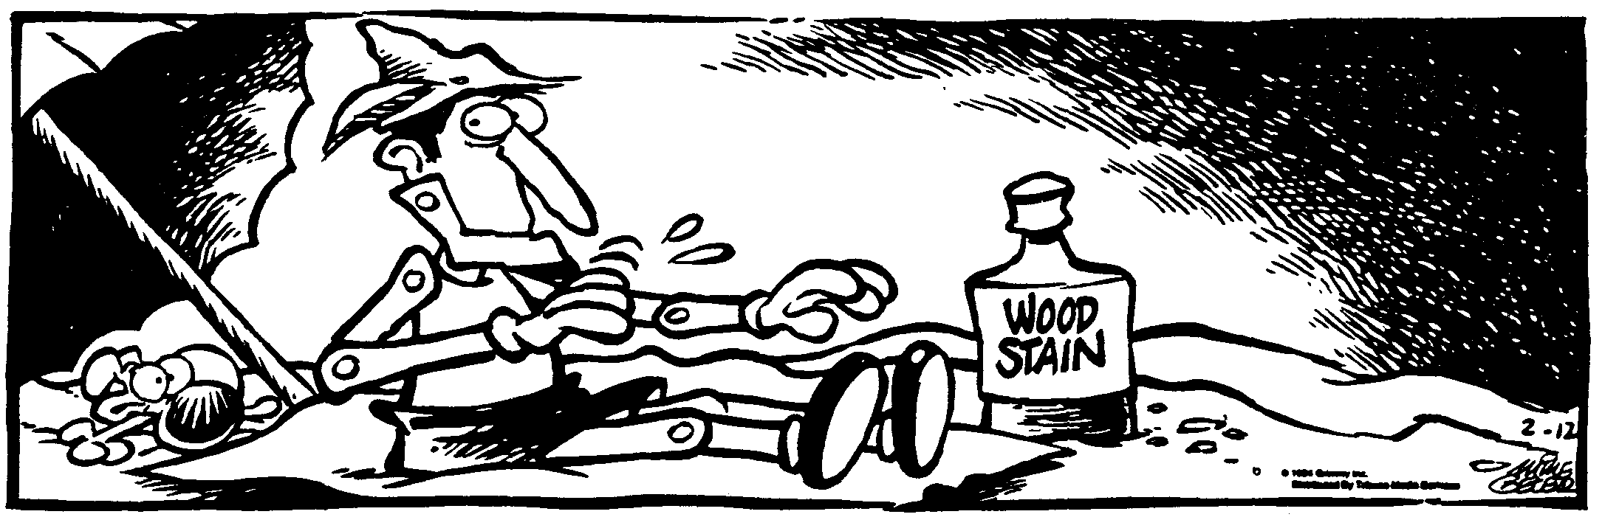
Id Thyself ____________________________________________________________________Per __
You can’t depend on your eyes if your imagination is out of focus. -- Mark Twain
- (20) Figure out the following for the circuit shown: (a) The total resistance, (b) the total current, (c) the power dissipated by the 8.50 Ω resistor.

- (60) A point in space is a distance of 11.0 cm from a 675 μC charge. Find (a) the electrical potential at point P, (b) the magnitude of the electric field at point P, (c) the amount of work that would be done in moving a charge of 45.0 μC to point P from infinity.

- (20) Draw in some arrows showing the direction of the magnetic field on the current carrying conductor.

- (20) Why was the 40 Watt bulb brighter than the 100 Watt bulb when they were in a series circuit that had 120 V applied to it?

- (60) A rectangular loop of wire moves at a constant speed of 6.5 m/s. At time 0, it enters a 2.4 T magnetic field that is perpendicular to the loop (going into the page). (a) What is the induced emf when the leading edge of the loop has traveled 3.0 cm into the field? (b) What is the direction of the induced current in the loop? Explain how you came up with your answer. (c) If the resistance of the loop is 1.5 Ω, what is the induced current?

