AP Physics – Electromagnetic Test

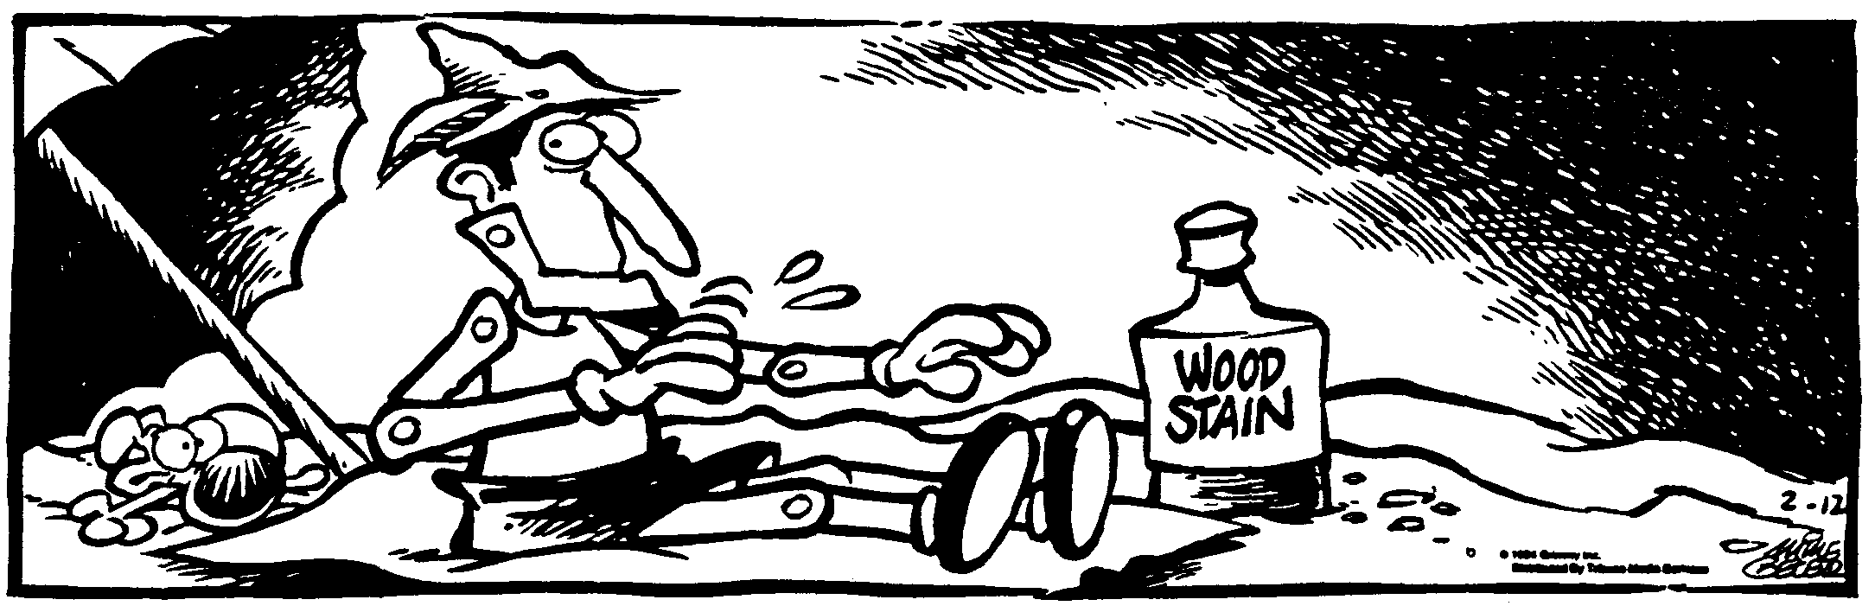
Id Thyself ____________________________________________________________________Per __
You can’t depend on your eyes if your imagination is out of focus. -- Mark Twain
- (20) Figure out the following for the circuit shown: (a) The total resistance, (b) the total current, (c) the power dissipated by the 8.50 Ω resistor.

- (60) A point in space is a distance of 11.0 cm from a 675 μC charge. Find (a) the electrical potential at point P, (b) the magnitude of the electric field at point P, (c) the amount of work that would be done in moving a charge of 45.0 μC to point P from infinity.

- (40) A proton is accelerated from rest through a potential difference of 9.0 V. Find (a) the energy of the particle, and (b) the speed of the particle.

- (20) A 21.5 cm wire carries a current of 0.85 A. The wire makes an angle of 65.0° with the lines of force in a magnetic field of 0.850 T. Find the force acting on the wire from the magnetic field.

- (20) Draw in some arrows showing the direction of the magnetic field on the current carrying conductor.

- (20) A color tv has an internal resistance of 15.4 Ω. It operates on 117 V household AC electricity. (a) How much current does it draw? (b) How much power does it develop? (c) If it operates for 8.0 hours, how much does it cost to run the thing if a kWh costs 5.50 cents?

- (20) An electron is moving perpendicular to a uniform magnetic field as shown. The direction of the field is into the paper. (a) Draw the direction of the force onto the picture. (b) Draw in the shape of the path the electron will take. (c) The field strength is 1.85 T, the velocity of the electron is 6.50 x 10⁶ m/s. Find the force acting on the particle. (d) What is the radius of its path?

- (20) A rectangular loop of wire moves at a constant speed of 6.5 m/s. At time 0, it enters a 2.4 T magnetic field that is perpendicular to the loop (going into the page). (a) What is the induced emf when the leading edge of the loop has traveled 6.0 cm into the field? (b) What is the direction of the induced current in the loop? Explain how you came up with your answer. (c) If the resistance of the loop is 1.5 Ω, what is the induced current?

