Electromagnetic Lab Stations 2
Lab Station 1: 3D glasses, Laptop with video
- 3D glasses work by separating 2 colors (usually blue and red). Your brain interprets the signal by putting the 2 images on top of each other, creating a 3D image.
- Put on the blue and red 3D glasses. Start the video and watch it for a minute.
- Put on the other 3D glasses and watch the video for a minute.
- View the pictures with the glasses.
- Describe what you see.

Lab Station 2: Strobe light, rotator, fidget spinners, fountain
- Strobe lights work by flashing light quickly. Your brain interprets the signal by filling in gaps.
- Turn on the rotator that has a paper attached. Turn on the strobe light and change the light flashes by turning the knob. Watch the rotating paper and observe. What do you observe?

- Spin the fidget spinners and shine the strobe light on it while changing the flashes. What do you observe?

- Observe the fountain. Put your hand in the water. Is the water really going upwards?
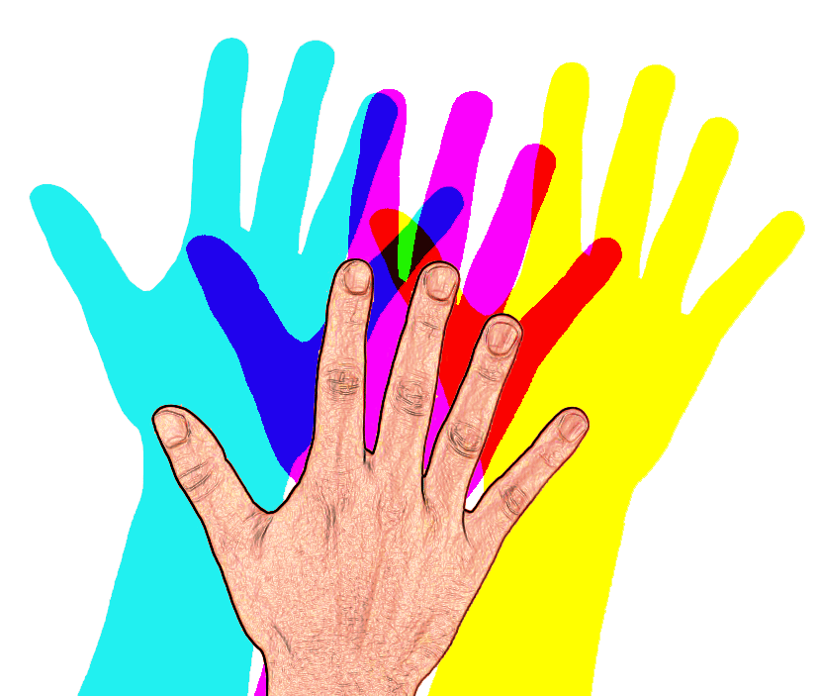
Station 3: Visible Light (Colored Shadows)
Materials:
Lamp with 3 bulbs
Blue, Yellow, and Red lightbulbs
White screen or white background
- Turn on all 3 colors of lights. Put your hand in front of the white screen and observe the shadows created. What colors are the shadows?

- Now cover the yellow light and only have the blue and red on. Put your hand in front of the lights and observe the shadows. What colors are the shadows?

- Now cover the blue light and only have the yellow and red on. Put your hand in front of the lights and observe the shadows. What colors are the shadows?

- Now cover the red light and only have the blue and yellow on. Put your hand in front of the lights and observe the shadows. What colors are the shadows?

Station 4: Diffraction Glasses, candle, flashlight, discharge tube, laser, colored paper, bubbles
- Put on the glasses and view a lit candle, the flashlight, and the discharge tube.
- Are there differences in the colors?
Describe the colors you see for each one:
Candle Flashlight Discharge Tube
- Shine the laser light on each piece of colored paper and observe with the glasses on.
- Are they different or the same?
- Make a bubble using the bubble wands. Look at the bubble through diffraction glasses while shining a bright light on it.
- Describe what you see on the edge of the bubbles.

Lab Station 5: UV lights, UV pens, Highlighters, White paper, UV objects
- An electron gains energy to move to a higher energy level. When it releases the energy to move back to a lower energy level, it releases the energy in the form of light.
- Use the highlighters and draw a picture on the white paper. View it using the blacklight.
- Use a UV pen and draw on your skin. View with the black light.
- Hold the various objects up to the blacklight to view them.
- Use the UV pen and shine it on the green glow paper.
- Describe what happens.

Lab Station 6: VR Goggles (Oculus)
VR Goggles work by using lenses. Ordinary glasses show a single image but 3D and virtual reality glasses contain lenses which show two images, one per each eye. These images appear to give an illusion of depth. The technical name for this is stereoscopy.
- Put on the Oculus and play any of the games you choose.
- When you are finished, PLEASE plug the Oculus back in so that it will be charged for the next class!

Lab Station 7: X-RAYS

X-Rays
- Identify each animal by viewing the XRays. List what animal you think it is:
1.
2.
3.
4.
5.
6.
7.
8.
9.
10.
- Identify the problem in each Xray. List the body part you think it is:
1.
2.
3.
4.
5.
6.
7.
8.
9.
10.

