AP Physics – Electric Test

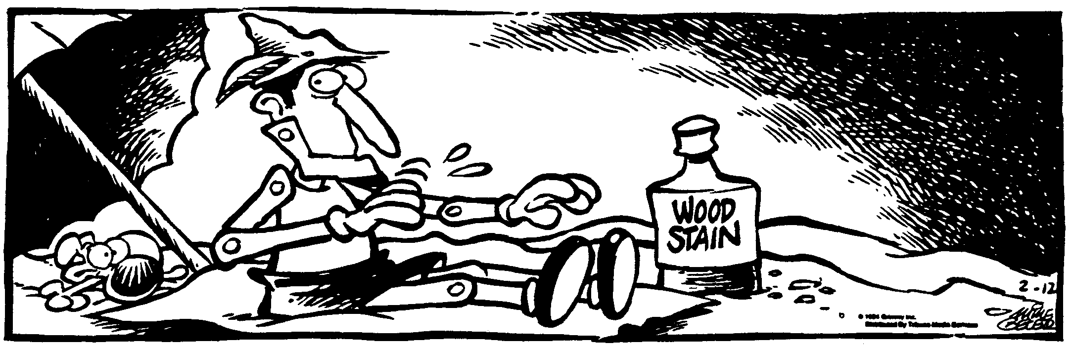
Id Thyself __________________________________________________________________Per__
You can’t depend on your eyes if your imagination is out of focus. -- Mark Twain
- (60) Figure out the following for the circuit shown: (a) The total resistance, (b) the total current, (c) the power dissipated by the 1.80 Ω resistor.

- (20) 1.45 x 10¹⁷ electrons take 0.700 seconds to flow past a point in the circuit. What is the current?

- (60) A color tv has an internal resistance of 5.4 Ω. It operates on 120 V household AC electricity. (a) How much current does it draw? (b) How much power does it develop? (c) If it operates for 8.0 hours, how much does it cost to run the thing if a kWh costs 5.5 cents?

- (60) A point in space is a distance of 11.0 cm from a 675 μC charge. Find (a) the electrical potential at point P, (b) the magnitude of the electric field at point P, (c) the amount of work that would be done in moving a charge of 45.0 μC to point P from infinity.

- (40) A proton is accelerated from rest through a potential difference of 9.0 V. Find (a) the energy of the particle, and (b) the speed of the particle.

