Electric House Project
Materials:
- Cardboard and Cardstock
- Duct tape or packing tape
- Christmas lights
- Paper clips
- Electric tape or masking tape
- Wire stripping tool
- Hot Glue
- 9v battery (only 1)
- Craft sticks

Construction time frame:
You will have this week to work on your project in class.
Grading: This project will count as one (1) test grade

Furniture must be primarily made of wood (craft sticks, toothpicks, etc.) and include the following:
Room 1
- Complex piece of furniture that includes more than one piece (such as kitchen table with 2 chairs)
- 1 single piece of furniture (your choice)
Room 2
- Complex piece of furniture that includes more than one piece (such as bed with nightstand)
- 1 single piece of furniture (your choice)
Room 3
- Complex piece of furniture that includes more than one piece (such as TV stand with a TV)
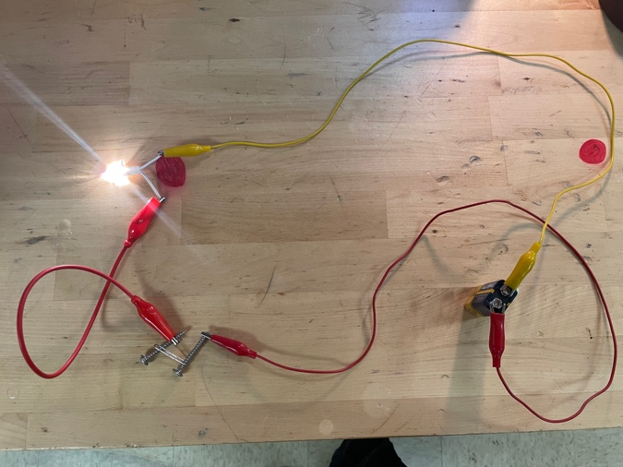
- 1 single piece of furniture (your choice)

Room 1
Lights up (1 light / 1 switch) - 15
Furniture – 12
Floor and wall covering - 6
Room 2
Lights up (2 lights / 2 switches) - 16
Furniture - 12
Floor and wall covering - 6
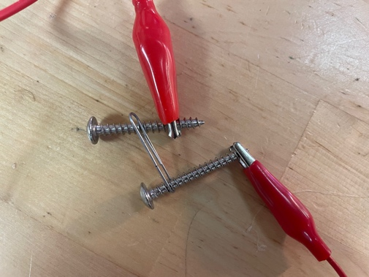
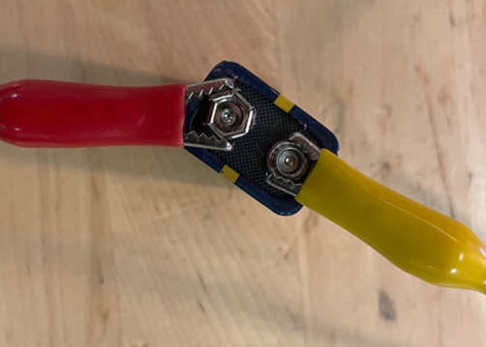
Room 3
Lights up (2 lights / 1 switch) - 15
Furniture - 12
Floor and wall covering - 6

Total Points - 100 points

