Rockets – Elastic
- Cut a wooden dowel rod down to what size rocket you want.
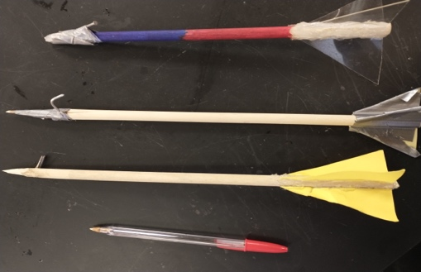

- Shave the tip of the dowel rod until it is sharp. This will help the rocket “cut” through the air. Use a razor blade, scissors, etc.
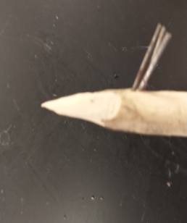
- Drill a small hole through the dowel rod using an electric drill and tiny drill bit. Place a nail or other object through the hole. Hot glue it in place and also secure with duct tape. This will need to be very strong since it will attach
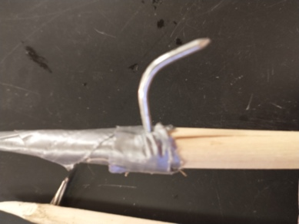
- Cut out 3 to 4 fins. You need them to be less flimsy so use cardboard.
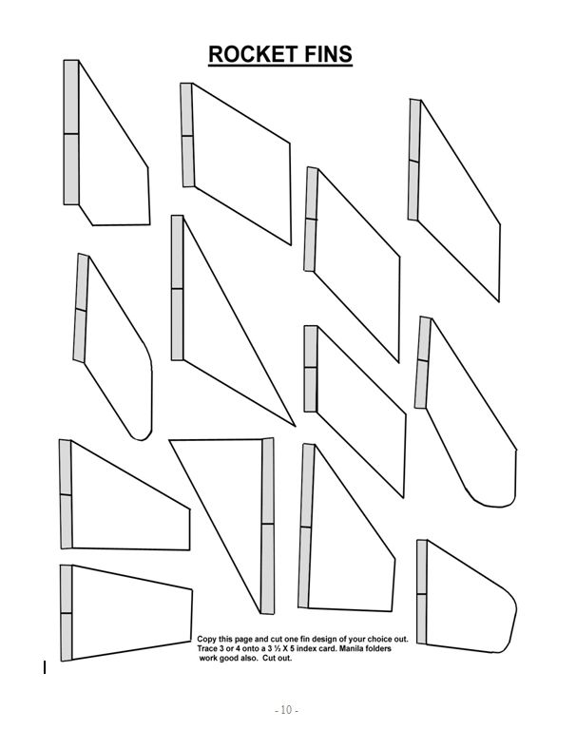
- Tape the fins to the rocket. It is very important that the fins are evening spaced apart. Use the picture below. Put your rocket body in the circle. Mark on your rocket where the lines are (use the dotted lines for 3 fins and the solid lines for 4 fins). Tape or hot glue your fins to your rocket body.
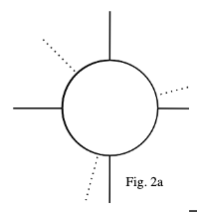

Rubber band Launcher

Criteria – what is being requested.

I want a rocket that will fly 50 meters or more that will be launched using rubber bands only.

Constraints – what is limited.

You must build the rocket from a dowel rod. It must be launched using no more than 50 rubber bands.

Materials: 50 rubber bands

Procedure:

- Tie or loop 5 rubber bands together so they make a rope. Repeat 10 times to get 10 ropes.
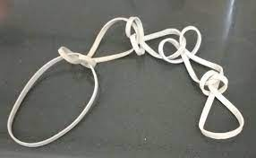
- Now place the ropes on a pole and braid them together.

- Place your rocket on the rubber band launcher and pull hard to make sure the rocket pin does not bend or break off.

