Earth, Moon, and Sun System Activity

Can a model be devised to show the positions of the sun, the moon, and Earth during various phases and eclipses? The Earth, moon, and sun work together to create spectacular events such as moon phases and both lunar and solar eclipses. If you have looked into the night sky, you may have noticed the Moon appears to change shape each night. Some nights, the Moon might look like a narrow crescent. Other nights, the Moon might look like a bright circle. And on other nights, you might not be able to see the Moon at all. The different shapes of the Moon that we see at different times of the month are called the Moon’s phases.
The Moon moves in an orbit around Earth. At the same time, Earth orbits the Sun. Sometimes Earth moves between the Sun and the Moon. When this happens, Earth blocks the sunlight that normally is reflected by the Moon. Sometimes when the Moon orbits Earth, the Moon moves between the Sun and Earth. When this happens, the Moon blocks the light of the Sun from reaching Earth. This causes an eclipse of the Sun, or a solar eclipse. During a solar eclipse, the Moon casts a shadow onto Earth. By creating models, features of the moon and its relationship with the Earth and sun can be studied.
Procedure
Materials:

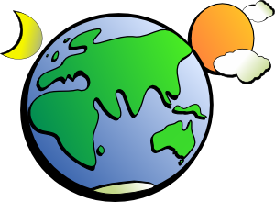
light Source:
- ring stand
- bulb, socket, extension cord assembly
- zip ties
(2) Polystyrene Balls of Different Size
(2) Dowel rods / Wooden Skewers
Resources

Steps:

1. Create the sun by using a zip tie to attach the end of the extension cord to the top of a
ring stand. Attach the socket and bulb to the end of the extension cord. Asked to be
checked prior to moving on.

2. Use and stick the smallest polystyrene ball on a dowel rod / skewer as a model moon.
Be careful not to damage the polystyrene ball too much; plus, there may already be a
hole there. Do the same for the other yet larger polystyrene ball as model of the Earth.

Moon Phases: See and Study Figure Below

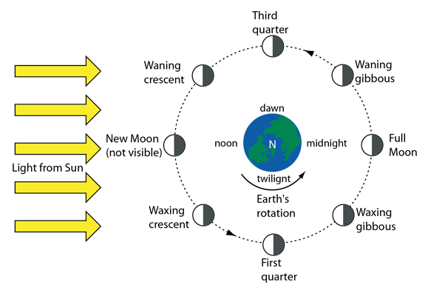
2

3. Place and hold the Earth model several inches from the sun.

4. Using the illustration(s) provided and the moon model only, move the moon around the
Earth to demonstrate the four (4) major phases: new moon, first quarter, full moon,
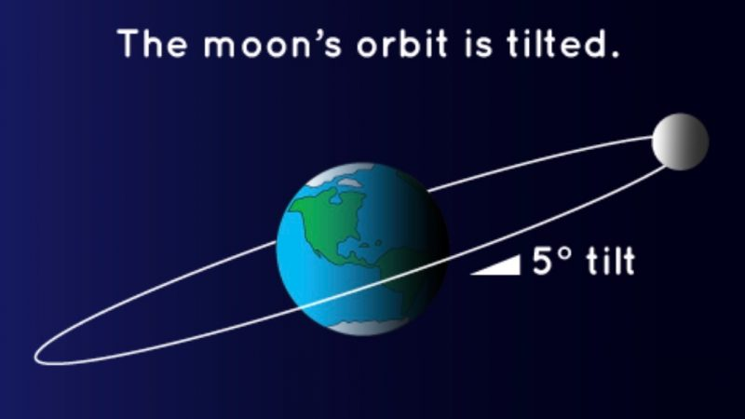
and then third quarter

Hint: The moon rotates at a slight angle; technically by5⁰;
you’ll have to simulate this to see a full moon.

5. Using the illustration(s) and moon model only, move the moon around the Earth to
demonstrate the “progressions” of going from one major phases to another by
demonstrating the other four (4) phases: waxing crescent, waxing gibbous, waning
gibbous, and then waning crescent

Check Point: Ask to now show all eight (8) phases of the moon when you are ready.

Eclipses: See and Study Figure Below

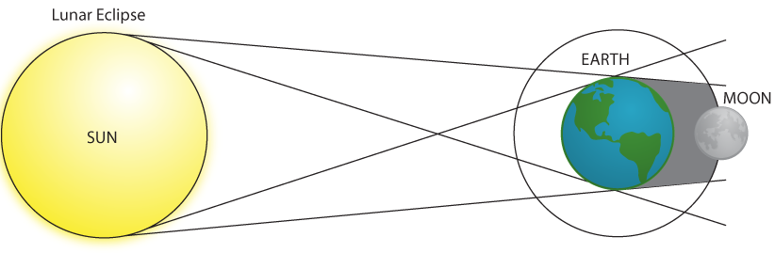

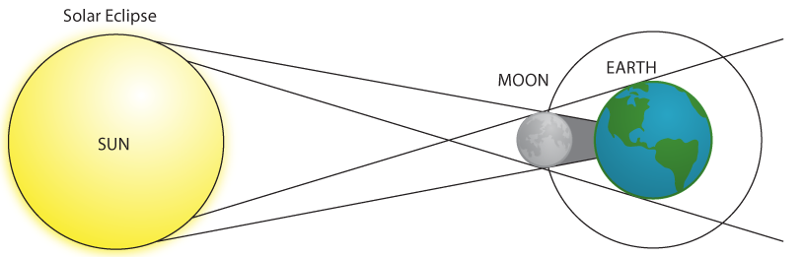

6. Using the sun, place the Earth model at a location where a lunar eclipse would occur.
You may have to make some adjustments with regards to distance between the moon
and Earth. Note, if done correctly the moon should be completely shadowed by the
sun.

7. Using the sun, place the moon model at a location what a solar eclipse would occur.
You may have to make some adjustments with regards to distance between the moon
and Earth. Note, if done correctly an umbra “and” penumbra should be noticeable.

Check Point: Ask to now show a solar eclipse model when you are ready.

8. Answer all the questions on the result date sheet provided.

Clean up all material as directed.

First and Last Name:
Period: /45

Earth, Moon, and Sun System Activity Result Data Sheet

Answer the following questions with the best responds: 2 pts each

1. Despite the distance between the moon and the sun, do they both look like the same size?

2. How many moon phases “total” where modeled?

3. Would you agree that the moon is always half lit despite which phase it is in?

4. Can one notice the moon phases through a day or are they noticed throughout a month?

5. When modeling the moon phases, were you modeling the moon rotation, revolution, or
both? (Hint: Did you have to twist the wooden stick whilst you went around the sun?)

6. Which two major moon phases help to best create an eclipse?

7. Between the penumbra and umbra shadows, which one covers the moon completely
during the movement of a “total” lunar eclipse?

8. Which is in the middle during a solar eclipse: Earth, moon, or sun?

9. What unforeseen event(s) happened during the lab? (never say none)
- ie Start off by writing… An unforeseen event was …

10. What improvement(s) could have been made in the activity? (never say none)
- ie Start off by writing… An improvement that could be made for this lab would be …

First and Last Name: KEY
Period: /45

Earth, Moon, and Sun System Activity Result Data Sheet

Answer the following questions with the best responds: 2 pts each

1. Despite the distance between the moon and the sun, do they both look like the same size?
YES

2. How many moon phases “total” where modeled?
8

3. Would you agree that the moon is always half lit despite which phase it is in?
YES

4. Can one notice the moon phases through a day or are they noticed throughout a month?
MONTH

5. When modeling the moon phases, were you modeling the moon rotation, revolution, or
both? (Hint: Did you have to twist the wooden stick whilst you went around the sun?)
BOTH

6. Which two major moon phases help to best create an eclipse?
FULL (lunar) and NEW (solar)

7. Between the penumbra and umbra shadows, which one covers the moon completely
during the movement of a “total” lunar eclipse?
UMBRA

8. Which is in the middle during a solar eclipse: Earth, moon, or sun?
MOON

9. What unforeseen event(s) happened during the lab? (never say none)
- ie Start off by writing… An unforeseen event was …
AWV

10. What improvement(s) could have been made in the activity? (never say none)
- ie Start off by writing… An improvement that could be made for this lab would be …
AWV

